Web Design and Development

4COSC011W

Report

Author: Ashfaaq Ahamed Hilal

Student ID: 2019394

Group Number: Half Foundation [1]

Student Role: 03

Link(s) to Website

URL:

<https://w1761334.users.ecs.westminster.ac.uk/>

1. Introduction 3

2. Technical Discussion 4

2.1 QUIZ PAGE 4

2.2 STUDENT DETAILS PAGE 9

2.3 Page Developer 11

2.4 PART B (Personal web page) 12

3. Discussion of UI and application of UX principles 17

3.1 Information architecture 17

a. Design 17

17

b. Code to achieve good Information architecture 21

3.2 Colour balance/composition/graphics/consistency 28

a. Design & Code to achieve good colour balance & ensure consistency 28

b. Colour contrast test results 35

3.3 Typography / consistency 37

a. Design & Code to achieve good typography / consistency 37

3.4 Gestalt principles grouping 42

a. Proximity 42

b. Similarity 44

c. Closure 45

d. Continuance 46

3.5 Accessibility (graphics/forms) 49

a. Graphical elements - Design/Code 49

3.6 Error prevention and recovery 52

a. Design & Code to address error prevention and recovery 52

4 Janet 54

5 Conclusions 54

References 55

Appendices 56

Appendix A: Code 56

Appendix B: Screenshots 111

Appendix C: Individual Statement 116

# Introduction

Section guidelines: List of the team members, allocation of tasks (student 1 to 4), and topic of the website.

We divided groups and our group consists of four members.

* Student 1 – Sudesh Dilshan
* Student 2 – Hamza Ziyard
* Student 3 – Ashfaaq Ahamed
* Student 4 – Archana Harankahawatta (Discontinued from degree program)

We collectively came up with a decision that we will be making a website about *“MOTOR VEHICLES”.* We selected this topic mainly focusing on the transportation sector. First and foremost, we came up with a name for our website as “PETROL PAGES”. Thereon, we divided our tasks and started working efficiently.

Since we selected the main topic as Motor Vehicles, we divided the sub-topics for the personal page as

* Student 1 – Jeeps
* Student 2 – Cars
* Student 3 – Bikes
* Student 4 – Vans (Discontinued from degree program)

# Technical Discussion

I selected the role of student 03 in the coursework. I had to make a Quiz page and page that contains the details of the students who are in my team. My personal page has a content on the topic Bikes.

Every page in my web page has a logo and a page developer button. When the user clicks on the logo, it will direct him to the home page of our website. When the user clicks of the page developer button, the user will get the information about who created that page.

## 2.1 QUIZ PAGE

The main page appears first on the start-up of our web-site. The QUIZ page I created should be opened through the navigation bar.

This is the page that will appear once the user clicks on the “Start Quiz” button. In the quiz page, there are 10 various questions related to motor vehicles. There is a timer set for two minutes.

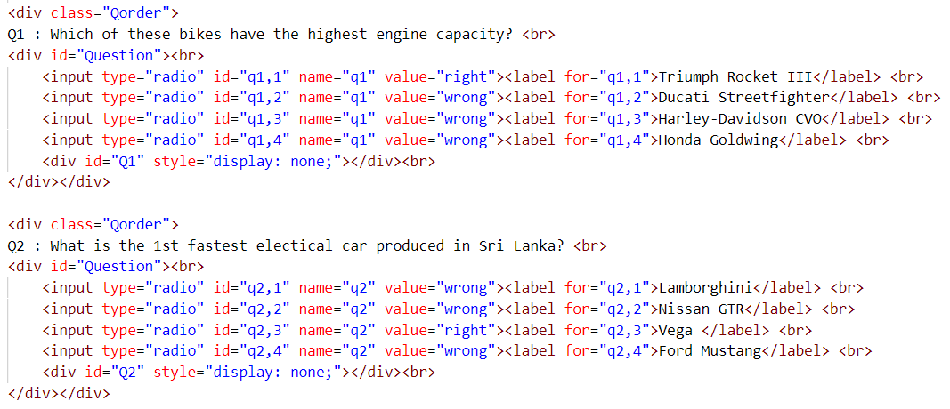The page starts with an instruction box giving the rules to perform the quiz. When the user clicks the “Start Quiz” button the quiz will be ready to answer. The structure of the quiz is done in a multiple-choice method. I have chosen the Radio buttons method to answer the quiz, since it is easy to access by the user.

**Checking radio buttons and their values**

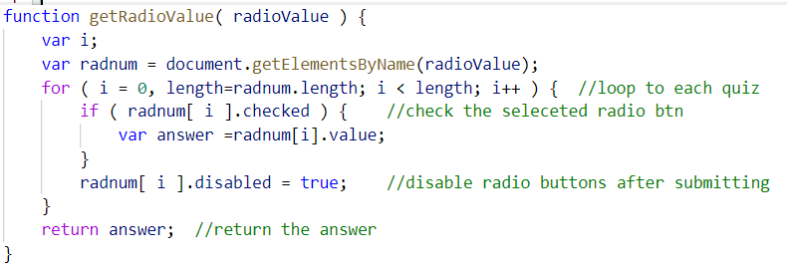A loop is created to iterate the quiz radio buttons. Every radio button has a different name. So, it is possible to access every question separately. After the quiz is submitted the radio buttons gets disabled. So, the user will not be able to change his answers even if it is wrong.

This loop will iterate each question individually. A question contains four radio buttons (i.e. 4 Answers). “radnum.length” checks all the radio buttons separately and the value of the checked button is set to a variable.

Each and every answer are set to a variable to check if the answer is correct or wrong.

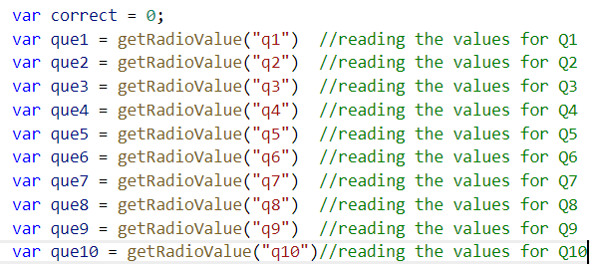.

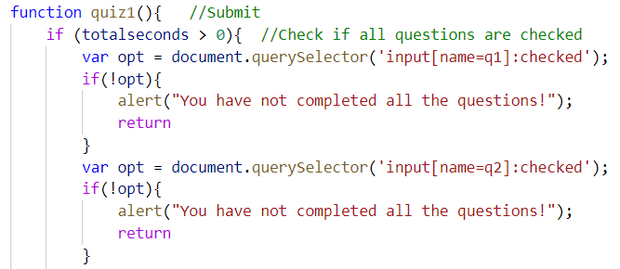Since it is an MCQ based Quiz, I developed the web page as, the user could submit only if he answers all the questions. This was considered because all the answers are displayed. An error message will be shown if it happens so.

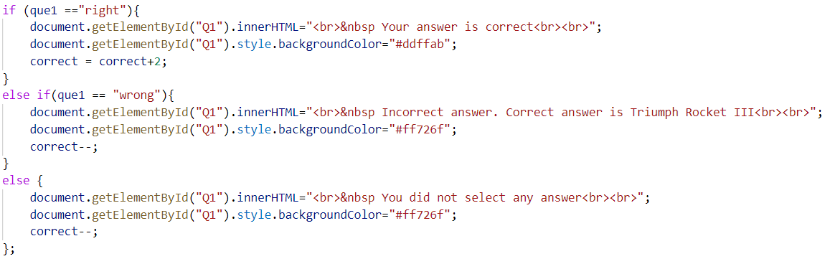When the submit button is clicked, a result sheet is shown up showing which are the correct answers and the incorrect answers. They are shown in different colours for easiness. Suppose the answer is wrong, it will automatically show the correct answer.

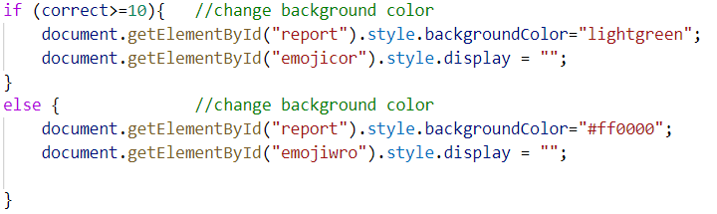Finally, the quiz section with answers turns to different colours considering the total score. If the total is above 10, the background colour turns green or else it turns red. The scores are giving in a particular way. For every correct answer, two marks are awarded. For every wrong answer, one mark is reduced. Even if the question is not marked and the quiz has been submitted, (-1) is awarded to that question. I have added an emoji additionally to this according to the final score.

**TIMER**

When the user starts the Quiz, the timer will start automatically. The timer is set to 02 minutes as default. The timer will reduce by 01 second due to the “*setTimeout*” function.

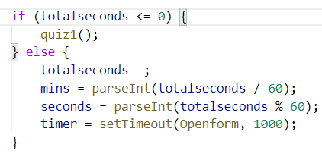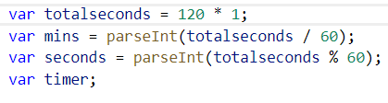

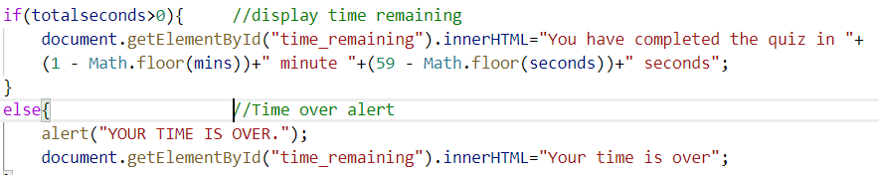After the end of 02 minutes, the timer will end and give out an alert informing that the time is over. Also, the quiz will get submitted automatically once the timer ends.

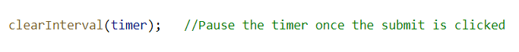The timer gets paused when the user clicks the submit button. This function is called when the user clicks the submit button.

A play again button is set after the submission is completed. It will reset the whole quiz, where the user can start it from the beginning.

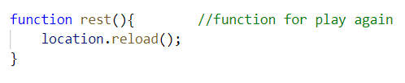

**Minimum marks is taken as 00.**

The minimum score allocated in my page is 00. I assumed in that way thinking that marks cannot be given in negative values. Therefore, I have taken it as zero.

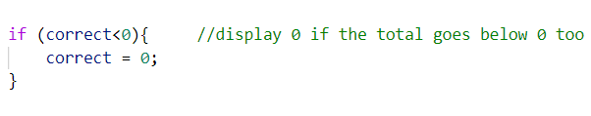

**Back to top scroll button**

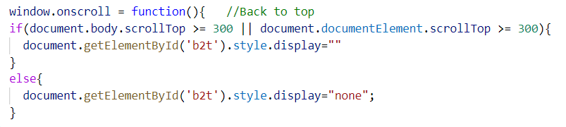A back to top button is used to scroll to the top of the page. The button is set that it will appear only if the user scrolls a certain amount of the page.

## STUDENT DETAILS PAGE



In this page, I have displayed the images of the team members on the start-up page. There are many functions in this page too.

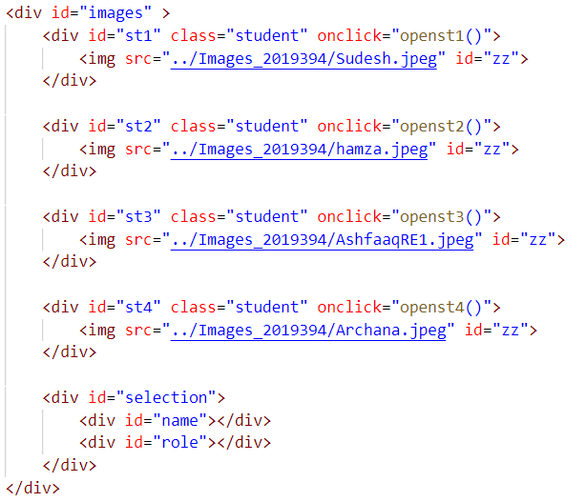

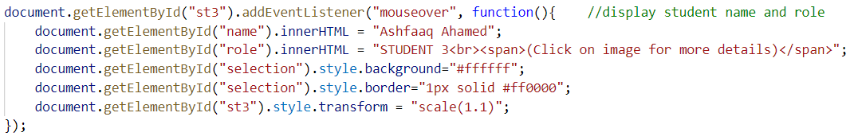Once the mouse is over the image, it displays the name and student role of the particular student.

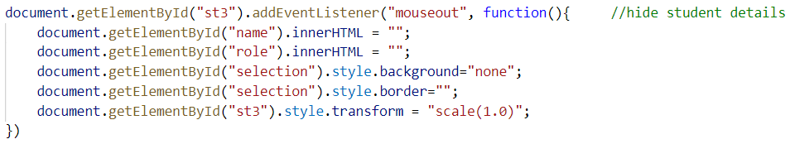Since the details would remain available all the time after the mouse is over the image, I enabled another function as mouse out.

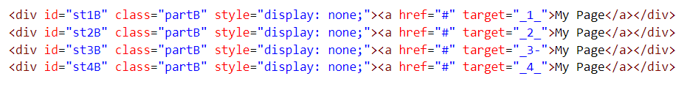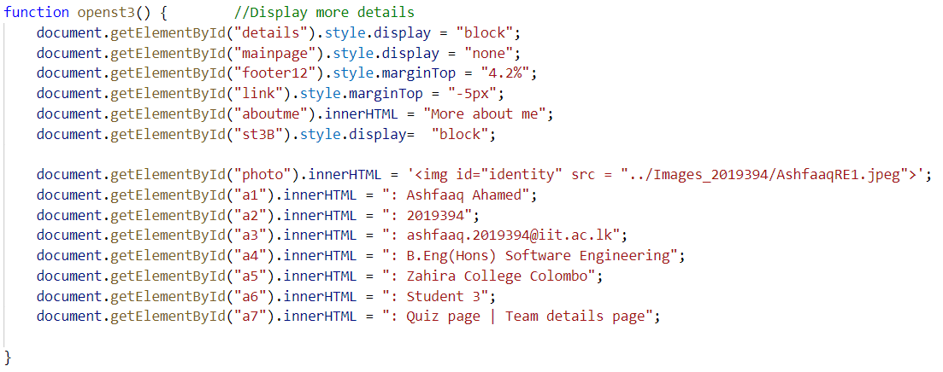I have added an additional feature, where the user can view more details about the particular student if he clicks over the image. This is unique for each and every individual student. This also contains a button to direct to the individual page created by the particular student.

There is an option to go back to the previous page too, when the user is in the more details section. It drives the user back to the page where the user was previously.

## Page Developer



By clicking on this button, the page developer page of the particular can be opened. The Page Developer page contains my personal details. I t gives a brief description about myself. I have used a simple player card format method to design this page.

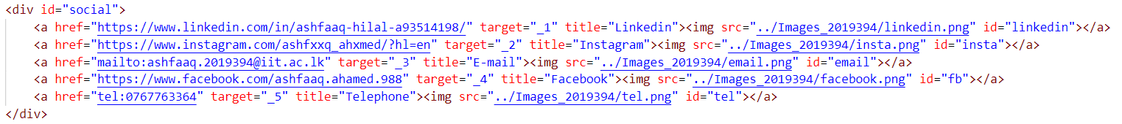I have connected my social media pages to this page as links. This also has a button to go back to main page of our website.

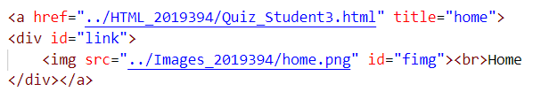

## PART B (Personal web page)

This page contains a brief description on the topic “BIKES”. The name of this personal web page is **“BIKERS PARADISE”**. There are four sections in the content of this web page.

1. Quotes
2. Image Gallery
3. Video Description
4. Feedback
5. Page Developer

**PRESENTATION PAGE**

When my web page is opened, a presentation page is started with a countdown and picturing the logo. The video is added using the video tag. This depicts the page will be related to bikes because I have set a background image related to it.

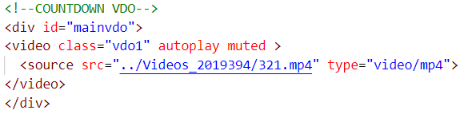

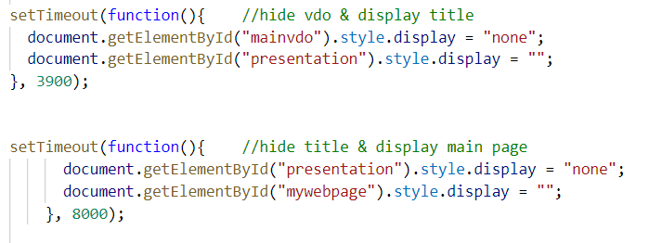

**MAIN PAGE**

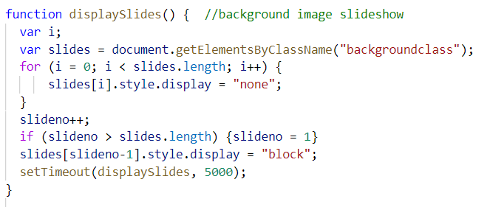The main page has multiple background image. I have put up a slideshow for the background images to change the images.

**NAVIGATION BAR**

I have personalized a unique logo for this personal web page. By clicking on the logo, the user could refresh to beginning of the page. A navigation bar is added. This will direct to specific part in the page. I have used a pop out method for the navigation bar.

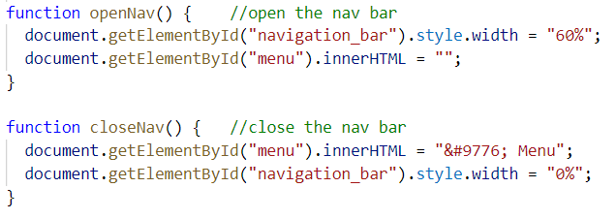

**QUOTES SECTION**

The Quotes section shows famous quotes of world class bikers. An image of the rider and their famous saying is displayed.

**GALLERY SECTION**

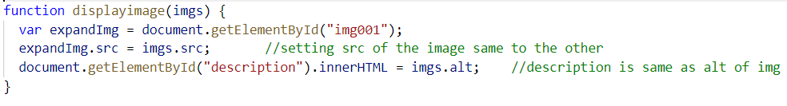The Gallery section shows images of various types of bikes. By clicking on the image, it will display an enlarged image of it in the display section. The name and a brief specification about the particular bike are mentioned below every image of it. The name of the bike is set as the same name given for “*alt*” of the image.

**VIDEO SECTION**

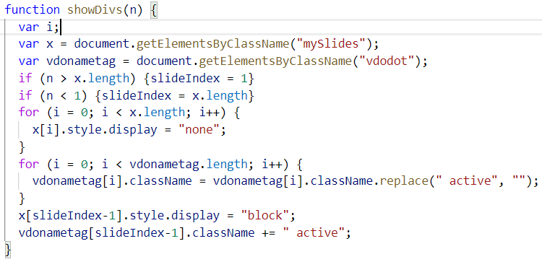There is a video section similar to a promotion page of three specific bikes. The three videos are inside one particular section. The user could switch the videos by clicking on the next button or the names of the particular bike below the video.

When the video is changed by clicking on the next / previous button or the name button of the bikes, the video gets paused and the selected video starts to play.

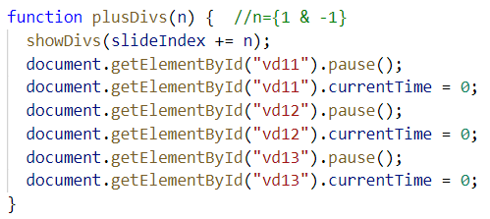

**FEEDBACK FORM**

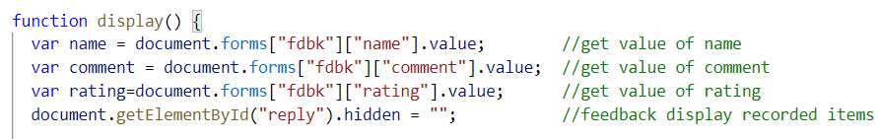The feedback section, which is the most important section of a webpage is placed at the end of the web page. So, the user could write comments after viewing the whole webpage. When the user submits after completing the form, the details filled will be shown parallel to the form.

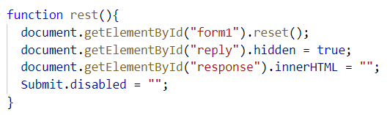 The user is unable to change his feedback after submitting a form. Thus, he can re-submit another form by clicking the reset button. This will clear out the form and the display section too.

A user is not allowed to submit the feedback without entering his or her name.

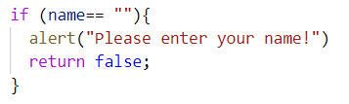

**BACK TO TOP SCROLL**

A back to top scroll option is available too. This will appear after the user scrolls a certain limit in the page.

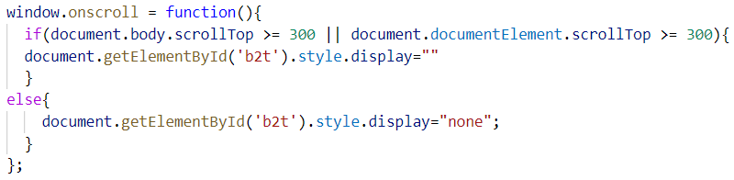

# Discussion of UI and application of UX principles

## 3.1 Information architecture

### a. Design

“Petrol Pages” is designed in a dark theme. The website is related vehicles and our focus was to keep the website calm and charm. Thereby, the page is designed in the colours related to black and grey.

The navigation process in our web site follows the “Breadcrumbs” method. This method allows us to navigate to any page required at any time. Every page prominently contains a page heading regarding what the particular page is about.

**CODE**

### 

**OUTPUT**

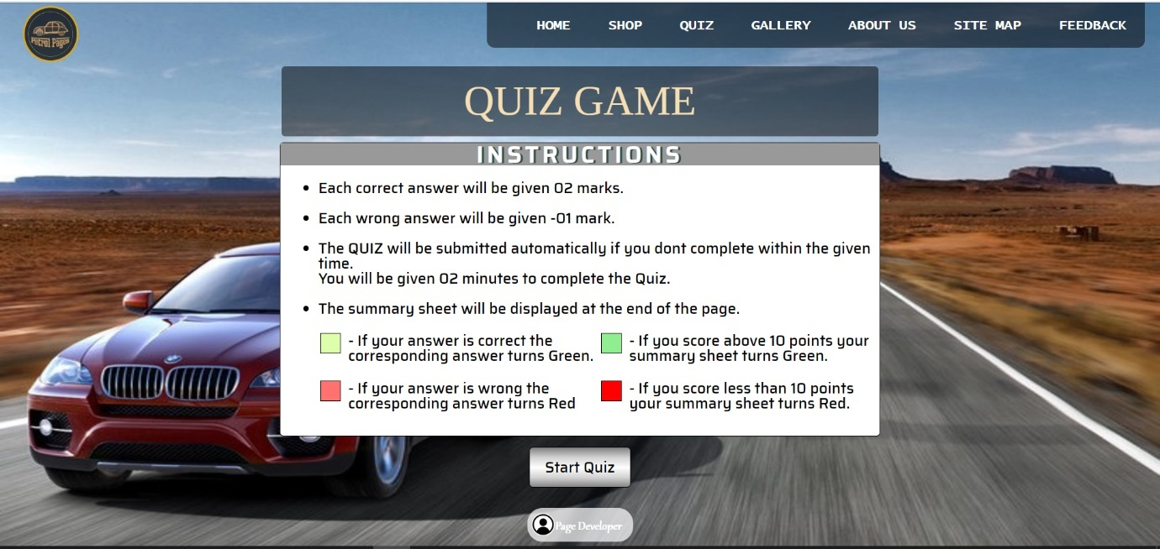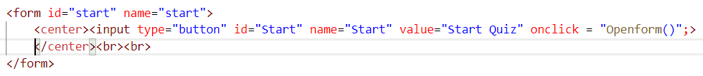**Start Quiz**

The same navigation bar is set to all the web pages. The page developer icon is placed at the bottom of each page. It is the place where footnotes are placed.

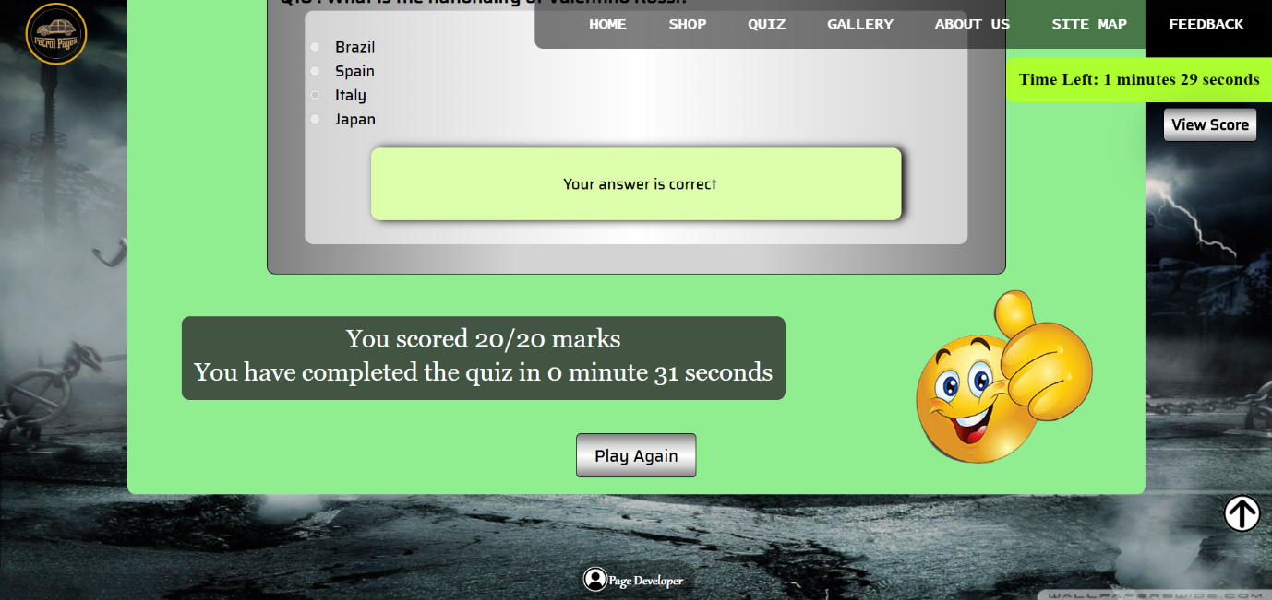**Play Again**

The “Play Again” button directs the user to the start-up page of the Quiz page. The user can play the quiz again too. The “View Score” button is placed to direct the user directly to the place where the marks are displayed. The “Back-to-Top” button is set for all scrollable pages. It scrolls the page to the top of the page.

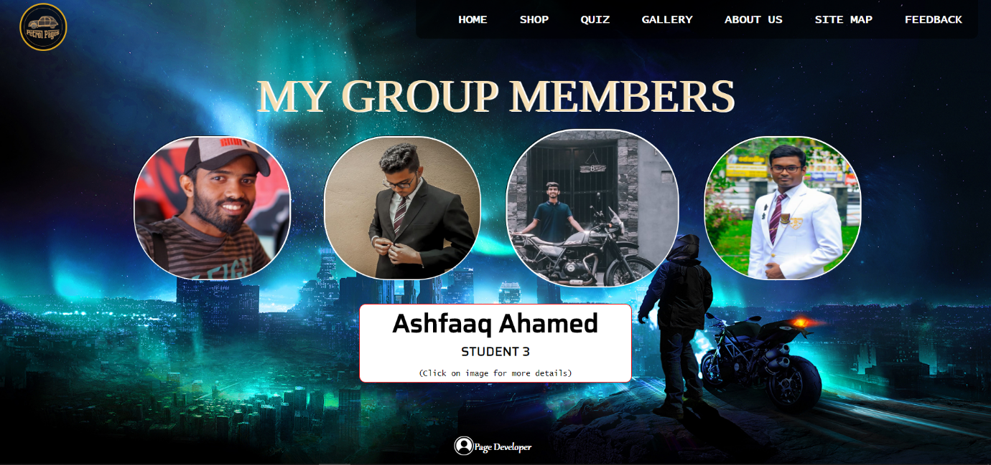**More about me**

This page contains the details of the team members. This page too contains a dark theme as the other pages of our website. If the user wants to see more details about the user, he can click on the relevant image to get it.

**Go Back & My Page**

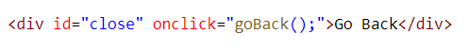

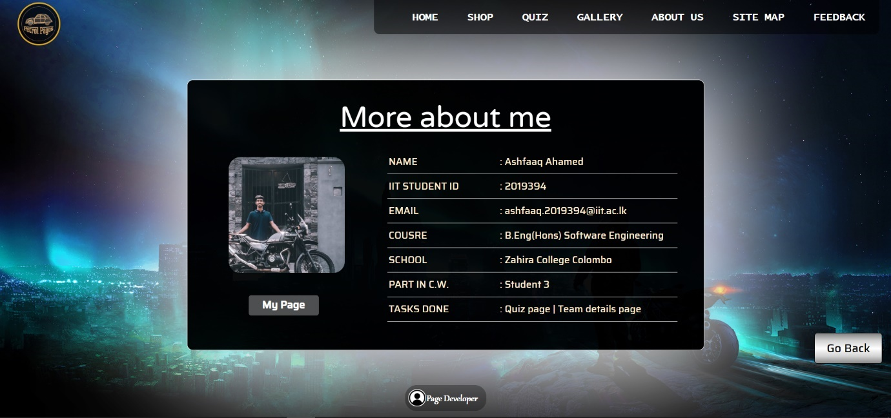

This is the more details view of a particular member. “My Page” button directs the user to the personal page that he has created. “Go Back” button helps the user to go to the previous location where he was.

**Home Page**

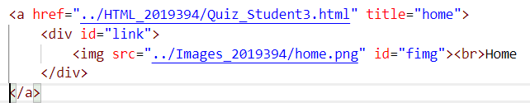

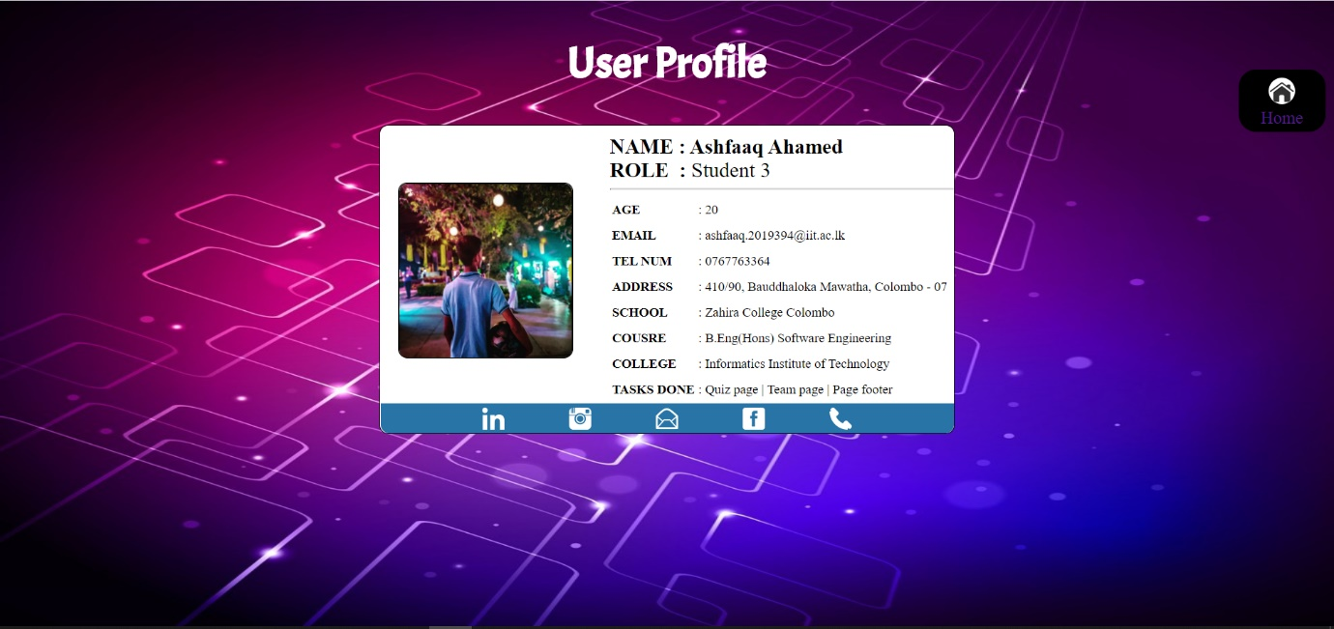

This is my personal details page. I have placed a “Home” button on the top right of the page. This will direct the user to the Home page of our web-site. The social media icons which are allocated in this page will direct the user to their particular pages on a new tab.

**CSS for all buttons**

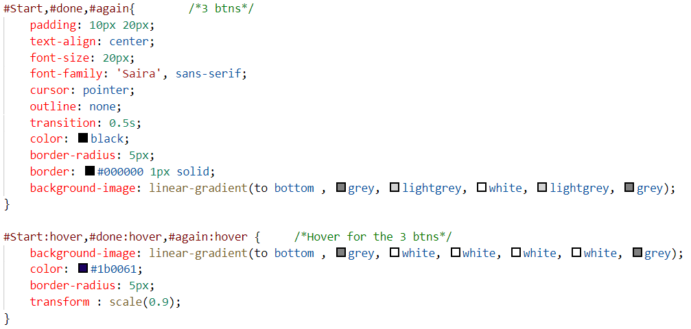

### b. Code to achieve good Information architecture

**RED BOX** – This is my page logo. If the user clicks on it, the page will be re-loaded.

When the user selects “My Page” from the team details section it will direct to my personal page.

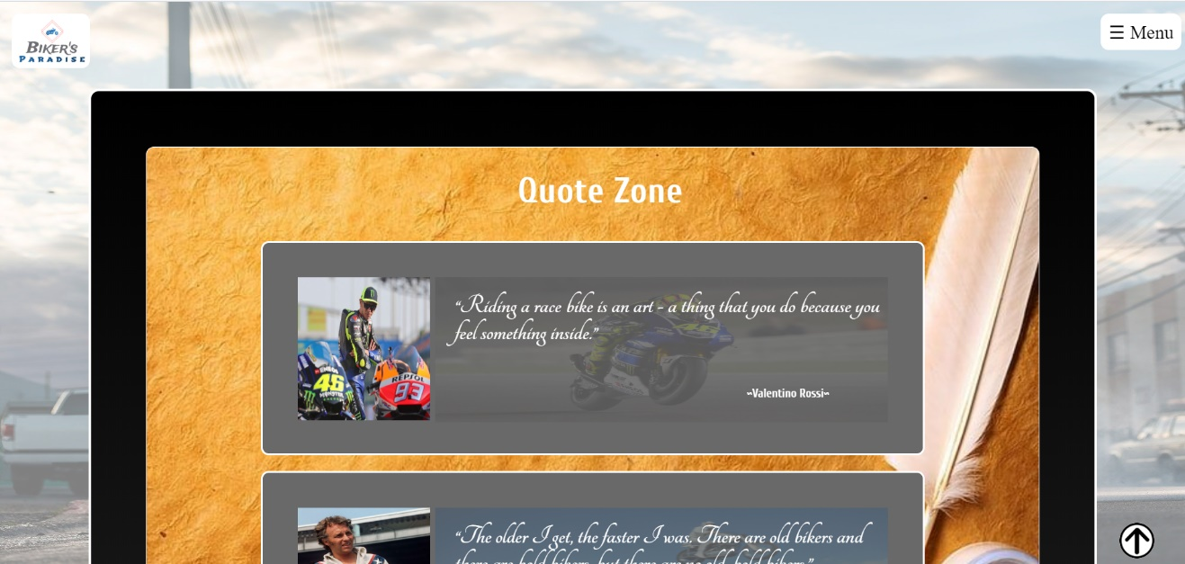I have enclosed each and every item in a div tag. The div tag contains multiple div tag nested inside one another. The below items marked using arrow heads are all div containers.

These thumbnails too contain inside div tag separately.

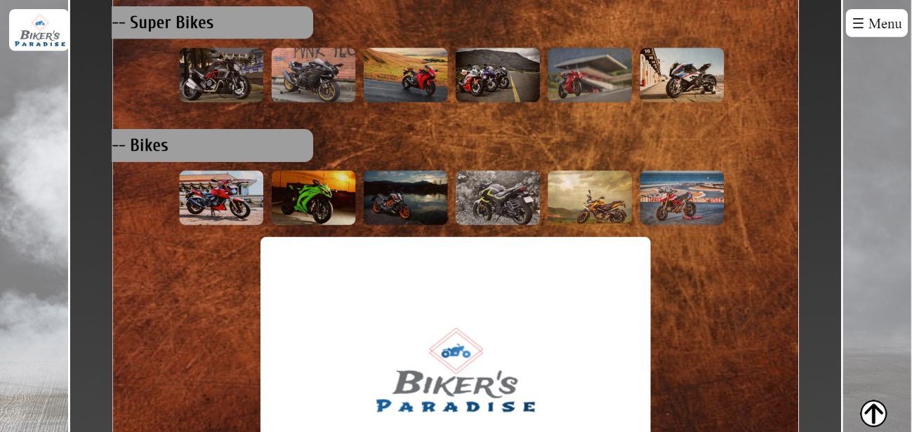

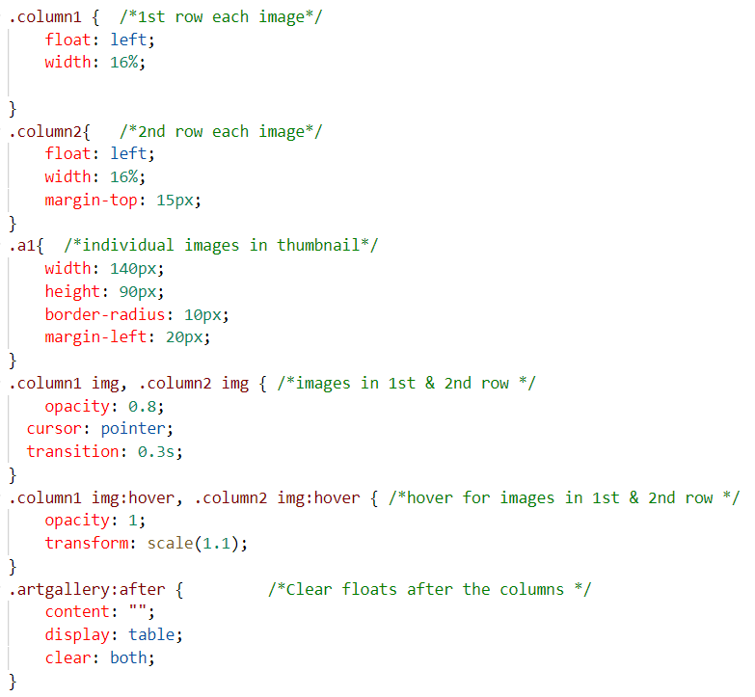

When a thumbnail is selected the respective image expands and gives a specification list about the bike selected.

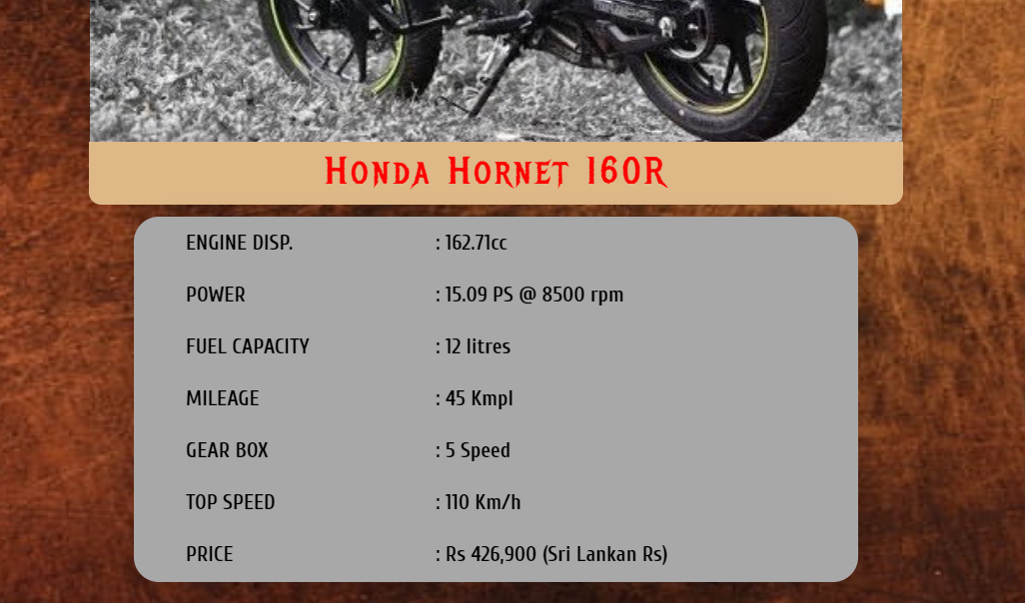

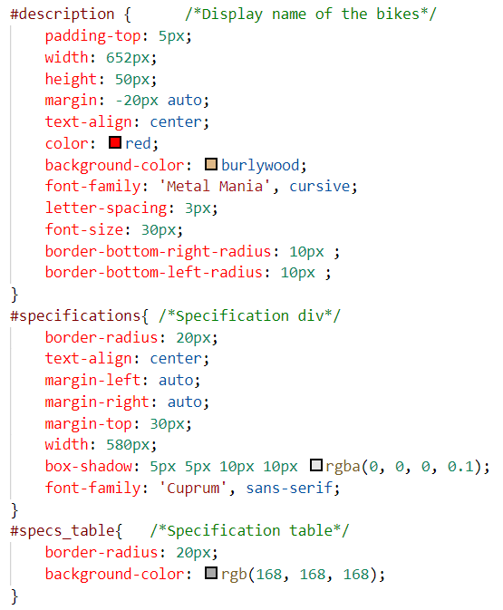

A table was created to display the description individually. I have added styling for each column separately.

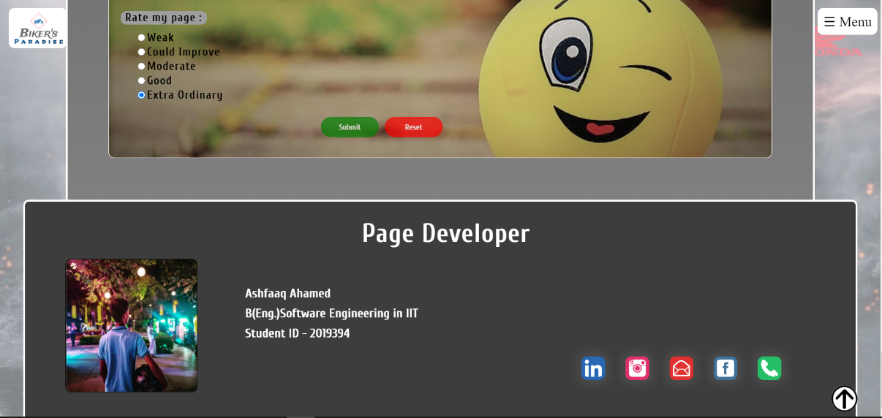

**RED ARROW** – Contents of the main page are in this div tag

**GREEN ARROW** – Page Developer contents remains in a separate div tag

**Individual Page Navigation bar**

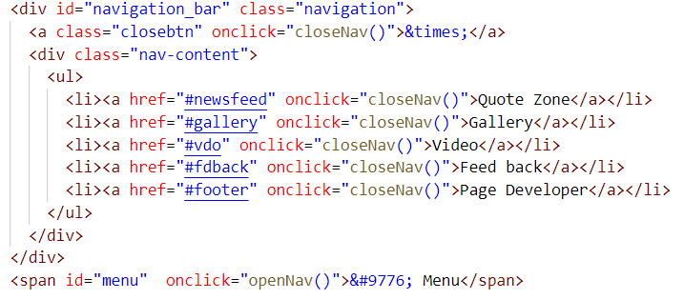

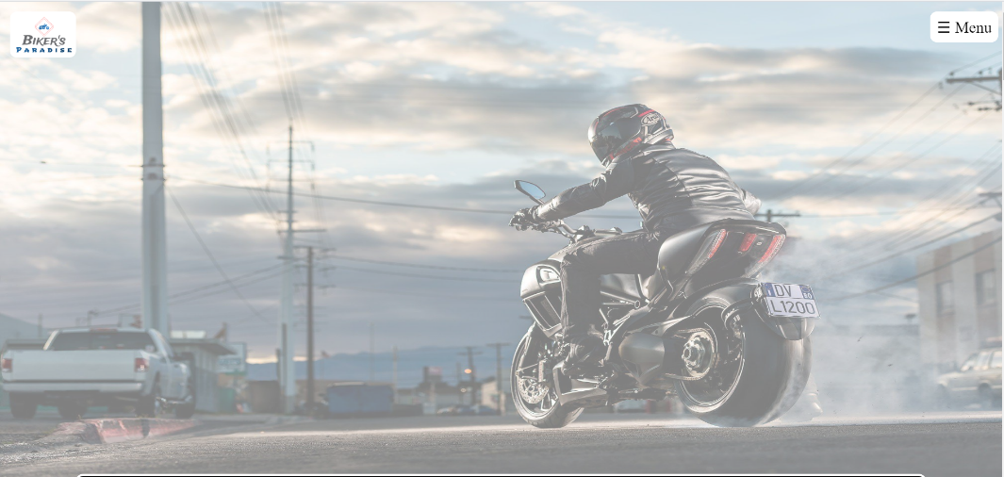

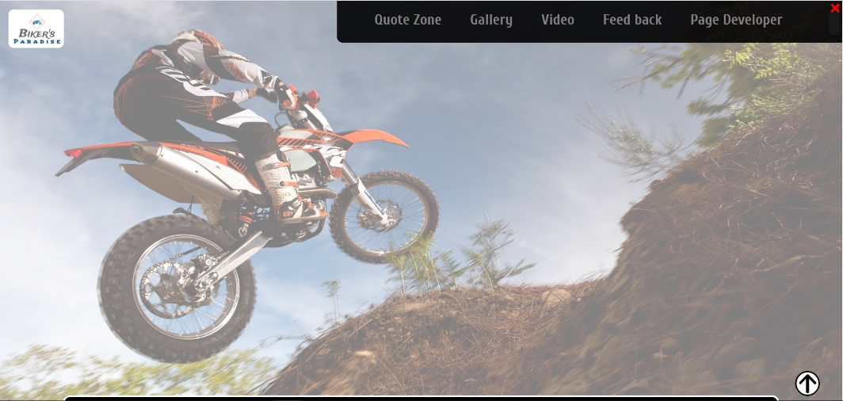

I have used a simple navigation system in my page. If the user clicks the “Menu” button, the user will get a pop-up navigation bar. It directs to specific areas in my web page.

**Styling for the Navigation Bar**

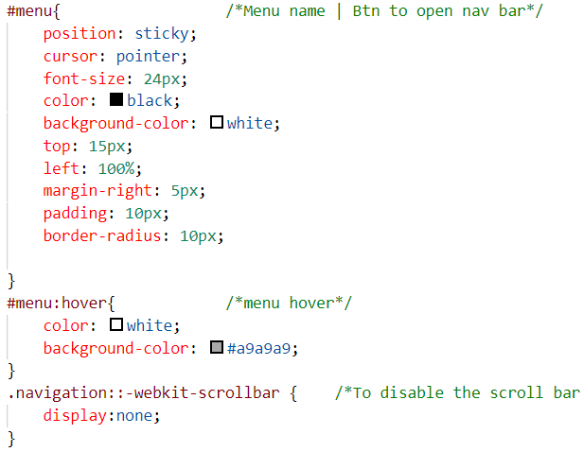

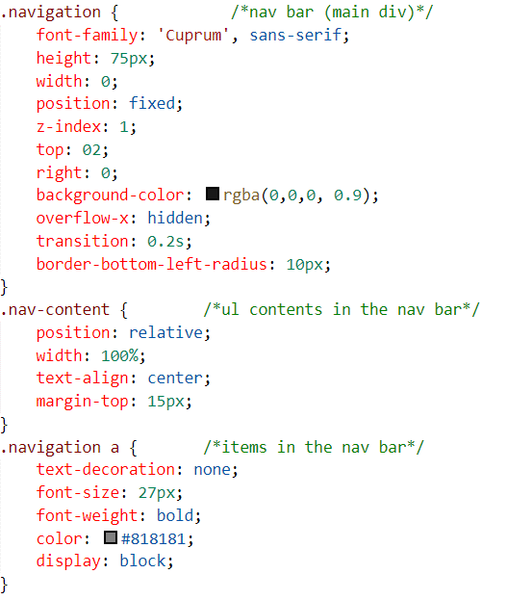

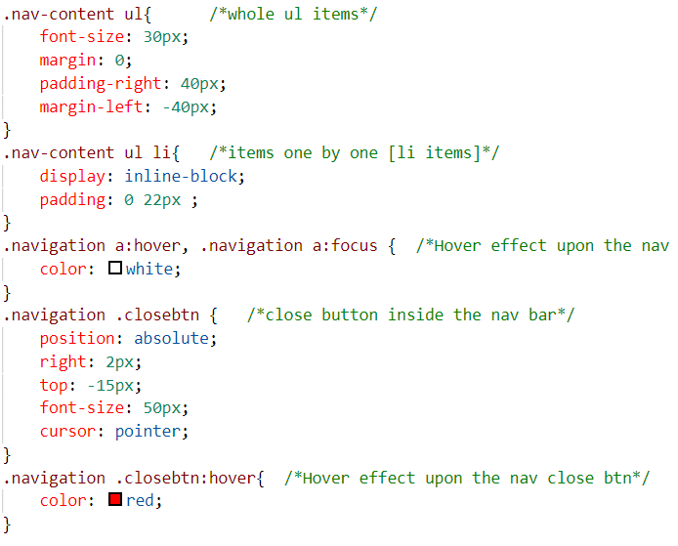

**Social media buttons**

These icons direct to a new tab and opens up their relevant page. The back-to-top has the same function of scrolling to the top of the page.



**Styling for Social Media buttons**

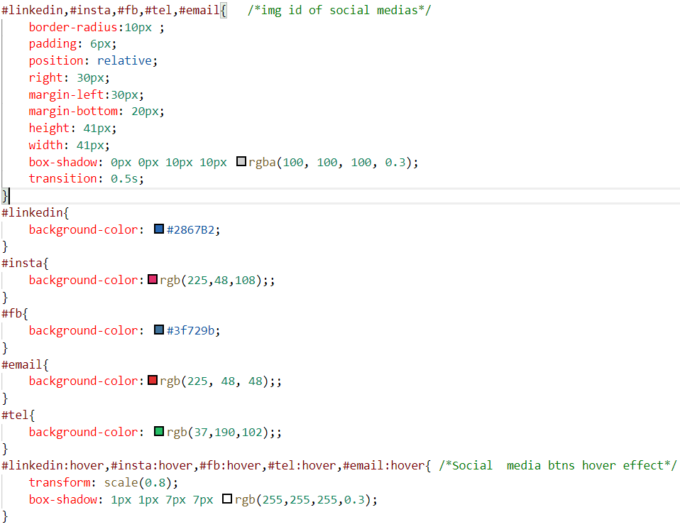

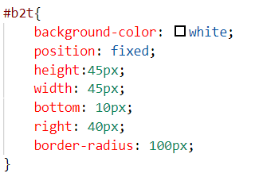**Styling for Back-to-Top button**

## Colour balance/composition/graphics/consistency

The dark theme selected by our team gives a collaborative contrast between the font and the background. We have used various styles to make it look featuring since our web page is related to “Motor Vehicles”. These pages are mostly viewed by teens of the society. Therefore, we have made it more eye catching with brief colour comparison.

### a. Design & Code to achieve good colour balance & ensure consistency

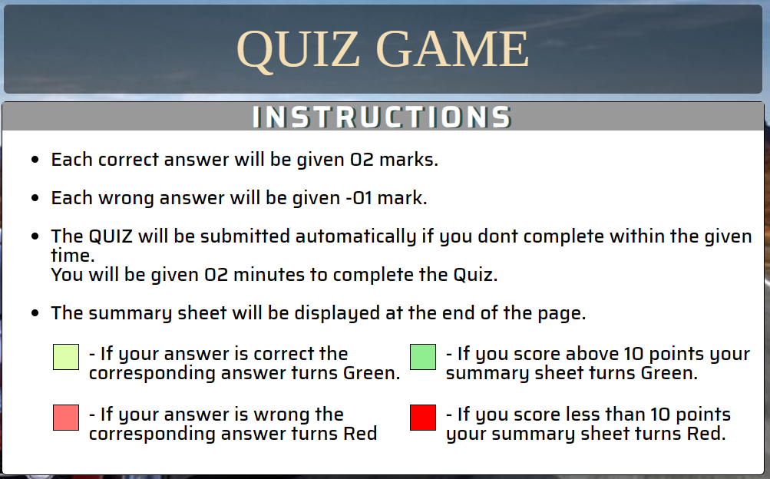

The main heading is given in a different colour than the body text. This looks more attractive since I have designed a Quiz page. This section of a web site is not attempted by most of the people. Therefore, in-order to make it more eye-catching, I have different colours to make it look attractive.

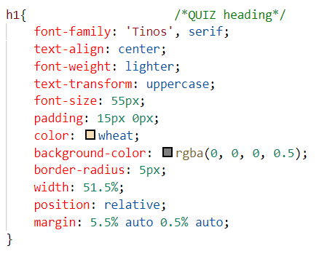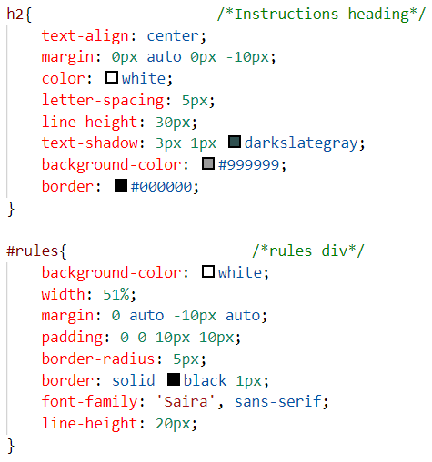

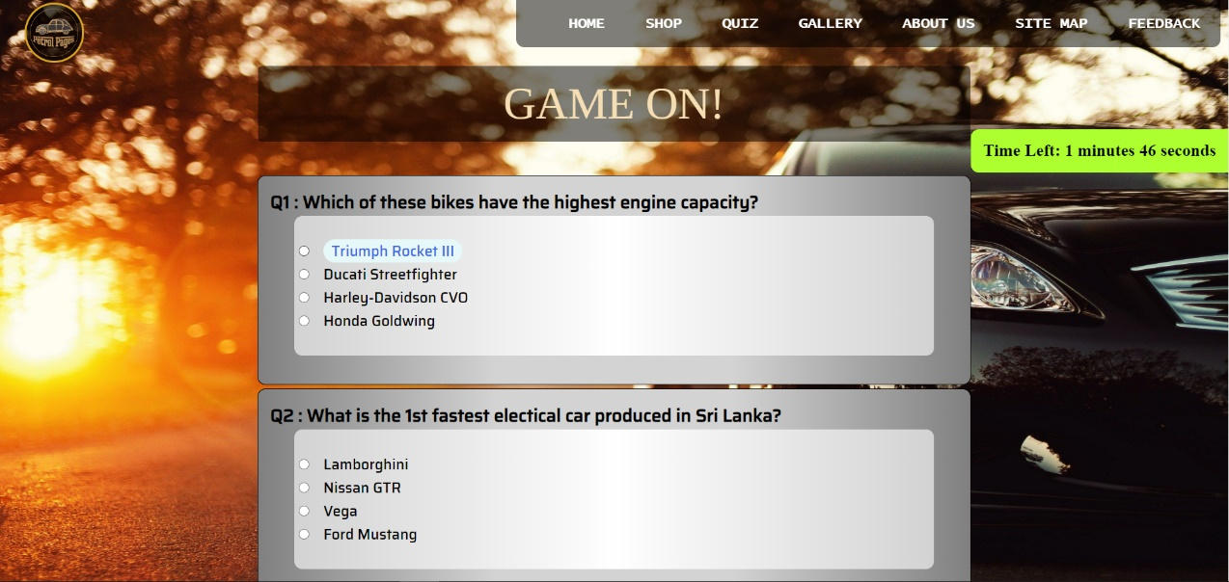

**(#) 🡪** The timer is shown in a bright colour, because it is an important section when a user takes part in a quiz. The font colour is also contractual.

**(#) 🡪** When the user hovers over an answer, the particular answer becomes blue with a light blue background. This feature was added for attractiveness.

**(#) 🡪** This is the background that separates each question. The font-colour used in this section is contractual.

**(#) 🡪** This section separates the question from its answers. This has a light background which matches the outer background too.

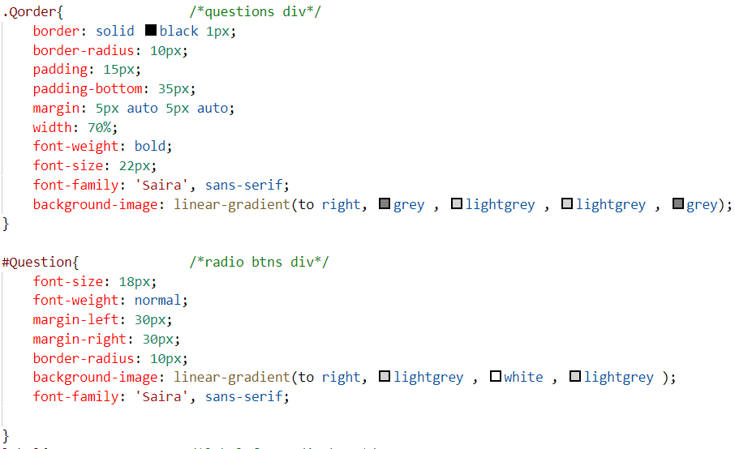

**Questions & Answers**

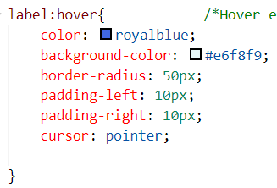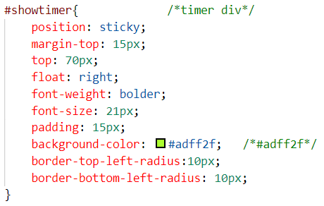

**Timer Answer hover effect**

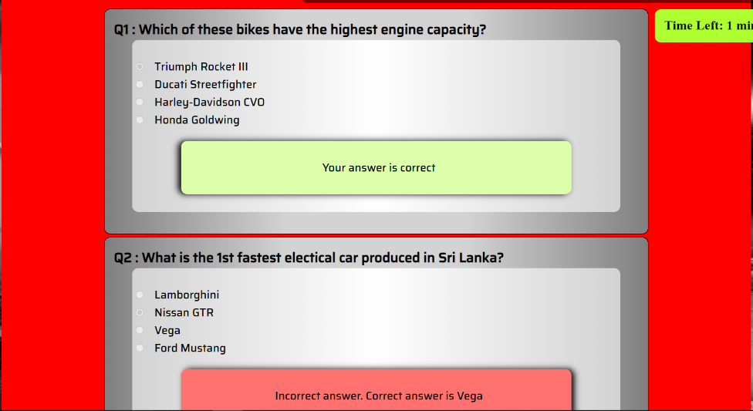

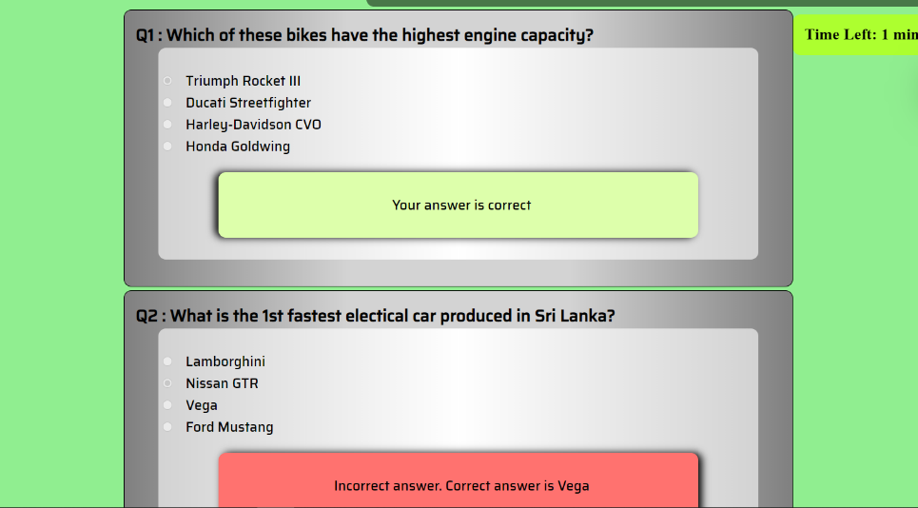

**(#) 🡪** Green background with black font. Green is to show the answer marked is correct.

**(#)🡪** Red background with black font. Red is to show the answer marked is wrong.

**(#) 🡪** Red back is to the total is less than 10.

**(#) 🡪** Green back is to the total is more than 10.

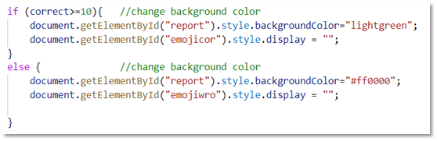

**TEAM DETAILS PAGE**

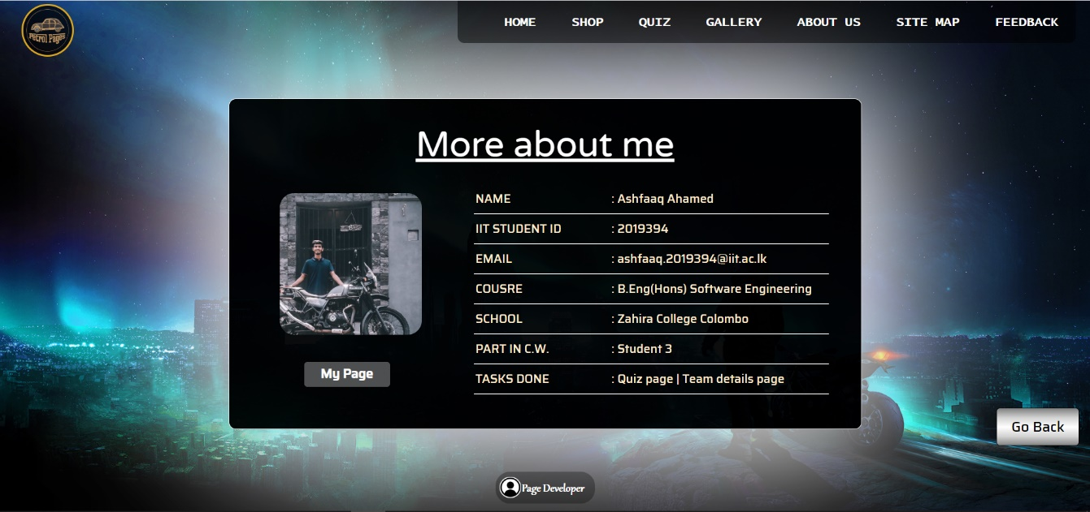

**(#)** 🡪The black ground is chosen to match with theme.

**(#)** 🡪I have given a smoke shadow effect in-order to make the black box highlighted.

**(#)** 🡪I have chosen a bright font colour to specifically make it contractual.

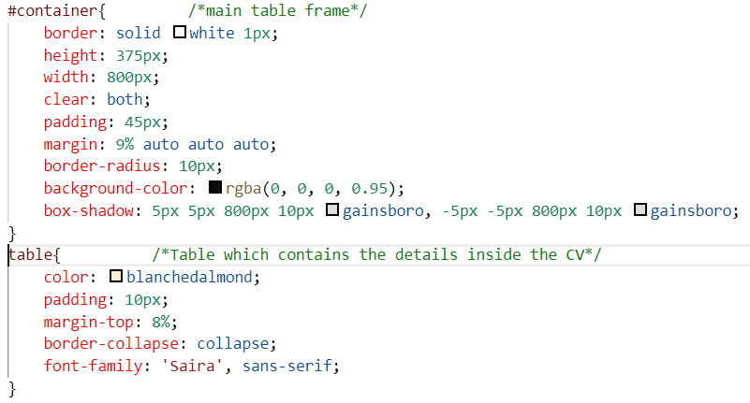

**INDIVIDUAL PAGE**

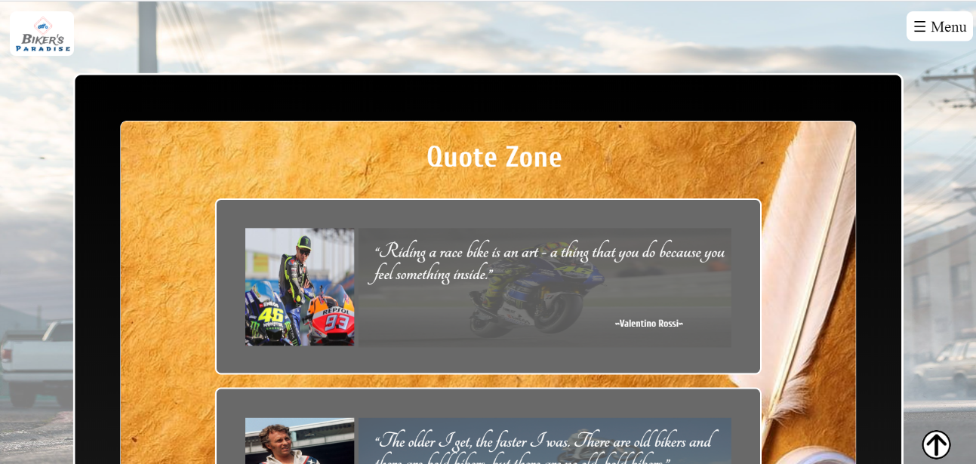

**(#) 🡪** This section has been given a radial-gradient as background image. It starts from black at the top and ends with grey in the bottom

**(#)🡪** Each section is separately given background images. This section contains a light background

**(#) 🡪** Since the outer background has a light background image, this section has a dark background colour.

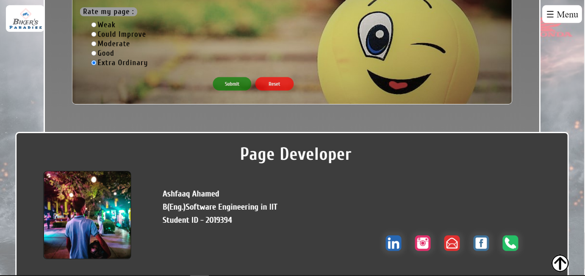

**(#) 🡪** The latter section of the above mention radial-gradient. It starts from black at the top and ends with grey in the bottom

**(#)🡪** This section has been given a dark grey background colour to match the theme.

**(#) 🡪** The font is in white in order to match the background colour and make it more contractual.

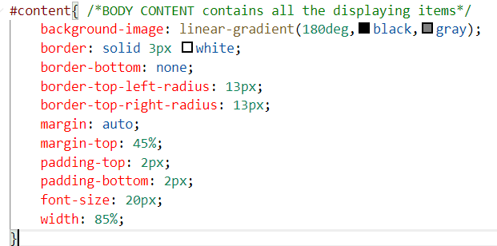

### b. Colour contrast test results

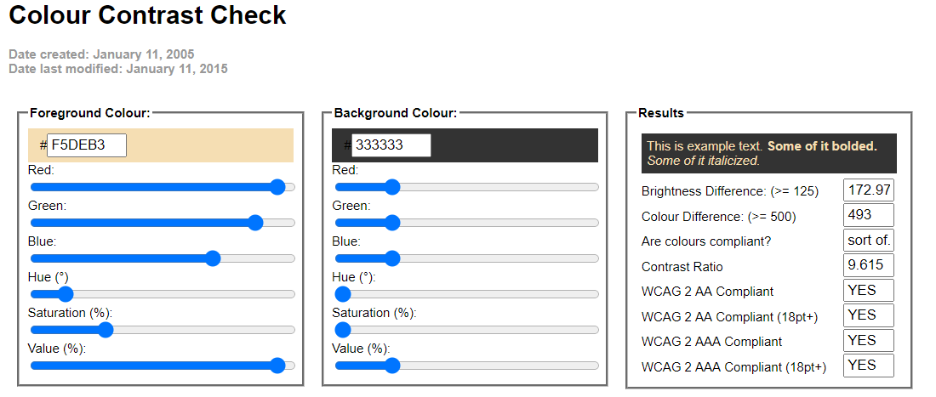**Main Headings in Quiz Page, Team Details Page (**Details table**) & Individual Page**

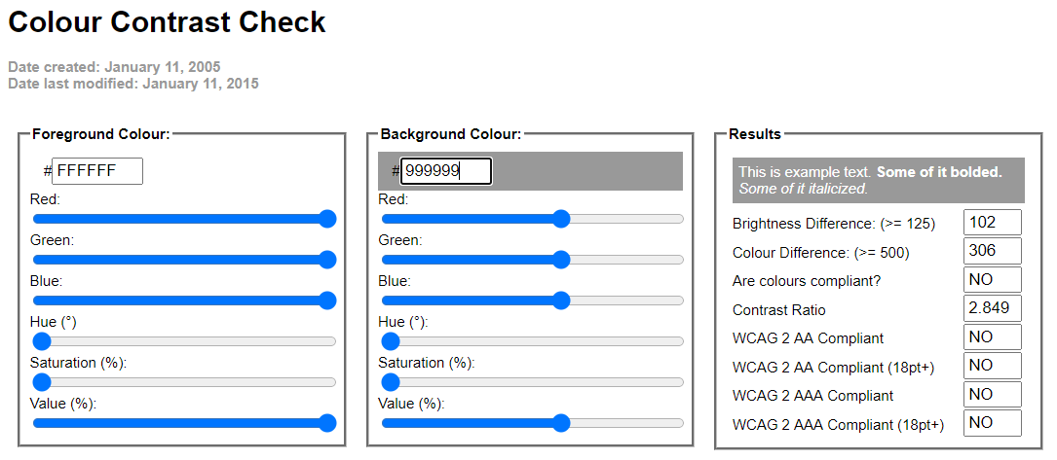**Instruction Box Headings in Quiz Page & Individual Page**

This gives a less contrast. Therefore, I have given a text shadow with “#2F4F4F”.

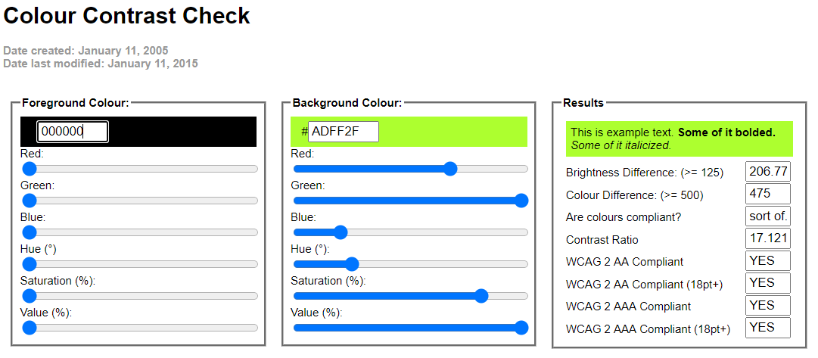**Timer in Quiz Page**

**Questions Section in Quiz Page**

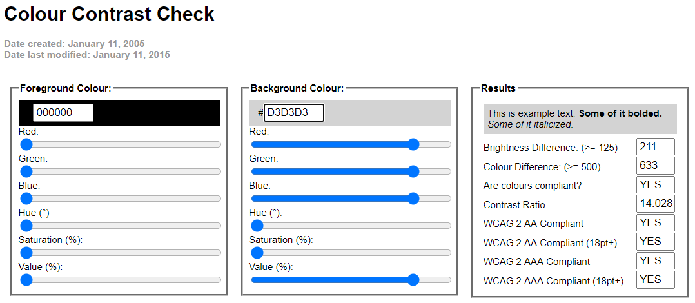

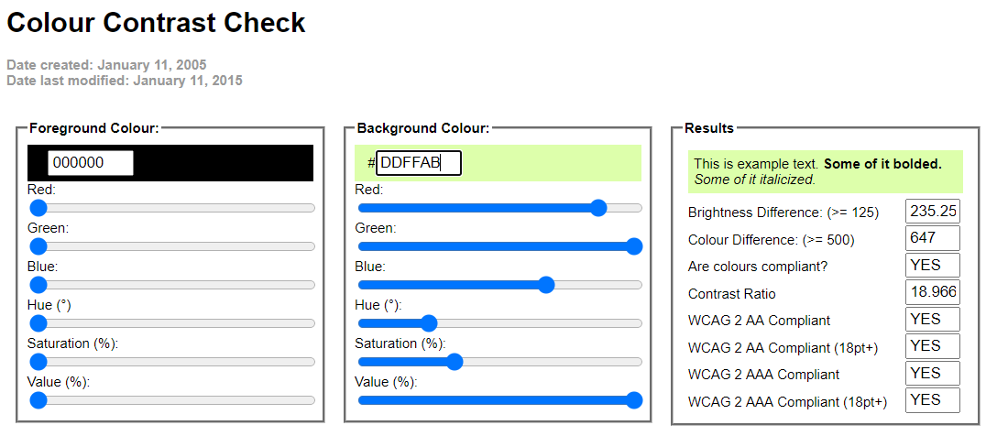**Correct Answer Display Section**

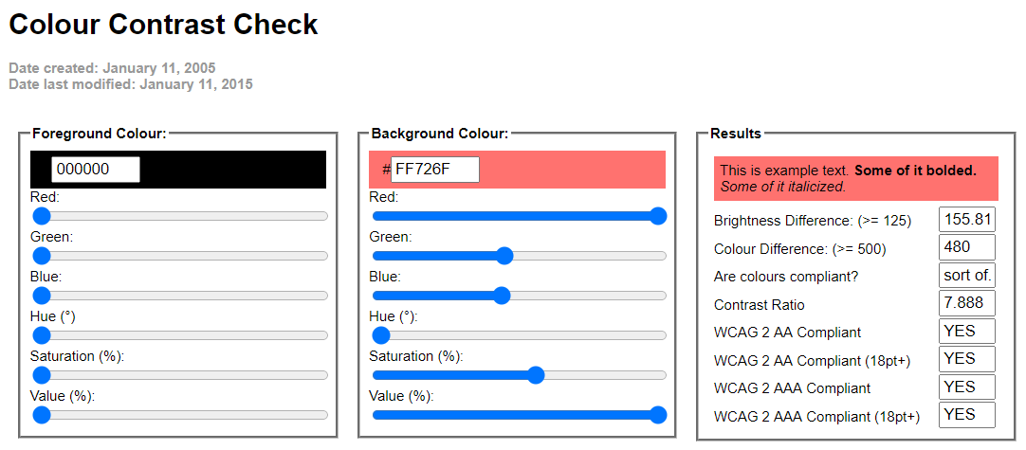**Wrong Answer Display Section**

## Typography / consistency

### a. Design & Code to achieve good typography / consistency

**Font-family for main headings**

The styling fonts and its consistency was widely focused in our website creation. The main headings follow a particular font and the contents of the page follow a separate unique font. Also, the font sizes are adjusted accordingly to make it good looking and contractual for the user.





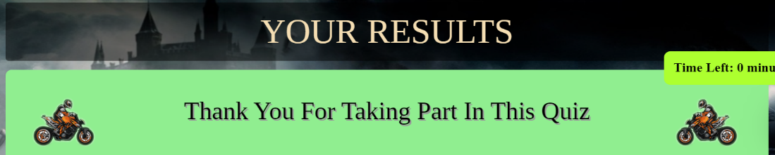

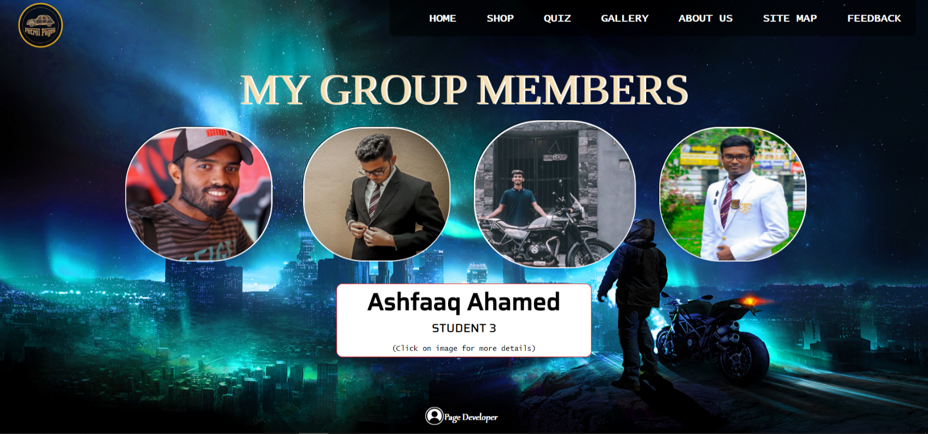

These are the main headings followed in my page. They are given a bright colour with a dark background to make it more legible. The font sizes are also contractual. This enables the user to grasp what the page is about immediately.



*“‘Tinos’, serif”* is the font family used for all the main headings in my web page. It is an imported font from google. Therefore, we have to connect it with its connector.

**Font-family for content page**

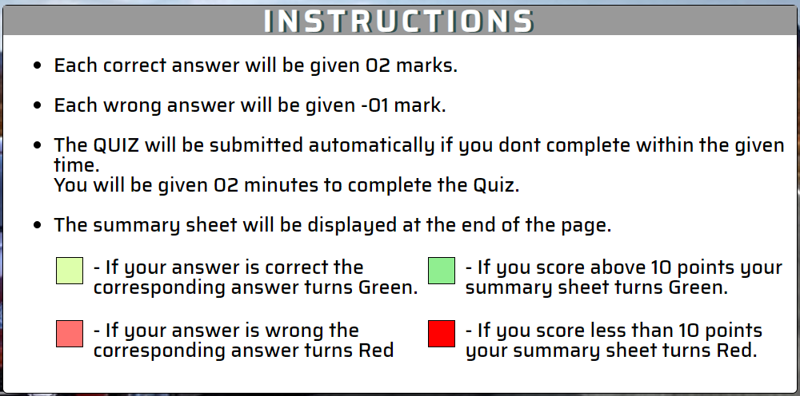

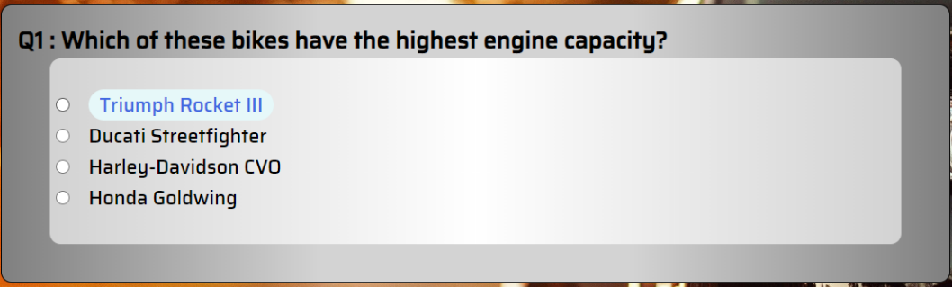

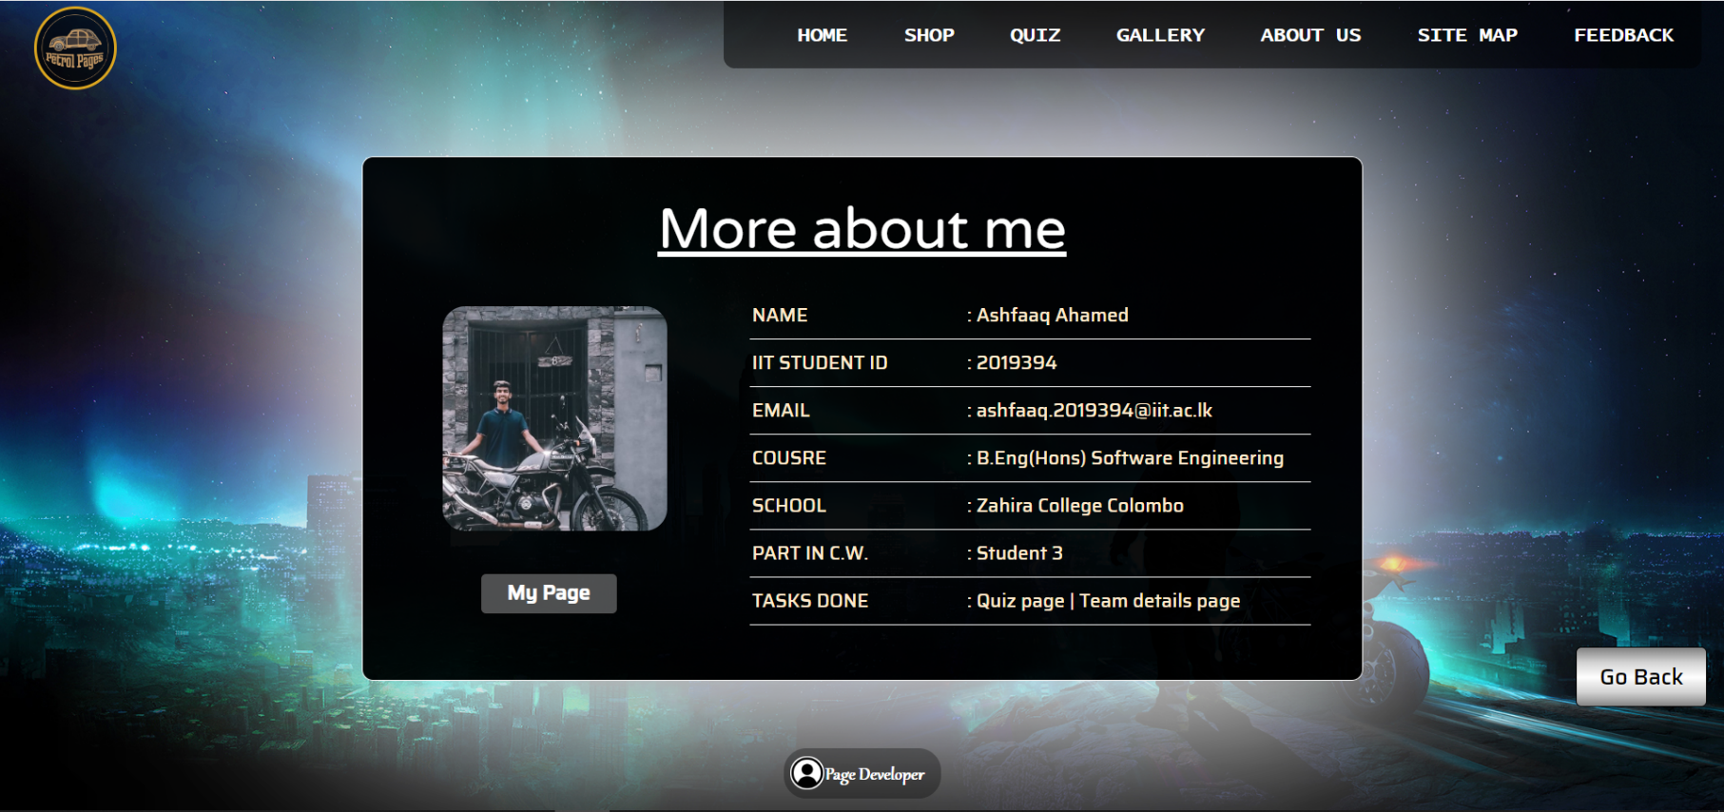

*“‘Saira’, sans-serif”* is the font family used for all the contents in my web page. It is an imported font from google. Therefore, we have to connect it with its connector. Even the buttons and other elements in the page contains the same font-family.



These are font-families which I had to import in-order to make the fonts effective in my page.



**Page Developer icon**



This icon contains a different font-family. “Gabriola” is used here. It is smooth font style which shows uniquely. The consideration of this was to make the footnote more appropriate and legible. It has a hover effect where the background colour changes. So, it is more effective.

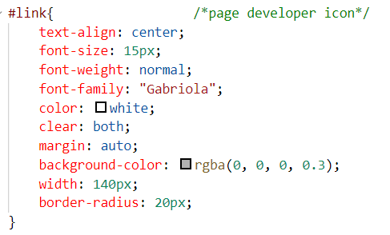

**Individual Page**

This is the logo display page. This page contains the name and the ID which uses a typical font to make it classy. The font-family used here is *“‘Metal Mania’*, Cursive”. Font size increased since it is the only content in the page.

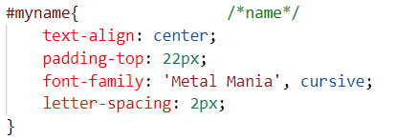

**Main Font-Family in Individual Page**







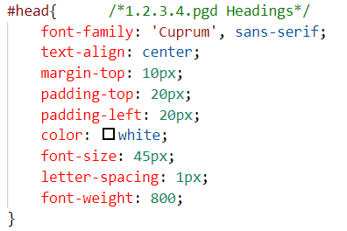These are the main headings used in my web page. They all contain the same font-family. The headings are set to the centre of the section to make it highlighted and more contractual. The same font-family is used for the contents in my page too.

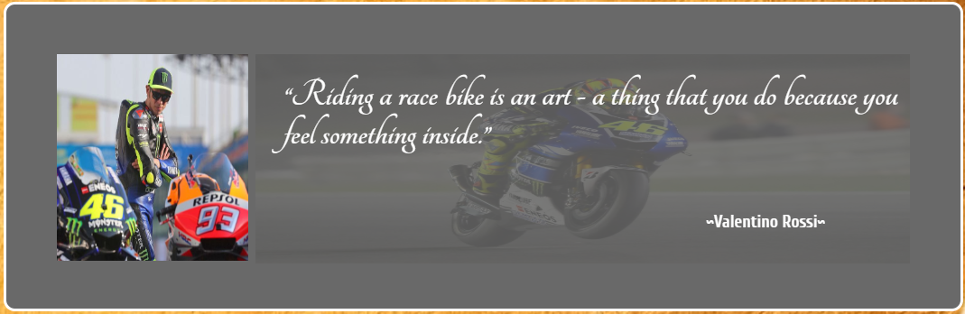**Quotes Section Individual Page**

The quote is written in a totally different style. This is considered because it is a saying of another person. I have used an italic font to draw the attention of the user who visits my page. Italic typing is mostly used to draw attention to key terms and phrases. The font-family used here is *“‘Tangerine’, cursive”.*

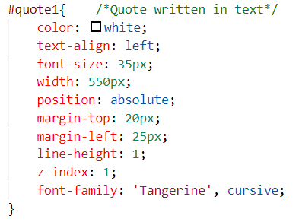

## Gestalt principles grouping

Gestalt Principle is a powerful role where psychology plays a major part in this. It is the visual perception given to a user about the web page. It has the ability to attract the user more towards website. The way people react upon viewing the site depends upon the way its has been organised and arranged.

### Proximity

The objects or shapes which are close to one another form a group. They are arranged in a well-mannered and a structured way which makes the user legible to view the website. This is an important factor. If it is neglected the elements would be scattered everywhere around and make the user exit the website with a confusion.

In the below image examples, I have shown how important **proximity** would affect a website.

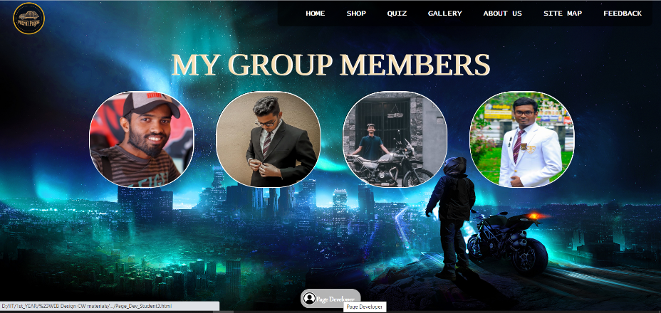

**Student Details Page**

In the Team Details page, the team members details are aligned accordingly, so that a user will understand quickly about what I have tried to do.

**Quiz page** (Questions)

The Quiz has been arranged in a way, where the user doesn’t feel discomfort while he is taking part in it. Each question is inside a div element and its relevant answers are in another div element. This makes the page simpler and more attractive.

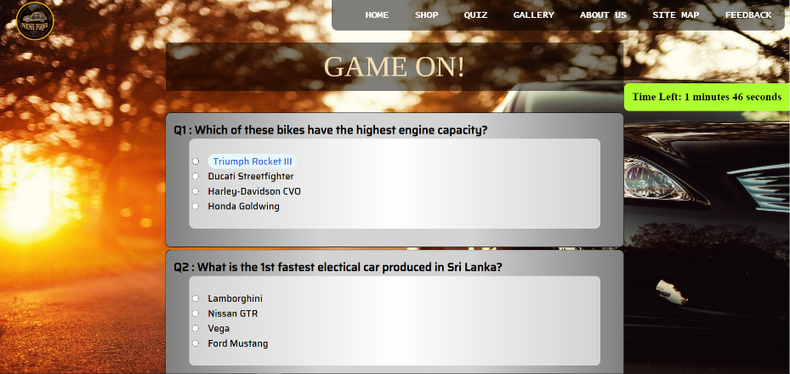

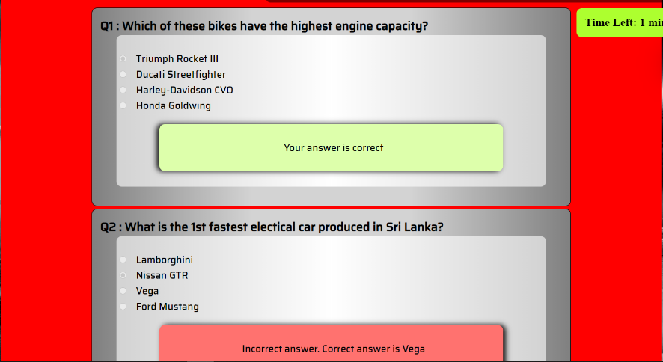

**Individual Page** (Quotes Section)

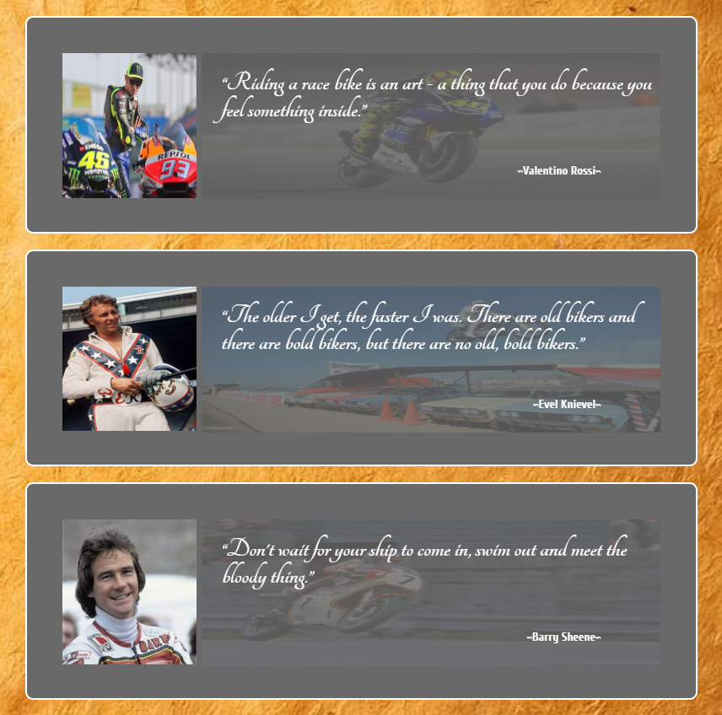

In my personal page the Quotes section follow proximity with high attention. The quotes are by three different people. But they are all “Quotes”. So, I have grouped them in an orderly manner.

### Similarity

When there are similar images or items, they are all assembled together in-order to get a clear understanding to get clear a clear comparison between them. Similarity shares items which has same visual characteristics such as shape, size, colour, texture, or value which will be seen as belonging together in the viewer’s mind.

In the below image examples, I have shown how important **similarity** would affect a website.



**Student Details Page**

In the Team Details page, the team members images are likely to have the same effect. The shape of the image and the size of the image look similar

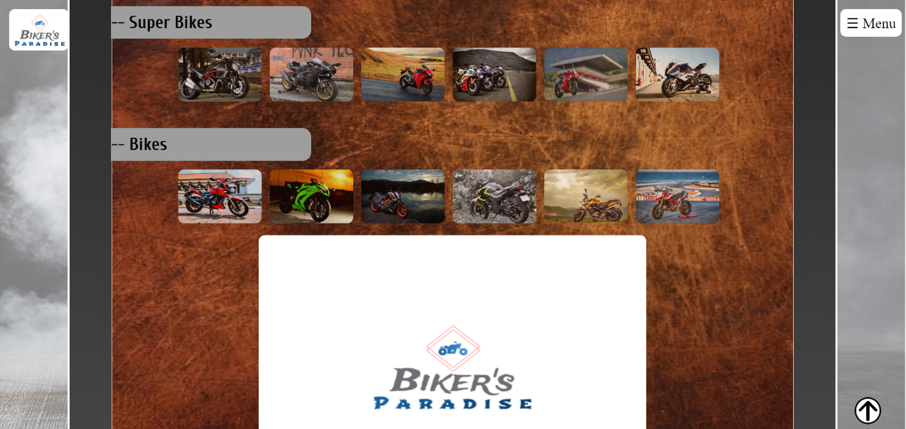

**Individual Page**

In this section, the thumbnail images look very much similar to the design they are surrounded with. The size and the shape are similar to each other. Therefore, I have arranged it in a manner which creates space to compare between the images.

The social media buttons too follow the same terminology. A user is able to find the needful social media icons at a common place. Here, social media icons are taken as common topic to match the similar icons under it.

In this page, the Quotes section too follow similarity. The images of the riders are aligned accordingly to the left side and the quote section is displayed in the right.



**Quiz Page**

The instruction box in this page shows an example to the similarity feature. The colour boxes mentioned below follows similarity feature methodically. The colour boxes are arranged accordingly.



### Closure

If the elements in the web page continues with similar content, it has to be divided accordingly. This briefly explains the idea of closure.

The below example describes well about the **closure** principle.



**Quiz Page**

The questions are arranged separately and uniquely. Each question is separated and enclosed with an identifiable background colour and it has space in between the two questions. I have left that space in-order to make it more contractual and legible to identify by the user.



**Team Details Page**

The student’s images are arranged separately and uniquely. Each image is separated and enclosed with an identifiable border colour and it has space in between them. The space in between the images is to make it more contractual and legible to identify by the user.

### Continuance

This is basically the way how the elements are aligned. A set of related elements should be aligned methodically. So that it is much more contractual for the user to view it and also gives a brief understanding about what the structure is. There are mainly two types followed under the continuance principle.

* 1. Horizontal continuance
  2. Vertical continuance

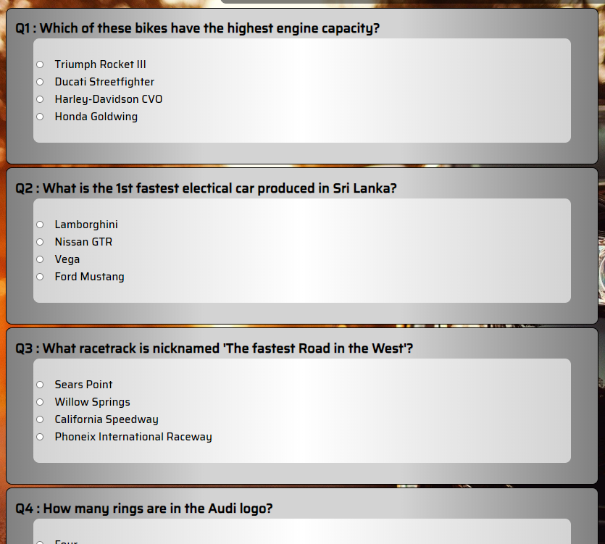



**Quiz Page & Individual Page** 🡪 The example above perfectly defines about the vertical continuance.



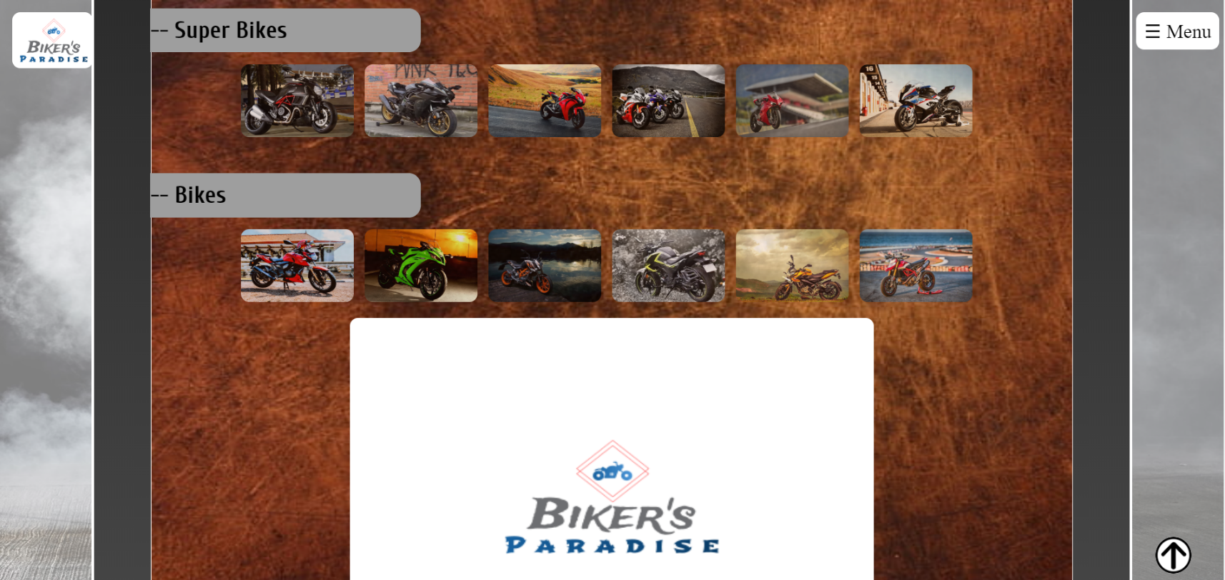

**Team Details Page & Individual Page** 🡪 The example above perfectly defines about the horizontal continuance.

## 3.5 Accessibility (graphics/forms)

### a. Graphical elements - Design/Code

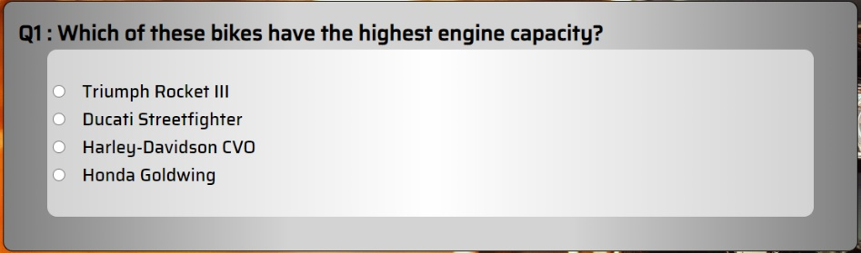

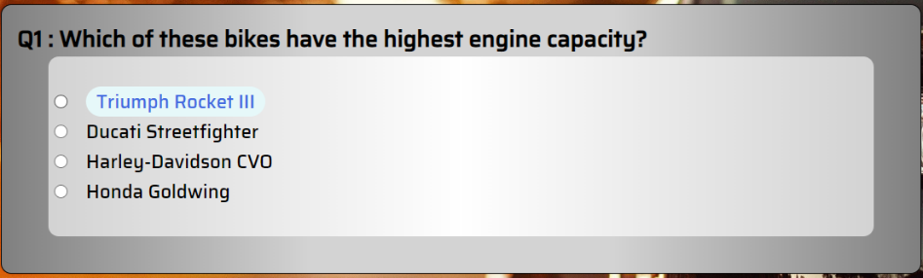

When the user hovers over an answer, particular answer will change its colour accordingly.



In the Quiz page, I have implemented this button for the user to navigate to the score section immediately without scrolling the page till the end.



This is the back to top button. This is implied in all scrollable pages. This is accessible only if the user scrolls a certain amount in the page.

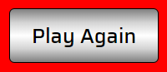

This is the play again button. This gives access for the user to restart the game and play again from the beginning.

When the user hovers over the image in the Team Details page, it will display the name and the role of the student in a certain area. Also, if the user clicks on the image it will direct him to “More Details” section in the same page. A “Go Back” button is also implemented to go to the previous section.

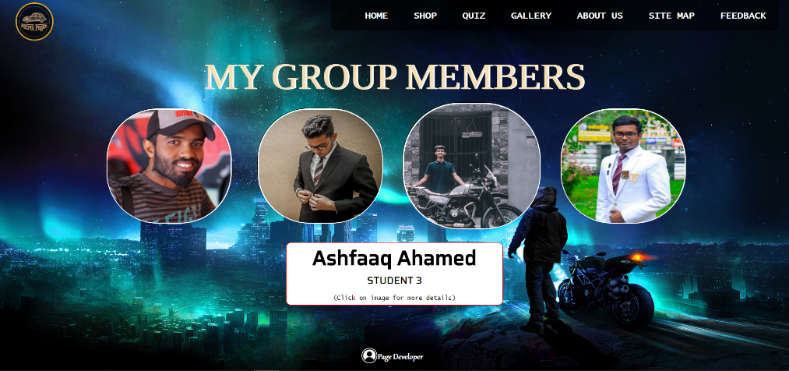

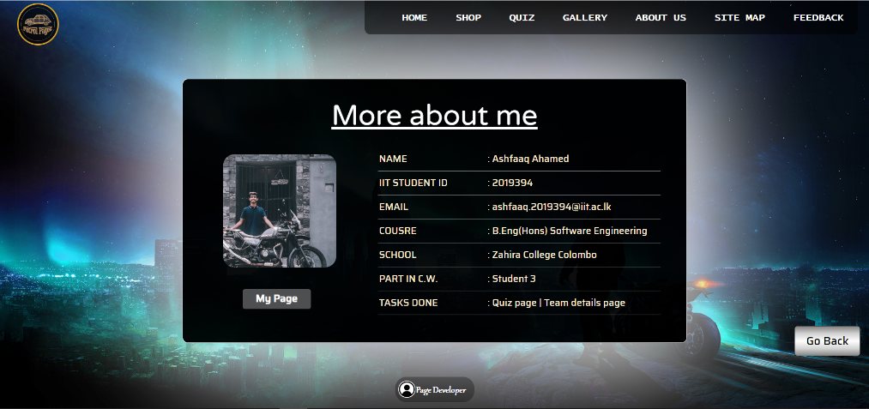

**(#) 🡪 Go Back button.**

**(#) 🡪** Display area when the mouse is taken over the image

**(#) 🡪** When the image is clicked the below section will be displayed

**(#) 🡪** This button will direct the user to the Individual Page created

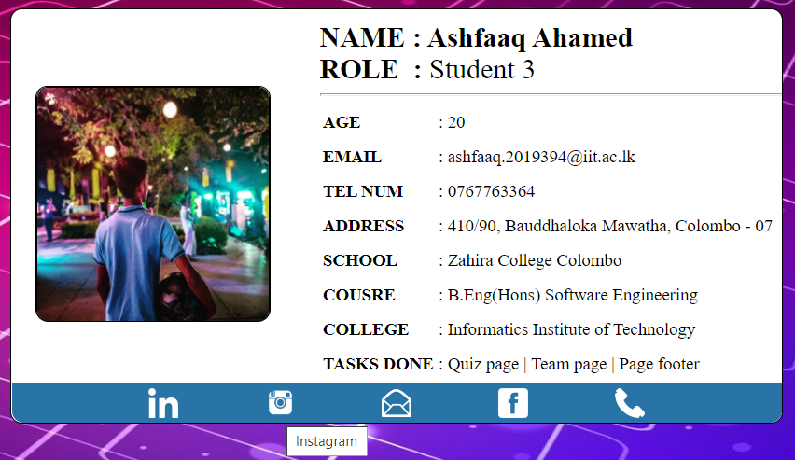



When the user clicks any of the above buttons in my page, it will direct him to the respective social media page in a new tab.

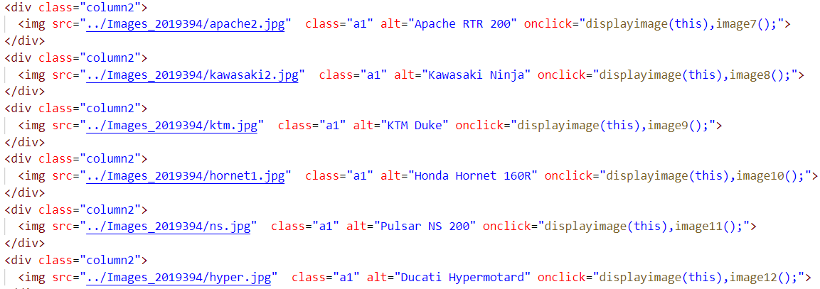

All the thumbnail images have been given alt tags. Even if the image doesn’t show up, the alternative image name will show without making any confusions.

## 3.6 Error prevention and recovery

### a. Design & Code to address error prevention and recovery

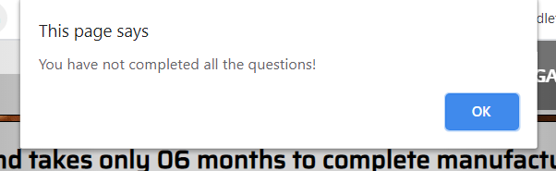

When the user submits the quiz without answering all the question, an alert box will arise giving this alert message. This came into consideration because the answers are displayed and the he can choose a random answer even if he doesn’t know it exactly.



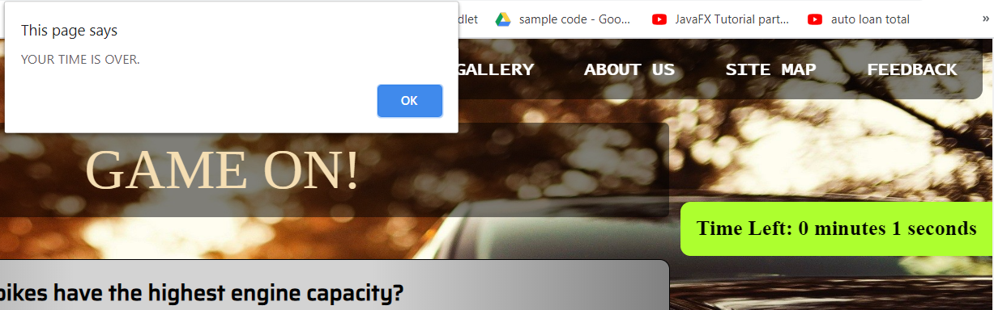If the user has exceeded the time limit while answering the quiz, an alert message will pop-up and the quiz will be submitted automatically.



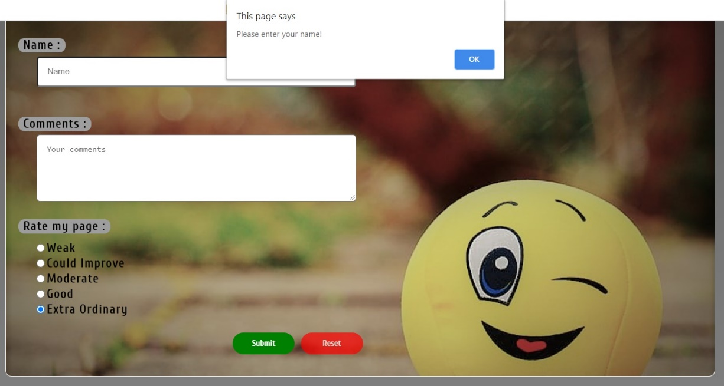In my individual page, I have set a feedback form. The user allowed to submit only if he has entered his name in it.

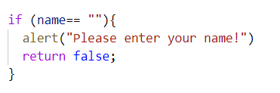

# Janet

All the contents used in my web-page does not disobey any rules and regulations followed in Janet Regulations. It follows all necessary rules and regulations which should be followed while making a web-page. All the data implied in my main web page do not violate any copyrights act. There are no obscene or offensive materials used in my page. Spamming is also not done in my page. These acts could make my page in-efficient. There is no transmission or development of harmful content in my page. It may threaten viewers who visit my page. My page also avoids contents that damages reputation of another person.

* The Data Protection Act 1998
* Copyright, Design and Patents Act 1990.
* The Computer Misuse Act 1990

The above mentioned are the Janet Regulations which are strictly followed in my web-page.

The individual page which I created contains quotes said by another person. I have mentioned the narrator of who said it beside that.

# Conclusions

Team work means a lot when it comes to assignment. The first step taken by us was to divide the tasks evenly, select a preferred topic and theme. Due to the prevailing situation around the world, it was a difficult task to collaborate between the members. Yet, we managed to come up with a good work.

This team work helped me in working together remotely. As student 3, I had to develop a Quiz Page and the Team Members Details page. This was developed based on UI and UX principles which were taught to us. This project also taught us to use online tools to check legibility and accessibility of our work too. The above report completely explains design and structure followed throughout my page.

By outcome after overcoming the project was extra-ordinary.

* Team work
* Time management
* Leadership
* Co-ordination and co-operation
* Adhering to members decisions.

These made us achieve our common goal. We also set a deadline by ourselves to complete the assignment. This was the utmost benefit we got. Thereby, we had more time to work on with other projects.

# References

* GeeksforGeeks. 2020. *Geeksforgeeks | A Computer Science Portal For Geeks*. [online] Available at: <https://www.geeksforgeeks.org/> [Accessed 30 March 2020].
* W3schools.com. 2020. *W3schools Online Web Tutorials*. [online] Available at: <https://www.w3schools.com/> [Accessed 2 April 2020].

# Appendices

## Appendix A: Code

* Quiz_Student3.html

<!DOCTYPE html>

<html lang="en">

<head>

    <link rel="stylesheet" type="text/css" href="../CSS_2019394/Quiz_Student3.css">   <!--Quiz page css-->

    <link rel="stylesheet" type="text/css" href="../CSS_2019407/external_2019407.css">   <!--Navigation bar-->

    <link href="https://fonts.googleapis.com/css2?family=Saira:wght@500&display=swap" rel="stylesheet"> <!--contents page-->

    <link href="https://fonts.googleapis.com/css2?family=Tinos&display=swap" rel="stylesheet"> <!--heading-->

<link rel="icon" href="../images_2019394/car2.png" type="image/icon type">

    <meta charset="UTF-8">

    <title>Quiz Page</title>

</head>

<body>

    <div id="header">

    <div id="logo">

        <a href="../HTML_2019407/Main_2019407.html"><img src="../Images_2019394/car2.png" id="img"></a>

    </div>

    <div class="navigation_bar">

        <nav>

            <ul>

                <li><a href="../HTML_2019407/Main_2019407.html">Home</a></li>

                <li><a href="../HTML_2019470/shopsite.html">Shop</a></li>

                <li><a href="../HTML_2019394/Quiz_Student3.html">Quiz</a></li>

                <li><a href="#">Gallery</a></li>

                <li><a href="../HTML_2019394/Team_Details_Student3.html">About Us</a></li>

                <li><a href="#">Site Map</a></li>

                <li><a href="../HTML_2019407/Feedback_form_2019407.html">Feedback</a></li>

            </ul>

        </nav>

    </div>

    </div>

    <div id="content">

    <h1 id="h1">Quiz Game</h1>

    <div id="rules">

        <h2>INSTRUCTIONS</h2>

        <ul>

            <li>Each correct answer will be given 02 marks.</li><br>

            <li>Each wrong answer will be given -01 mark.</li><br>

            <li>The QUIZ will be submitted automatically if you dont complete within the given time.<br>

                You will be given 02 minutes to complete the Quiz.</li><br>

            <li>The summary sheet will be displayed at the end of the page.</li><br>

            <table>

                <tr>

                    <td><div id="green1"></div> - If your answer is correct the corresponding answer turns Green.<br><br></td>

                    <td><div id="green2"></div> - If you score above 10 points your summary sheet turns Green.<br><br></td>

                </tr>

                <tr>

                    <td><div id="red1"></div> - If your answer is wrong the corresponding answer turns Red<br></td>

                    <td><div id="red2"></div> - If you score less than 10 points your summary sheet turns Red.<br></td>

                </tr>

            </table>

        </ul>

    </div>

    <form id="start" name="start">

        <center><input type="button" id="Start" name="Start" value="Start Quiz" onclick = "Openform()";></center><br><br>

    </form>

    <div id = "displayquiz" style = "display:none">

        <form id="quiz" name="quiz" action="">

            <div id="showtimer"> </div><br><br>

            <div id="report">

                <br>

                <div id="ex" style="display: none;"><img src="../Images_2019394/ash bike 2.png" id="img2"></div>

                <div id="ex2" style="display: none;"><img src="../Images_2019394/ash bike 3.png" id="img02"></div>

                <div id="report_head"></div>

                <a href="#end"><div id="score" name="score" style="display: none;">View Score</div></a>

            <div class="Qorder">

            Q1 : Which of these bikes have the highest engine capacity? <br>

            <div id="Question"><br>

                <input type="radio" id="q1,1" name="q1" value="right"><label for="q1,1">Triumph Rocket III</label> <br>

                <input type="radio" id="q1,2" name="q1" value="wrong"><label for="q1,2">Ducati Streetfighter</label> <br>

                <input type="radio" id="q1,3" name="q1" value="wrong"><label for="q1,3">Harley-Davidson CVO</label> <br>

                <input type="radio" id="q1,4" name="q1" value="wrong"><label for="q1,4">Honda Goldwing</label> <br>

                <div id="Q1" style="display: none;"></div><br>

            </div></div>

            <div class="Qorder">

            Q2 : What is the 1st fastest electical car produced in Sri Lanka? <br>

            <div id="Question"><br>

                <input type="radio" id="q2,1" name="q2" value="wrong"><label for="q2,1">Lamborghini</label> <br>

                <input type="radio" id="q2,2" name="q2" value="wrong"><label for="q2,2">Nissan GTR</label> <br>

                <input type="radio" id="q2,3" name="q2" value="right"><label for="q2,3">Vega </label> <br>

                <input type="radio" id="q2,4" name="q2" value="wrong"><label for="q2,4">Ford Mustang</label> <br>

                <div id="Q2" style="display: none;"></div><br>

            </div></div>

            <div class="Qorder">

            Q3 : What racetrack is nicknamed 'The fastest Road in the West'?<br>

            <div id="Question"><br>

                <input type="radio" id="q3,1" name="q3" value="wrong"><label for="q3,1">Sears Point</label> <br>

                <input type="radio" id="q3,2" name="q3" value="right"><label for="q3,2">Willow Springs</label> <br>

                <input type="radio" id="q3,3" name="q3" value="wrong"><label for="q3,3">California Speedway</label> <br>

                <input type="radio" id="q3,4" name="q3" value="wrong"><label for="q3,4">Phoneix International Raceway</label> <br>

                <div id="Q3" style="display: none;"></div><br>

            </div></div>

            <div class="Qorder">

            Q4 : How many rings are in the Audi logo? <br>

            <div id="Question"><br>

                <input type="radio" id="q4,1" name="q4" value="right"><label for="q4,1">Four</label> <br>

                <input type="radio" id="q4,2" name="q4" value="wrong"><label for="q4,2">Three</label> <br>

                <input type="radio" id="q4,3" name="q4" value="wrong"><label for="q4,3">Five</label> <br>

                <input type="radio" id="q4,4" name="q4" value="wrong"><label for="q4,4">One</label> <br>

                <div id="Q4" style="display: none;"></div><br>

            </div></div>

            <div class="Qorder">

            Q5 : Who was the 1st lady to drive an aircraft? <br>

            <div id="Question"><br>

                <input type="radio" id="q5,1" name="q5" value="wrong"><label for="q5,1">Shawna Rochelle Kimbrell</label> <br>

                <input type="radio" id="q5,2" name="q5" value="wrong"><label for="q5,2">Amy Johnson</label> <br>

                <input type="radio" id="q5,3" name="q5" value="wrong"><label for="q5,3">Write Brothers</label> <br>

                <input type="radio" id="q5,4" name="q5" value="right"><label for="q5,4">Amelia Earhart</label> <br>

                <div id="Q5" style="display: none;"></div><br>

            </div></div>

            <div class="Qorder">

            Q6 : Lexus is the luxury vehicle division of which Japanese car manufacturer?<br>

            <div id="Question"><br>

                <input type="radio" id="q6,1" name="q6" value="right"><label for="q6,1">Toyota</label> <br>

                <input type="radio" id="q6,2" name="q6" value="wrong"><label for="q6,2">Honda</label> <br>

                <input type="radio" id="q6,3" name="q6" value="wrong"><label for="q6,3">Subaru</label> <br>

                <input type="radio" id="q6,4" name="q6" value="wrong"><label for="q6,4">Mazda</label> <br>

                <div id="Q6" style="display: none;"></div><br>

            </div></div>

            <div class="Qorder">

            Q7 : Why do ships float on water? <br>

            <div id="Question"><br>

                <input type="radio" id="q7,1" name="q7" value="wrong"><label for="q7,1">Upthrust created</label> <br>

                <input type="radio" id="q7,2" name="q7" value="right"><label for="q7,2">Buoyancy force</label> <br>

                <input type="radio" id="q7,3" name="q7" value="wrong"><label for="q7,3">Gravitational force</label> <br>

                <input type="radio" id="q7,4" name="q7" value="wrong"><label for="q7,4">High weight of the ship</label> <br>

                <div id="Q7" style="display: none;"></div><br>

            </div></div>

            <div class="Qorder">

            Q8 : Which jeep that can stay a long time in water? <br>

            <div id="Question"><br>

                <input type="radio" id="q8,1" name="q8" value="wrong"><label for="q8,1">Range Rover</label> <br>

                <input type="radio" id="q8,2" name="q8" value="wrong"><label for="q8,2">Land Rover</label> <br>

                <input type="radio" id="q8,3" name="q8" value="wrong"><label for="q8,3">Mahindra</label> <br>

                <input type="radio" id="q8,4" name="q8" value="right"><label for="q8,4">Jeep</label> <br>

                <div id="Q8" style="display: none;"></div><br>

            </div></div>

            <div class="Qorder">

            Q9 : Which car brand takes only 06 months to complete manufacturing? <br>

            <div id="Question"><br>

                <input type="radio" id="q9,1" name="q9" value="wrong"><label for="q9,1">Tesla</label> <br>

                <input type="radio" id="q9,2" name="q9" value="right"><label for="q9,2">Rolls-Royce</label> <br>

                <input type="radio" id="q9,3" name="q9" value="wrong"><label for="q9,3">Bentley</label> <br>

                <input type="radio" id="q9,4" name="q9" value="wrong"><label for="q9,4">Bugatti</label> <br>

                <div id="Q9" style="display: none;"></div><br>

            </div></div>

            <div class="Qorder">

            Q10 : What is the nationality of Valentino Rossi?<br>

            <div id="Question"><br>

                <input type="radio" id="q10,1" name="q10" value="wrong"><label for="q10,1">Brazil</label> <br>

                <input type="radio" id="q10,2" name="q10" value="wrong"><label for="q10,2">Spain</label> <br>

                <input type="radio" id="q10,3" name="q10" value="right"><label for="q10,3">Italy</label> <br>

                <input type="radio" id="q10,4" name="q10" value="wrong"><label for="q10,4">Japan</label> <br>

                <div id="Q10" style="display: none;"></div><br>

            </div></div>

            <a href="#"><input type="button" id="done" value="Submit" onclick="quiz1()"></a>

                <div id="end">

                    <div id="total-marks"></div>

                    <div id="time_remaining"></div>

                </div>

                <div id="emojicor" style = "display:none"><img src="../Images_2019394/emoji1.png" class="emo1"></div>

                <div id="emojiwro" style = "display:none"><img src="../Images_2019394/tri2.png" class="emo2"></div>

                <center><input type="button" id="again" value="Play Again" onclick="rest()" style = "display:none"></center>

            </div>

        </form>

        <a href="#" title="Back to top"><img src="../Images_2019394/backtotop.png" id="b2t"></a>

    </div>

    <div id="footer12">

        <div id="link"><a href="../HTML_2019394/Page_Dev_Student3.html" title="Page Developer">

            <img src="../Images_2019394/abt3.png" id="fimg"/><div id="pgd">Page Developer</div></a>

            </div>

    </div>

    </div>

    <script src="../JS_2019394/Quiz_Student3.js"></script>

</body>

</html>

* Quiz_Student3.css

body{

    background-image: url('../Images_2019394/b14a.jpg');

    background-repeat: no-repeat;

    background-attachment: fixed;

    background-position: relative;

    background-size: 100% 100%;

    margin: 0px;

}

#content{               /*whole html body*/

    margin-top: 65px;

}

#img{                   /*logo img*/

    height: 85px;

    width: 85px;

    background-color: rgba(0, 0, 0, 0.7);

    border-radius: 1000px;

    padding: 5px;

    border: solid 2px goldenrod;

}

#logo{                  /*logo div*/

    text-align: center;

    float: left;

    position: fixed;

    top: 10px;

    margin-left: 10px;

}

h1{                     /*QUIZ heading*/

    font-family: 'Tinos', serif;

    text-align: center;

    font-weight: lighter;

    text-transform: uppercase;

    font-size: 55px;

    padding: 15px 0px;

    color: wheat;

    background-color: rgba(0, 0, 0, 0.5);

    border-radius: 5px;

    width: 51.5%;

    position: relative;

    margin: 5.5% auto 0.5% auto;

}

h2{                     /*Instructions heading*/

    text-align: center;

    margin: 0px auto 0px -10px;

    color: white;

    letter-spacing: 5px;

    line-height: 30px;

    text-shadow: 3px 1px darkslategray;

    background-color: #999999;

    border: #000000;

}

#rules{                     /*rules div*/

    background-color: white;

    width: 51%;

    margin: 0 auto -10px auto;

    padding: 0 0 10px 10px;

    border-radius: 5px;

    border: solid black 1px;

    font-family: 'Saira', sans-serif;

    line-height: 20px;

}

#green1,#green2,#red1,#red2{ /*color boxes*/

    float: left;

    width: 25px;

    height: 25px;

    margin: auto;

    margin-right: 10px;

    border: solid black 1px;

}

#green1{                    /*box inside the rules*/

    background-color: #ddffab;

}

#red1{                      /*box inside the rules*/

    background-color: #ff726f;

}

#green2{                    /*box inside the rules*/

    background-color: lightgreen;

}

#red2{                      /*box inside the rules*/

    background-color: #ff0000;

}

#Start,#done,#again{        /*3 btns*/

    padding: 10px 20px;

    text-align: center;

    font-size: 20px;

    font-family: 'Saira', sans-serif;

    cursor: pointer;

    outline: none;

    transition: 0.5s;

    color: black;

    border-radius: 5px;

    border: #000000 1px solid;

    background-image: linear-gradient(to bottom , grey, lightgrey, white, lightgrey, grey);

}

#Start:hover,#done:hover,#again:hover {     /*Hover for the 3 btns*/

    background-image: linear-gradient(to bottom , grey, white, white, white, white, grey);

    color: #1b0061;

    border-radius: 5px;

    transform : scale(0.9);

}

#Start{                     /*start btn*/

    margin: 25px 0px -20px 0;

}

#done{                      /*submit btn*/

    float: right;

    margin-right: 45px;

}

#again{                     /*again btn*/

    margin-top: 20px;

    margin-bottom: 20px;

}

#quiz{                  /*Form created with the questions*/

    margin-top: -2%;

}

#showtimer{             /*timer div*/

    position: sticky;

    margin-top: 15px;

    top: 70px;

    float: right;

    font-weight: bolder;

    font-size: 21px;

    padding: 15px;

    background-color: #adff2f;   /*#adff2f*/

    border-top-left-radius:10px;

    border-bottom-left-radius: 10px;

}

.Qorder{                /*questions div*/

    border: solid black 1px;

    border-radius: 10px;

    padding: 15px;

    padding-bottom: 35px;

    margin: 5px auto 5px auto;

    width: 70%;

    font-weight: bold;

    font-size: 22px;

    font-family: 'Saira', sans-serif;

    background-image: linear-gradient(to right, grey , lightgrey , lightgrey , grey);

}

#Question{              /*radio btns div*/

    font-size: 18px;

    font-weight: normal;

    margin-left: 30px;

    margin-right: 30px;

    border-radius: 10px;

    background-image: linear-gradient(to right, lightgrey , white , lightgrey );

    font-family: 'Saira', sans-serif;

}

label{                  /*label for radio btns*/

    margin: 15px;

}

label:hover{            /*Hover effect for the radio btns in quiz*/

    color: royalblue;

    background-color: #e6f8f9;

    border-radius: 50px;

    padding-left: 10px;

    padding-right: 10px;

    cursor: pointer;

}

#report_head{           /*print heading for report*/

    text-align: center;

    text-transform: capitalize;

    font-weight: 500;

    font-size: 40px;

    text-shadow: 2px 2px #999;

    font-family: 'Tinos', serif;

}

#score{                 /*Scroll to score btn*/

    padding: 5px;

    margin: -7% -11% auto auto;

    position: sticky;

    float: right;

    top: 130px;

    width: 100px;

    text-align: center;

    font-size: 18px;

    font-family: 'Saira', sans-serif;

    cursor: pointer;

    outline: none;

    transition: 0.5s;

    color: black;

    border-radius: 5px;

    border: #000000 1px solid;

    box-shadow: 0 20px 50px rgba(0, 0, 0, 0.5);

    background-image: linear-gradient(to bottom , grey, lightgrey, white, lightgrey, grey);

}

#score:hover {          /*Scroll to score btn Hover*/

    background-image: linear-gradient(to bottom , grey, white, white, white, grey);

    color: #1b0061;

    transform : scale(0.9);

  }

#Q1,#Q3,#Q5,#Q7,#Q9{    /*summary report order*/

    box-shadow: -5px 0px 10px black;

    border-radius: 10px;

    margin: 20px auto 0px auto;

    width: 80%;

    text-align: center;

    font-family: 'Saira', sans-serif;

}

#Q2,#Q4,#Q6,#Q8,#Q10{   /*summary report order*/

    box-shadow: 5px 0px 10px black;

    border-radius: 10px;

    margin: 20px auto 0px auto;

    width: 80%;

    text-align: center;

    font-family: 'Saira', sans-serif;

}

#report{                /*display whole report*/

    border-radius: 10px;

    margin: auto;

    font-size: 20px;

    width: 80%;

}

#img2{                  /*animation bike (left side)*/

    margin-top: -70px;

    margin-left: -90px;

    height: 250px;

    width: 350px;

}

#img02{                 /*animation bike (right side)*/

    margin-top: -80px;

    margin-left: 950px;

    height: 250px;

    width: 350px;

}

#ex,#ex2 {              /*bike div animation*/

    width: 100px;

    height: 10px;

    position: relative;

    animation-duration: 4s;

    animation-iteration-count: infinite;

}

#ex{                    /*bike div animation (left)*/

    animation-name: example;

}

#ex2{                   /*bike div animation (right)*/

    animation-name: example2;

}

  @keyframes example {  /*Animation from left to right*/

    0%    {left:0; top:0px;}

    50%  { left:80%; top:0px;}

  }

  @keyframes example2 { /*Animation from right to left*/

    0%    {right:0px; top:0px;}

    50%  { right:80%; top:0px;}

  }

#emojicor,#emojiwro{    /*emojis div*/

    float: right;

    margin: -155px 220px auto auto;

    padding-bottom: 5px;

    width: 60px;

    height: 60px;

    border-radius: 20px;

}

.emo1{                  /*correct image*/

    height: 220px;

    width: 220px;

}

.emo2{                  /*wrong image*/

    height: 260px;

    width: 260px;

}

#end{                   /*display score & time*/

    margin-left: 65px;

    width: max-content;

    border-radius: 10px;

    background-color: rgba(46, 46, 46, 0.8);

    /* background-image: linear-gradient(to right, lightgrey , white , lightgrey ); */

    padding-left: 15px;

    padding-right: 15px;

}

#total-marks{           /*display total marks*/

    font-size: 30px;

    height: 40px;

    text-align: center;

    margin-top: 50px;

    padding-top: 10px ;

    border-radius: 15px;

    font-family: Georgia, 'Times New Roman', Times, serif;

    color: white;

    width: auto;

}

#time_remaining{        /*display time_remaining*/

    font-size: 30px;

    height: 50px;

    margin-bottom: 20px;

    border-radius: 15px;

    font-family: Georgia, 'Times New Roman', Times, serif;

    color: white;

    width: auto;

    text-align: center;

}

#footer12{              /*footer black background*/

    position: fixed;

    bottom: 0;

    width: 100%;

    height: 35px;

    color: white;

    margin-bottom: 5px;

    padding-top: 9px;

    padding-bottom: 12px;

}

#link{                  /*page developer icon*/

    text-align: center;

    font-size: 15px;

    font-weight: normal;

    font-family: "Gabriola";

    color: white;

    clear: both;

    margin: auto;

    background-color: rgba(0, 0, 0, 0.3);

    width: 140px;

    border-radius: 20px;

}

#link:hover{            /*Hover for pgd*/

    color: black;

    background-color: rgba(255, 255, 255, 0.7);

}

#fimg{                  /*page developer image*/

    height: 30px;

    width: 30px;

    margin-top: 7px;

    margin-bottom: -4px;

    border-radius: 1000px;

    background-color: white;

}

#pgd{                   /*page developer div*/

    float: right;

    text-align: center;

    margin: 10px 15px 10px -5px;

}

#b2t{                   /*back to top*/

    background-color: white;

    position: sticky;

    height:45px;

    width: 45px;

    bottom: 10px;

    right: 14px;

    float: right;

    border-radius: 100px;

}

* Quiz_Student3.js

function getRadioValue( radioValue ) {

    var i;

    var radnum = document.getElementsByName(radioValue);

    for ( i = 0, length=radnum.length; i < length; i++ ) {  //loop to each quiz

        if ( radnum[ i ].checked ) {    //check the seleceted radio btn

            var answer =radnum[i].value;

        }

        radnum[ i ].disabled = true;    //disable radio buttons after submitting

    }

    return answer;  //return the answer

}

var totalseconds = 120 * 1;                 //setting the timer

var mins = parseInt(totalseconds / 60);     //converting total secondds to minutes

var seconds = parseInt(totalseconds % 60);  //balancing the seconds out from the minutes left

var timer;

function Openform(){    //Start Quiz

    document.getElementById("footer12").style.marginTop = "70px";

    document.getElementById("footer12").style.position = "unset";

    document.getElementById("b2t").style.marginRight = "-255px";

    document.getElementById("rules").hidden = true;

    document.getElementById("end").style.display = "none";

    document.getElementById("displayquiz").style.display = '';

    document.getElementById("start").style.display = "none";

    document.getElementById("h1").style.marginBottom = "0"

    document.getElementById("h1").innerHTML = "Game On!"

    document.getElementById("h1").style.width = "58%"

    document.body.style.backgroundImage = "url('../Images_2019394/bg2.jpg')";

    document.getElementById("showtimer").innerHTML = 'Time Left: ' + mins + ' minutes ' + seconds + ' seconds ';

    if (totalseconds <= 0) {                    //end quiz if timer ends

        quiz1();

    } else {

        totalseconds--;

        mins = parseInt(totalseconds / 60);     //reduce the timer by 1 second

        seconds = parseInt(totalseconds % 60);

        timer = setTimeout(Openform, 1000);     //calling the timer

    }

}

function quiz1(){   //Submit

    if (totalseconds > 0){  //Check if all questions are checked

        var opt = document.querySelector('input[name=q1]:checked');

        if(!opt){

            alert("You have not completed all the questions!");

            return

        }

        var opt = document.querySelector('input[name=q2]:checked');

        if(!opt){

            alert("You have not completed all the questions!");

            return

        }

        var opt = document.querySelector('input[name=q3]:checked');

        if(!opt){

            alert("You have not completed all the questions!");

            return

        }

        var opt = document.querySelector('input[name=q4]:checked');

        if(!opt){

            alert("You have not completed all the questions!");

            return

        }

        var opt = document.querySelector('input[name=q5]:checked');

        if(!opt){

            alert("You have not completed all the questions!");

            return

        }

        var opt = document.querySelector('input[name=q6]:checked');

        if(!opt){

            alert("You have not completed all the questions!");

            return

        }

        var opt = document.querySelector('input[name=q7]:checked');

        if(!opt){

            alert("You have not completed all the questions!");

            return

        }

        var opt = document.querySelector('input[name=q8]:checked');

        if(!opt){

            alert("You have not completed all the questions!");

            return

        }

        var opt = document.querySelector('input[name=q9]:checked');

        if(!opt){

            alert("You have not completed all the questions!");

            return

        }

        var opt = document.querySelector('input[name=q10]:checked');

        if(!opt){

            alert("You have not completed all the questions!");

            return

        }

    }

        clearInterval(timer);   //Pause the timer once the submit is clicked

        document.getElementById("h1").style.width = "80%";

        document.getElementById("h1").innerHTML = "Your results"

        document.body.style.backgroundImage = "url('../Images_2019394/caar.jpeg')";

        var correct = 0;

        var que1 = getRadioValue("q1")  //reading the values for Q1

        var que2 = getRadioValue("q2")  //reading the values for Q2

        var que3 = getRadioValue("q3")  //reading the values for Q3

        var que4 = getRadioValue("q4")  //reading the values for Q4

        var que5 = getRadioValue("q5")  //reading the values for Q5

        var que6 = getRadioValue("q6")  //reading the values for Q6

        var que7 = getRadioValue("q7")  //reading the values for Q7

        var que8 = getRadioValue("q8")  //reading the values for Q8

        var que9 = getRadioValue("q9")  //reading the values for Q9

        var que10 = getRadioValue("q10")//reading the values for Q10

        document.getElementById("report_head").innerHTML="Thank you for taking part in this Quiz<br><br>";

        document.getElementById("ex").style.display = '';   //emoji display

        document.getElementById("ex2").style.display = '';  //emoji display

        document.getElementById("score").style.display = '';    //final score display

        document.getElementById("Q1").style.display = '';   //display every answer

        document.getElementById("Q2").style.display = '';

        document.getElementById("Q3").style.display = '';

        document.getElementById("Q4").style.display = '';

        document.getElementById("Q5").style.display = '';

        document.getElementById("Q6").style.display = '';

        document.getElementById("Q7").style.display = '';

        document.getElementById("Q8").style.display = '';

        document.getElementById("Q9").style.display = '';

        document.getElementById("Q10").style.display = '';

        document.getElementById("end").style.display = '';

        document.getElementById("b2t").style.marginRight = "14px";

        //CHECKING IF THE ANSWERS ARE CORRECT

        if (que1 =="right"){

            document.getElementById("Q1").innerHTML="<br>&nbsp Your answer is correct<br><br>";

            document.getElementById("Q1").style.backgroundColor="#ddffab";

            correct = correct+2;

        }

        else if(que1 == "wrong"){

            document.getElementById("Q1").innerHTML="<br>&nbsp Incorrect answer. Correct answer is Triumph Rocket III<br><br>";

            document.getElementById("Q1").style.backgroundColor="#ff726f";

            correct--;

        }

        else {

            document.getElementById("Q1").innerHTML="<br>&nbsp You did not select any answer<br><br>";

            document.getElementById("Q1").style.backgroundColor="#ff726f";

            correct--;

        };

        if (que2 =="right"){

            document.getElementById("Q2").innerHTML="<br>&nbsp Your answer is correct<br><br>";

            document.getElementById("Q2").style.backgroundColor="#ddffab";

            correct = correct+2;

        }

        else if (que2 == "wrong"){

            document.getElementById("Q2").innerHTML="<br>&nbsp Incorrect answer. Correct answer is Vega<br><br>";

            document.getElementById("Q2").style.backgroundColor="#ff726f";

            correct--;

        }

        else {

            document.getElementById("Q2").innerHTML="<br>&nbsp You did not select any answer<br><br>";

            document.getElementById("Q2").style.backgroundColor="#ff726f";

            correct--;

        }

        if (que3 =="right"){

            document.getElementById("Q3").innerHTML="<br>&nbsp Your answer is correct<br><br>";

            document.getElementById("Q3").style.backgroundColor="#ddffab";

            correct = correct+2;

        }

        else if (que3 == "wrong") {

            document.getElementById("Q3").innerHTML="<br>&nbsp Incorrect answer. Correct answer is Willow Springs<br><br>";

            document.getElementById("Q3").style.backgroundColor="#ff726f";

            correct--;

        }

        else {

            document.getElementById("Q3").innerHTML="<br>&nbsp You did not select any answer<br><br>";

            document.getElementById("Q3").style.backgroundColor="#ff726f";

            correct--;

        }

        if (que4 =="right"){

            document.getElementById("Q4").innerHTML="<br>&nbsp Your answer is correct<br><br>";

            document.getElementById("Q4").style.backgroundColor="#ddffab";

            correct = correct+2;

        }

        else if (que4 == "wrong"){

            document.getElementById("Q4").innerHTML="<br>&nbsp Incorrect answer. Correct answer is Four<br><br>";

            document.getElementById("Q4").style.backgroundColor="#ff726f";

            correct--;

        }

        else {

            document.getElementById("Q4").innerHTML="<br>&nbsp You did not select any answer<br><br>";

            document.getElementById("Q4").style.backgroundColor="#ff726f";

            correct--;

        }

        if (que5 =="right"){

            document.getElementById("Q5").innerHTML="<br>&nbsp Your answer is correct<br><br>";

            document.getElementById("Q5").style.backgroundColor="#ddffab";

            correct = correct+2;

        }

        else if (que5 == "wrong") {

            document.getElementById("Q5").innerHTML="<br>&nbsp Incorect answer. Correct answer is Amelia Earhart<br><br>";

            document.getElementById("Q5").style.backgroundColor="#ff726f";

            correct--;

        }

        else {

            document.getElementById("Q5").innerHTML="<br>&nbsp You did not select any answer<br><br>";

            document.getElementById("Q5").style.backgroundColor="#ff726f";

            correct--;

        }

        if (que6 =="right"){

            document.getElementById("Q6").innerHTML="<br>&nbsp Your answer is correct<br><br>";

            document.getElementById("Q6").style.backgroundColor="#ddffab";

            correct = correct+2;

        }

        else if (que6 == "wrong"){

            document.getElementById("Q6").innerHTML="<br>&nbsp Incorrect answer. Correct answer is Toyota<br><br>";

            document.getElementById("Q6").style.backgroundColor="#ff726f";

            correct--;

        }

        else {

            document.getElementById("Q6").innerHTML="<br>&nbsp You did not select any answer<br><br>";

            document.getElementById("Q6").style.backgroundColor="#ff726f";

            correct--;

        }

        if (que7 =="right"){

            document.getElementById("Q7").innerHTML="<br>&nbsp Your answer is correct<br><br>";

            document.getElementById("Q7").style.backgroundColor="#ddffab";

            correct = correct+2;

        }

        else if (que7 == "wrong"){

            document.getElementById("Q7").innerHTML="<br>&nbsp Incorrect answer. Correct answer is Buoyancy force<br><br>";

            document.getElementById("Q7").style.backgroundColor="#ff726f";

            correct--;

        }

        else {

            document.getElementById("Q7").innerHTML="<br>&nbsp You did not select any answer<br><br>";

            document.getElementById("Q7").style.backgroundColor="#ff726f";

            correct--;

        }

        if (que8 =="right"){

            document.getElementById("Q8").innerHTML="<br>&nbsp Your answer is correct<br><br>";

            document.getElementById("Q8").style.backgroundColor="#ddffab";

            correct = correct+2;

        }

        else if(que8 == "wrong"){

            document.getElementById("Q8").innerHTML="<br>&nbsp Incorrect answer. Correct answer is Jeep<br><br>";

            document.getElementById("Q8").style.backgroundColor="#ff726f";

            correct--;

        }

        else {

            document.getElementById("Q8").innerHTML="<br>&nbsp You did not select any answer<br><br>";

            document.getElementById("Q8").style.backgroundColor="#ff726f";

            correct--;

        }

        if (que9 =="right"){

            document.getElementById("Q9").innerHTML="<br>&nbsp Your answer is correct<br><br>";

            document.getElementById("Q9").style.backgroundColor="#ddffab";

            correct = correct+2;

        }

        else if (que9 == "wrong"){

            document.getElementById("Q9").innerHTML="<br>&nbsp Incorrect answer. Correct answer is Rolls-Royce<br><br>";

            document.getElementById("Q9").style.backgroundColor="#ff726f";

            correct--;

        }

        else {

            document.getElementById("Q9").innerHTML="<br>&nbsp You did not select any answer<br><br>";

            document.getElementById("Q9").style.backgroundColor="#ff726f";

            correct--;

        }

        if (que10 =="right"){

            document.getElementById("Q10").innerHTML="<br>&nbsp Your answer is correct<br><br>";

            document.getElementById("Q10").style.backgroundColor="#ddffab";

            correct = correct+2;

        }

        else if (que10 == "wrong"){

            document.getElementById("Q10").innerHTML="<br>&nbsp Incorrect answer. Correct answer is Italy<br><br>";

            document.getElementById("Q10").style.backgroundColor="#ff726f";

            correct--;

        }

        else {

            document.getElementById("Q10").innerHTML="<br>&nbsp You did not select any answer<br><br>";

            document.getElementById("Q10").style.backgroundColor="#ff726f";

            correct--;

        }

        if (correct<0){     //display 0 if the total goes below 0 too

            correct = 0;

        }

        document.getElementById("total-marks").innerHTML="You scored "+ correct + "/20 marks<br><br>";  //display marks

        if(totalseconds>0){     //display time remaining

            document.getElementById("time_remaining").innerHTML="You have completed the quiz in "+ (1 - Math.floor(mins))+" minute "+(59 - Math.floor(seconds))+" seconds";

        }

        else{                   //Time over alert

            alert("YOUR TIME IS OVER.");

            document.getElementById("time_remaining").innerHTML="Your time is over";

        }

        if (correct>=10){   //change background color

            document.getElementById("report").style.backgroundColor="lightgreen";

            document.getElementById("emojicor").style.display = "";

        }

        else {              //change background color

            document.getElementById("report").style.backgroundColor="#ff0000";

            document.getElementById("emojiwro").style.display = "";

        }

        document.getElementById("done").hidden = true;      //hide submit btn

        document.getElementById("again").style.display = '';    //show paly again btn

};

function rest(){        //function for play again

    location.reload();

}

window.onscroll = function(){   //Back to top

if(document.body.scrollTop >= 300 || document.documentElement.scrollTop >= 300){

  document.getElementById('b2t').style.display=""

}

else{

  document.getElementById('b2t').style.display="none";

}

};

* Team_Details_Student3.html

<!DOCTYPE html>

<html lang="en">

<head>

    <link rel="stylesheet" type="text/css" href="../CSS_2019407/external_2019407.css">   <!--Navigation bar-->

    <link rel="stylesheet" type="text/css" href="../CSS_2019394/Team_Details_Student3.css">   <!--Student detail css-->

    <link href="https://fonts.googleapis.com/css2?family=Varela+Round&display=swap" rel="stylesheet">

    <link href="https://fonts.googleapis.com/css2?family=Saira:wght@500&display=swap" rel="stylesheet"> <!--COMMON FONT-->

    <link href="https://fonts.googleapis.com/css2?family=Tinos&display=swap" rel="stylesheet"> <!--heading-->

<link rel="icon" href="../images_2019394/car2.png" type="image/icon type">

    <meta charset="UTF-8">

    <title>Student images</title>

</head>

<body>

    <div id="header">

        <div id="logo">

            <a href="../HTML_2019407/Main_2019407.html"><img src="../Images_2019394/car2.png" id="img"></a>

        </div>

        <div class="navigation_bar">

            <nav>

                <ul>

                    <li><a href="../HTML_2019407/Main_2019407.html">Home</a></li>

                    <li><a href="../HTML_2019470/shopsite.html">Shop</a></li>

                    <li><a href="../HTML_2019394/Quiz_Student3.html">Quiz</a></li>

                    <li><a href="#">Gallery</a></li>

                    <li><a href="../HTML_2019394/Team_Details_Student3.html">About Us</a></li>

                    <li><a href="#">Site Map</a></li>

                    <li><a href="../HTML_2019407/Feedback_form_2019407.html">Feedback</a></li>

                </ul>

            </nav>

        </div>

    </div>

    <div id="mainpage">

    <h1>MY GROUP MEMBERS</h1>

    <div id="images" >

        <div id="st1" class="student" onclick="openst1()">

            <img src="../Images_2019394/Sudesh.jpeg" id="zz">

        </div>

        <div id="st2" class="student" onclick="openst2()">

            <img src="../Images_2019394/hamza.jpeg" id="zz">

        </div>

        <div id="st3" class="student" onclick="openst3()">

            <img src="../Images_2019394/AshfaaqRE1.jpeg" id="zz">

        </div>

        <div id="st4" class="student" onclick="openst4()">

            <img src="../Images_2019394/Archana.jpeg" id="zz">

        </div>

        <div id="selection">

            <div id="name"></div>

            <div id="role"></div>

        </div>

    </div>

    </div>

    <div id="details" style="display: none;">

        <div id="container">

            <div id="aboutme"></div>

            <div id="photo"></div>

            <div id="cv">

                <table>

                    <tr>

                        <td id="r1">NAME</td>

                        <td id="a1"></td>

                    </tr>

                    <tr>

                        <td id="r1">IIT STUDENT ID</td>

                        <td id="a2"></td>

                    </tr>

                    <tr>

                        <td id="r1">EMAIL</td>

                        <td id="a3"></td>

                    </tr>

                    <tr>

                        <td id="r1">COUSRE</td>

                        <td id="a4"></td>

                    </tr>

                    <tr>

                        <td id="r1">SCHOOL</td>

                        <td id="a5"></td>

                    </tr>

                    <tr>

                        <td id="r1">PART IN C.W.</td>

                        <td id="a6"></td>

                    </tr>

                    <tr>

                        <td id="r1">TASKS DONE</td>

                        <td id="a7"></td>

                    </tr>

                </table>

            </div>

            <div id="st1B" class="partB" style="display: none;"><a href="#">My Page</a></div>

            <div id="st2B" class="partB" style="display: none;"><a href="../HTML_2019407/Part_B_2019407.html" target="_2_">My Page</a></div>

            <div id="st3B" class="partB" style="display: none;"><a href="../HTML_2019394/Part_B_Student3.html" target="_3_">My Page</a></div>

            <div id="st4B" class="partB" style="display: none;"><a href="#">My Page</a></div>

        </div>

        <div id="close" onclick="goBack();">Go Back</div>

    </div>

    <div id="footer12">

            <div id="link"><a href="../HTML_2019394/Page_Dev_Student3.html" title="Page Developer">

            <img src="../Images_2019394/abt3.png" id="fimg"/><div id="pgd">Page Developer</div></a>

            </div>

    </div>

    <script src="../JS_2019394/Team_Details_Student3.js"></script>

</body>

</html>

* Team_Details_Student3.css

body{

    text-align: center;

    background-image: url('../Images_2019394/bike6.jpg');

    background-repeat: no-repeat;

    background-attachment: fixed;

    background-position: relative;

    background-size: 100% 100%;

    margin: 0px;

}

h1{         /*TEAM members heading*/

    color: ghostwhite;

    font-family: 'Tinos', serif;

    text-align: center;

    margin: 7% 0 2% 0;

    font-size: 72px;

    font-weight: lighter;

    color: wheat;

    text-shadow: 3px 1px #fff;

}

#images{    /*main div tag for images*/

    width: 100%;

    text-align: center;

    margin-left: auto;

    margin-right: auto;

    margin-top: -50px;

}

.student{      /*Each stdnt div tags*/

    border: solid thin black;

    border-radius: 100px;

    margin: 40px 25px 40px 25px;

    padding: 10px 0 10px 0;

    display: inline-block;

    width: 238px;

    height: 200px;

    cursor: pointer;

}

#zz{            /*images inside div tags*/

    border: solid 2px white;

    height: 220px;

    width: 240px;

    margin-top: -10px;

    border-radius: 100px;

}

#st1, #st2, #st3, #st4{ /*Each stdnt div tags*/

    transition: 0.5s;

}

#selection{             /*diplaying details area*/

    width: 400px;

    height: 100px;

    margin: auto;

    clear: both;

    padding: 10px 10px 10px 10px;

    border-radius: 10px;

}

#name{                  /*div for diplaying name*/

    text-align: center;

    font-size: 40px;

    font-weight: bolder;

    height: 50px;

    margin-top: -13px;

    font-family: 'Saira', sans-serif;

}

#role{                  /*div for diplaying st role*/

    font-size: 20px;

    text-align: center;

    height: 50px;

    margin-top: 10px;

    font-family: 'Saira', sans-serif;

}

span{                   /*LABEL click on image for further details*/

    text-align: center;

    font-style: normal;

    font-size: 12px;

    font-family: 'Lucida Console',Monaco,monospace;

}

#footer12{             /*footer black background*/

    position: fixed;

    bottom: 5px;

    width: 100%;

    height: 35px;

    color: white;

    padding-top: 9px;

    padding-bottom: 12px;

}

#link{ /*page developer div icon*/

    text-align: center;

    font-size: 15px;

    font-weight: normal;

    font-family: "Gabriola";

    color: white;

    clear: both;

    margin: auto;

    background-color: rgba(0, 0, 0, 0.3);

    width: 140px;

    border-radius: 20px;

}

#link:hover{

    color: black;

    background-color: rgba(255, 255, 255, 0.7);

}

#fimg{ /*page developer image*/

    height: 30px;

    width: 30px;

    margin-top: 7px;

    margin-bottom: -4px;

    border-radius: 1000px;

    background-color: white;

}

#pgd{ /*page developer txt*/

    float: right;

    text-align: center;

    margin: 10px 15px 10px -5px;

}

 /* On click for further details*/

#container{         /*main table frame*/

    border: solid white 1px;

    height: 375px;

    width: 800px;

    clear: both;

    padding: 45px;

    margin: 9% auto auto auto;

    border-radius: 10px;

    background-color: rgba(0, 0, 0, 0.95);

    box-shadow: 5px 5px 800px 10px gainsboro, -5px -5px 800px 10px gainsboro;

}

#photo{             /*image of student*/

    height: 250px;

    float: left;

    width: 205px;

    margin: 3.5% auto auto 3%;

}

#identity{      /*image inside about me*/

    height: 200px;

    width: 200px;

    margin-top: 10px;

    border-radius: 20px;

}

#cv{                /*student details*/

    height: 350px;

    float: right;

    width: 500px;

    margin-bottom: -20px;

    margin-top: -15px;

    margin-left: 25px;

}

table{          /*Table which contains the details inside the CV*/

    color: blanchedalmond;

    padding: 10px;

    margin-top: 8%;

    border-collapse: collapse;

    font-family: 'Saira', sans-serif;

}

#r1{            /*left column */

    width: 170px;

    height: 40px;

    text-align: left;

    padding-left: 2px;

}

td{

    height: 40px;

    width: 330px;

    padding-left: 40px;

    text-align: left;

    font-size: 17px;

}

#aboutme{       /*abt me heading*/

    color: white;

    font-size: 50px;

    font-family: 'Varela Round', sans-serif;

    text-decoration: underline;

    margin-top: -10px;

}

tr{

    border-bottom: 1px solid white;

}

#close{        /*Close btn*/

    float: right;

    clear: both;

    padding: 10px 20px;

    text-align: center;

    font-size: 20px;

    font-family: 'Saira', sans-serif;

    cursor: pointer;

    outline: none;

    margin-top: -30px;

    margin-right: 15px;

    transition: 0.5s;

    color: black;

    border-radius: 5px;

    border: #000000 1px solid;

    background-image: linear-gradient(to bottom , grey, lightgrey, white, lightgrey, grey);

}

#close:hover{   /*Close btn - Hover*/

    background-image: linear-gradient(to bottom , grey, white, white, white, white, grey);

    color: #1b0061;

    border-radius: 5px;

    transform : scale(0.9);

}

.partB a{

    float: left;

    clear: both;

    margin-left: 60px;

    margin-top: -40px;

    text-align: center;

    width: 120px;

    height: 35px;

    font-size: 20px;

    font-family: 'Saira', sans-serif;

    cursor: pointer;

    outline: none;

    color: white;

    border-radius: 5px;

    border: #000000 1px solid;

    background-color: rgba(255, 255, 255, 0.3);

}

.partB a:hover{   /*Close btn - Hover*/

    color: #000000;

    background-color: rgba(255, 255, 255, 0.7);

    border-radius: 5px;

}

* Team_Details_Student3.css

document.getElementById("st1").addEventListener("mouseover", function(){    //display student name and role

    document.getElementById("name").innerHTML = "Sudesh Dilshan";

    document.getElementById("role").innerHTML = "STUDENT 1<br><span>(Click on image for more details)</span>";

    document.getElementById("selection").style.background="#ffffff";

    document.getElementById("selection").style.border="1px solid #ff0000";

    document.getElementById("st1").style.transform = "scale(1.1)";

});

document.getElementById("st2").addEventListener("mouseover", function(){    //display student name and role

    document.getElementById("name").innerHTML = "Hamza Ziyard";

    document.getElementById("role").innerHTML = "STUDENT 2<br><span>(Click on image for more details)</span>";

    document.getElementById("selection").style.background="#ffffff";

    document.getElementById("selection").style.border="1px solid #ff0000";

    document.getElementById("st2").style.transform = "scale(1.1)";

});

document.getElementById("st3").addEventListener("mouseover", function(){    //display student name and role

    document.getElementById("name").innerHTML = "Ashfaaq Ahamed";

    document.getElementById("role").innerHTML = "STUDENT 3<br><span>(Click on image for more details)</span>";

    document.getElementById("selection").style.background="#ffffff";

    document.getElementById("selection").style.border="1px solid #ff0000";

    document.getElementById("st3").style.transform = "scale(1.1)";

});

document.getElementById("st4").addEventListener("mouseover", function(){    //display student name and role

    document.getElementById("name").innerHTML = "Archana";

    document.getElementById("role").innerHTML = "STUDENT 4<br><span>(Click on image for more details)</span>";

    document.getElementById("selection").style.background="#ffffff";

    document.getElementById("selection").style.border="1px solid #ff0000";

    document.getElementById("st4").style.transform = "scale(1.1)";

})

document.getElementById("st1").addEventListener("mouseout", function(){     //hide student details

    document.getElementById("name").innerHTML = "";

    document.getElementById("role").innerHTML = "";

    document.getElementById("selection").style.background="";

    document.getElementById("selection").style.border="";

    document.getElementById("st1").style.transform = "scale(1.0)";

})

document.getElementById("st2").addEventListener("mouseout", function(){     //hide student details

    document.getElementById("name").innerHTML = "";

    document.getElementById("role").innerHTML = "";

    document.getElementById("selection").style.background="none";

    document.getElementById("selection").style.border="";

    document.getElementById("st2").style.transform = "scale(1.0)";

})

document.getElementById("st3").addEventListener("mouseout", function(){     //hide student details

    document.getElementById("name").innerHTML = "";

    document.getElementById("role").innerHTML = "";

    document.getElementById("selection").style.background="none";

    document.getElementById("selection").style.border="";

    document.getElementById("st3").style.transform = "scale(1.0)";

})

document.getElementById("st4").addEventListener("mouseout", function(){     //hide student details

    document.getElementById("name").innerHTML = "";

    document.getElementById("role").innerHTML = "";

    document.getElementById("selection").style.background="none";

    document.getElementById("selection").style.border="";

    document.getElementById("st4").style.transform = "scale(1.0)";

})

function openst1() {    //Display more details

    document.getElementById("details").style.display = "block";

    document.getElementById("mainpage").style.display = "none";

    document.getElementById("footer12").style.marginTop = "4.2%";

    document.getElementById("link").style.marginTop = "-5px";

    document.getElementById("aboutme").innerHTML = "More about me";

    document.getElementById("st1B").style.display=  "block";

    document.getElementById("photo").innerHTML = '<img id="identity" src = "../Images_2019394/Sudesh.jpeg">';

    document.getElementById("a1").innerHTML = ": Sudesh Dilshan";

    document.getElementById("a2").innerHTML = ": 2019470";

    document.getElementById("a3").innerHTML = ": dilshan.2019470@iit.ac.lk";

    document.getElementById("a4").innerHTML = ": B.Eng(Hons) Software Engineering";

    document.getElementById("a5").innerHTML = ": Leads";

    document.getElementById("a6").innerHTML = ": Student 1 ";

    document.getElementById("a7").innerHTML = ": Presentation | Shop | Font-size ";

}

function openst2() {        //Display more details

    document.getElementById("details").style.display = "block";

    document.getElementById("mainpage").style.display = "none";

    document.getElementById("footer12").style.marginTop = "4.2%";

    document.getElementById("link").style.marginTop = "-5px";

    document.getElementById("aboutme").innerHTML = "More about me";

    document.getElementById("st2B").style.display=  "block";

    document.getElementById("photo").innerHTML = '<img id="identity" src = "../Images_2019394/hamza.jpeg">';

    document.getElementById("a1").innerHTML = ": Hamza Ziyard";

    document.getElementById("a2").innerHTML = ": 2029407";

    document.getElementById("a3").innerHTML = ": hamza.2019407@iit.ac.lk";

    document.getElementById("a4").innerHTML = ": B.Eng(Hons) Software Engineering";

    document.getElementById("a5").innerHTML = ": Zahira College Colombo";

    document.getElementById("a6").innerHTML = ": Student 2";

    document.getElementById("a7").innerHTML = ": Main page | Feedback form ";

}

function openst3() {        //Display more details

    document.getElementById("details").style.display = "block";

    document.getElementById("mainpage").style.display = "none";

    document.getElementById("footer12").style.marginTop = "4.2%";

    document.getElementById("link").style.marginTop = "-5px";

    document.getElementById("aboutme").innerHTML = "More about me";

    document.getElementById("st3B").style.display=  "block";

    document.getElementById("photo").innerHTML = '<img id="identity" src = "../Images_2019394/AshfaaqRE1.jpeg">';

    document.getElementById("a1").innerHTML = ": Ashfaaq Ahamed";

    document.getElementById("a2").innerHTML = ": 2019394";

    document.getElementById("a3").innerHTML = ": ashfaaq.2019394@iit.ac.lk";

    document.getElementById("a4").innerHTML = ": B.Eng(Hons) Software Engineering";

    document.getElementById("a5").innerHTML = ": Zahira College Colombo";

    document.getElementById("a6").innerHTML = ": Student 3";

    document.getElementById("a7").innerHTML = ": Quiz page | Team details page";

}

function openst4() {        //Display more details

    document.getElementById("details").style.display = "block";

    document.getElementById("mainpage").style.display = "none";

    document.getElementById("footer12").style.marginTop = "4.2%";

    document.getElementById("link").style.marginTop = "-5px";

    document.getElementById("aboutme").innerHTML = "More about me";

    document.getElementById("st4B").style.display=  "block";

    document.getElementById("photo").innerHTML = '<img id="identity" src = "../Images_2019394/Archana.jpeg">';

    document.getElementById("a1").innerHTML = ": Archana Harankahawatta";

    document.getElementById("a2").innerHTML = ": 2019300";

    document.getElementById("a3").innerHTML = ": archana.2019300@iit.ac.lk";

    document.getElementById("a4").innerHTML = ": B.Eng(Hons) Software Engineering";

    document.getElementById("a5").innerHTML = ": Dharmapala Vidyalaya Pannipitiya";

    document.getElementById("a6").innerHTML = ": Student 4";

    document.getElementById("a7").innerHTML = ": Gallery | Sitemap";

}

function goBack() {     //Back button

    document.getElementById("details").style.display = "none";

    document.getElementById("mainpage").style.display = "";

    document.getElementById("footer12").style.marginTop = "3.5%";

    document.getElementById("link").style.margin = "auto";

}

* Page_Dev_Student3.html

<!DOCTYPE html>

<html lang="en">

<head>

    <meta charset="UTF-8">

    <link rel="stylesheet" type="text/css" href="../CSS_2019394/Page_Dev_Student3.css">

    <link href="https://fonts.googleapis.com/css2?family=Acme&display=swap" rel="stylesheet">

<link rel="icon" href="../images_2019394/car2.png" type="image/icon type">

    <title>User profile</title>

</head>

<body>

    <h1>User Profile</h1>

    <div id="main">

        <div id="photo">

            <img src="../Images_2019394/me.jpeg" id="pic">

        </div>

        <div id="details">

            <header>

                <b>NAME : Ashfaaq Ahamed</b><br>

                <b>ROLE&nbsp; :</b> Student 3

            </header><hr>

            <table>

                <tr>

                    <td id="r1">AGE</td>

                    <td>: 20</td>

                </tr>

                <tr>

                    <td id="r1">EMAIL</td>

                    <td>: ashfaaq.2019394@iit.ac.lk</td>

                </tr>

                <tr>

                    <td id="r1">TEL NUM </td>

                    <td>: 0767763364</td>

                </tr>

                <tr>

                    <td id="r1">ADDRESS</td>

                    <td>: 410/90, Bauddhaloka Mawatha, Colombo - 07</td>

                </tr>

                <tr>

                    <td id="r1">SCHOOL</td>

                    <td>: Zahira College Colombo</td>

                </tr>

                <tr>

                    <td id="r1">COUSRE</td>

                    <td>: B.Eng(Hons) Software Engineering</td>

                </tr>

                <tr>

                    <td id="r1">COLLEGE</td>

                    <td>: Informatics Institute of Technology</td>

                </tr>

                <tr>

                    <td id="r1">TASKS DONE</td>

                    <td>: Quiz page | Team Members Details</td>

                </tr>

            </table>

        </div>

        <div id="social">

            <a href="https://www.linkedin.com/in/ashfaaq-hilal-a93514198/" target="_1" title="Linkedin"><img src="../Images_2019394/linkedin.png" id="linkedin"></a>

            <a href="https://www.instagram.com/ashfxxq_ahxmed/?hl=en" target="_2" title="Instagram"><img src="../Images_2019394/insta.png" id="insta"></a>

            <a href="mailto:ashfaaq.2019394@iit.ac.lk" target="_3" title="E-mail"><img src="../Images_2019394/email.png" id="email"></a>

            <a href="https://www.facebook.com/ashfaaq.ahamed.988" target="_4" title="Facebook"><img src="../Images_2019394/facebook.png" id="fb"></a>

            <a href="tel:0767763364" target="_5" title="Telephone"><img src="../Images_2019394/tel.png" id="tel"></a>

        </div>

    </div><br><br>

    <a href="../HTML_2019407/Main_2019407.html" title="home">

    <div id="link">

        <img src="../Images_2019394/home.png" id="fimg"><br>Home

    </div></a>

</body>

</html>

* Page_Dev_Student3.css

body{

    background-image: url('../Images_2019394/coder7.jpg');

    background-repeat: no-repeat;

    background-attachment: fixed;

    background-position: relative;

    background-size: 100% 100%;

    margin: 0px;

}

h1{

    text-align: center;

    color: #ffffff;

    font-size: 50px;

    margin-top: 40px;

    font-family: 'Acme', sans-serif;

}

#photo{

    float: left;

    width: 200px;

    height: 200px;

    margin: 55px 0 20px 20px;

    border: solid black 1px;

    border-radius: 10px;

}

#pic{

    border: solid black 1px;

    height: 200px;

    width: 198px;

    margin: 0px 20px 20px 0px;

    border-radius: 10px;

}

#details{

    float: right;

    width: 60%;

    text-align: left;

    font-size: 15px;

}

#main{

    width: 660px;

    height: 331px;

    margin: auto;

    margin-top: 40px;

    padding-top: 10px;

    border: solid black 1px;

    border-radius: 10px;

    background-color: #ffffff;

}

header{

    top: 10px;

    font-size: large;

}

tr{

    height: 28px;

}

#r1{

    font-weight: bold;

}

#social{

    background-color: #2874A6;

    text-align: center;

    margin-top: 215px;

    height: 34px;

    clear: both;

    border-bottom-left-radius: 10px;

    border-bottom-right-radius: 10px;

}

#linkedin,#insta,#fb,#tel,#email{

    padding: 5px 35px 0px 35px;

    height: 25px;

    width: 25px;

    transition: 0.3s;

}

#linkedin:hover,#insta:hover,#fb:hover,#tel:hover,#email:hover{

    transform: scale(0.8);

}

#link:hover{

    transform: scale(0.95);

}

#link{

    float: right;

    text-align: center;

    font-size: 20px;

    text-decoration-color: white;

    clear: both;

    margin: -465px 10px auto auto;

    background-color: black;

    padding-bottom: 5px;

    width: 100px;

    border-radius: 20px;

    transition: 0.3s;

}

#fimg{

    height: 30px;

    width: 30px;

    border-radius: 50px;

    background-color: white;

    margin-top: 10px;

}

a:link {

    text-decoration: none;

}

a:hover {

    color: blue;

    text-decoration: none;

}

a:active{

    color: red;

}

* Part_B_Student3.html

<!DOCTYPE html>

<html lang="en">

<head>

    <meta charset="UTF-8">

    <meta name="viewport" content="width=device-width, initial-scale=1.0">

    <title>Bikers Paradise</title>

    <link href="https://fonts.googleapis.com/css2?family=Tangerine:wght@700&display=swap" rel="stylesheet">

    <link href="https://fonts.googleapis.com/css2?family=Cuprum:wght@700&display=swap" rel="stylesheet">

    <link href="https://fonts.googleapis.com/css2?family=Varela+Round&display=swap" rel="stylesheet"> <!--feedback-->

    <link href="https://fonts.googleapis.com/css2?family=Montserrat:wght@500&display=swap" rel="stylesheet"><!--main headings-->

    <link href="https://fonts.googleapis.com/css2?family=Metal+Mania&display=swap" rel="stylesheet"> <!--Logo name-->

    <link href="https://fonts.googleapis.com/css2?family=Varela+Round&display=swap" rel="stylesheet"><!--Specification table-->

    <link rel="stylesheet" type="text/css" href="../CSS_2019394/Part_B_Student3.css">

    <link rel="icon" href="../images_2019394/logb2.png" type="image/icon type">

</head>

<body>

  <!--COUNTDOWN VDO-->

  <div id="mainvdo">

  <video class="vdo1" autoplay muted >

    <source src="../Videos_2019394/321.mp4" type="video/mp4">

  </video>

  </div>

  <!--TITLE AND  LOGO-->

  <div id="presentation" style="display: none;">

    <div id="logo" >

      <img src="../Images_2019394/logb2.png" id="logoimg">

    </div>

    <div id="identity">

      <div id="myname">

      ASHFAAQ AHAMED <br> 2019394

    </div></div>

  </div>

  <!--Page start-->

  <div id="mywebpage" style="display: none;">

    <div id="logo_main" onclick="logo()">

      <img src="../Images_2019394/logb2.png" id="logoimg_main">

    </div>

    <div class="backgroundclass">

      <img src="../Images_2019394/b3.jpg"  class="bg_img" >

    </div>

    <div class="backgroundclass">

        <img src="../Images_2019394/b16.jpg"  class="bg_img">

    </div>

    <div class="backgroundclass">

        <img src="../Images_2019394/b7.jpg"  class="bg_img">

    </div>

    <div class="backgroundclass">

      <img src="../Images_2019394/b13.jpg"  class="bg_img">

    </div>

    <div class="backgroundclass">

      <img src="../Images_2019394/b14.jpg"  class="bg_img">

    </div>

    <div class="backgroundclass">

      <img src="../Images_2019394/b15.jpg"  class="bg_img">

    </div>

    <div class="backgroundclass">

      <img src="../Images_2019394/b12.jpg"  class="bg_img">

    </div>

    <div class="backgroundclass">

      <img src="../Images_2019394/b5.jpg"  class="bg_img">

    </div>

    <div class="backgroundclass">

      <img src="../Images_2019394/b17.jpg"  class="bg_img">

    </div>

    <div class="backgroundclass">

      <img src="../Images_2019394/b20.jpg"  class="bg_img">

    </div>

    <div class="backgroundclass">

      <img src="../Images_2019394/b21.jpg"  class="bg_img">

    </div>

    <div class="backgroundclass">

      <img src="../Images_2019394/b18.jpg"  class="bg_img">

    </div>

    <div class="backgroundclass">

      <img src="../Images_2019394/b19.jpg"  class="bg_img">

    </div>

    <div id="navigation_bar" class="navigation">

      <a class="closebtn" onclick="closeNav()">&times;</a>

      <div class="nav-content">

        <ul>

          <li><a href="#newsfeed" onclick="closeNav()">Quotes</a></li>

          <li><a href="#gallery" onclick="closeNav()">Gallery</a></li>

          <li><a href="#vdo" onclick="closeNav()">Video</a></li>

          <li><a href="#fdback" onclick="closeNav()">Feed back</a></li>

          <li><a href="#footer" onclick="closeNav()">Page Developer</a></li>

        </ul>

      </div>

    </div>

    <span id="menu"  onclick="openNav()">&#9776; Menu</span>

    <div id="content">

    <!--section 1-->

    <div id="newsfeed">

    <h2 id="head">News Feed</h2>

        <div id="news1">

            <div id="photo">

              <img src="../Images_2019394/valentino.jpg" id="quote1img">

            </div>

            <div id="text">

              <div id="quote1">“Riding a race bike is an art - a thing that you do because you feel something inside.”</div>

              <div id="author1">~Valentino Rossi~</div>

              <img src="../Images_2019394/Valentino-Rossi.jpg" id="bgquote">

            </div>

        </div>

        <div id="news2">

            <div id="photo">

              <img src="../Images_2019394/Evel-Knievel.jpg" id="quote1img">

            </div>

            <div id="text">

              <div id="quote1">“The older I get, the faster I was. There are old bikers and there are bold bikers, but there are no old, bold bikers.”</div>

              <div id="author1">~Evel Knievel~</div>

              <img src="../Images_2019394/evel.jpg" id="bgquote">

            </div>

        </div>

        <div id="news3">

            <div id="photo">

              <img src="../Images_2019394/Barrys.jpg" id="quote1img">

            </div>

            <div id="text">

              <div id="quote1">“Don't wait for your ship to come in, swim out and meet the bloody thing.”</div>

              <div id="author1">~Barry Sheene~</div>

              <img src="../Images_2019394/Barry.jpg" id="bgquote">

            </div>

        </div>

    </div>

    <!--section 2-->

    <div id="gallery">

        <h2 id="head">Gallery</h2>

    <div class="artgallery">

        <div id="thumbnails">

          <div id="upper">

            <h2 class="spb1">-- Super Bikes</h2>

              <div class="column1">

                <img src="../Images_2019394/diavel.jpg" class="a1" alt="Ducati Diavel" onclick="displayimage(this),image1();">

              </div>

              <div class="column1">

                <img src="../Images_2019394/Kawasaki h2.jpeg" class="a1" alt="Kawasaki Ninja H2" onclick="displayimage(this),image2();">

              </div>

              <div class="column1">

                <img src="../Images_2019394/cbr1.jpeg"  class="a1" alt="Honda CBR" onclick="displayimage(this),image3();">

              </div>

              <div class="column1">

                <img src="../Images_2019394/r1.jpg"  class="a1" alt="Yamaha YZF R1" onclick="displayimage(this),image4();" >

              </div>

              <div class="column1">

                <img src="../Images_2019394/pani1.jpg"  class="a1" alt="Ducati Panigale V4" onclick="displayimage(this),image5();">

              </div>

              <div class="column1">

                <img src="../Images_2019394/1000bmw.jpg"  class="a1" alt="BMW 1000RR" onclick="displayimage(this),image6();">

              </div>

          </div>

          <div id="lower">

            <h2 class="spb2">-- Bikes</h2>

              <div class="column2">

                <img src="../Images_2019394/apache2.jpg"  class="a1" alt="Apache RTR 200" onclick="displayimage(this),image7();">

              </div>

              <div class="column2">

                <img src="../Images_2019394/kawasaki2.jpg"  class="a1" alt="Kawasaki Ninja" onclick="displayimage(this),image8();">

              </div>

              <div class="column2">

                <img src="../Images_2019394/ktm.jpg"  class="a1" alt="KTM Duke" onclick="displayimage(this),image9();">

              </div>

              <div class="column2">

                <img src="../Images_2019394/hornet1.jpg"  class="a1" alt="Honda Hornet 160R" onclick="displayimage(this),image10();">

              </div>

              <div class="column2">

                <img src="../Images_2019394/ns.jpg"  class="a1" alt="Pulsar NS 200" onclick="displayimage(this),image11();">

              </div>

              <div class="column2">

                <img src="../Images_2019394/hyper.jpg"  class="a1" alt="Ducati Hypermotard" onclick="displayimage(this),image12();">

              </div>

          </div>

          </div>

      </div>

        <div id="picture">

          <div class="showimage"><img src="../Images_2019394/logaa2.png" id="img001"></div>

        </div>

        <div id="description" style="text-align: center;">BIKERS PARADISE</div>

        <div id="specifications" style="display: none;">

          <div id="specs">

          <table id="specs_table">

            <tr>

                <td id="left_col">ENGINE DISP.</td>

                <td id="a1" class="r2"></td>

            </tr>

            <tr>

                <td id="left_col">POWER</td>

                <td id="a2" class="r2"></td>

            </tr>

            <tr>

                <td id="left_col">FUEL CAPACITY</td>

                <td id="a3" class="r2"></td>

            </tr>

            <tr>

                <td id="left_col">MILEAGE</td>

                <td id="a4" class="r2"></td>

            </tr>

            <tr>

                <td id="left_col">GEAR BOX</td>

                <td id="a5"></td>

            </tr>

            <tr>

                <td id="left_col">TOP SPEED</td>

                <td id="a6"></td>

            </tr>

            <tr>

                <td id="left_col">PRICE</td>

                <td id="a7"></td>

            </tr>

        </table>

        </div>

      </div>

      </div>

      <!--VDO CLIPS-->

      <div id="vdo">

        <h2 id="head">Video</h2>

        <div class="line">

          <div id="displayvdo">

              <video class="mySlides" id="vd11" onmouseover="cont();" onmouseout="remcont()">

                <source src="../Videos_2019394/hornet-promo.mp4" type="video/mp4">

              </video>

              <video class="mySlides" id="vd12" onmouseover="cont();" onmouseout="remcont()">

                  <source src="../Videos_2019394/r1-promo.mp4" type="video/mp4">

              </video>

              <video class="mySlides" id="vd13" onmouseover="cont();" onmouseout="remcont()">

                  <source src="../Videos_2019394/bmw1000-rr.mp4" type="video/mp4">

              </video>

            <button class="next" onclick="plusDivs(1)">&#10095;</button>

            <button class="prev" onclick="plusDivs(-1)">  &#10094;</button>

            <div id="vidname">

              <span class="vdodot" onclick="currentSlide(1),start1()">HONDA HORNET 160R</span>

              <span class="vdodot" onclick="currentSlide(2),start2()">YAMAHA R1</span>

              <span class="vdodot" onclick="currentSlide(3),start3()">BMW 1000RR</span>

            </div>

          </div>

        </div>

      </div>

    <!--feedback-->

    <div id="fdback">

    <h2 id="head">Feedback</h2>

        <div id="form">

            <form name="fdbk" id="form1" >

                <label class="lbl"><b>Name : </b></label><div id="name"><input type="text" placeholder="Name" id="inputname" name="name" required></div><br>

                <label class="lbl"><b>Comments : </b></label> <div id="txtarea"><textarea placeholder="Your comments" cols="25" rows="5" name="comment" ></textarea></div>

                <label class="lbl"><b>Rate my page :</b></label><br>

                <div id="rdo">

                  <input type="radio" value="Weak" id="r1" class="rad" name="rating"><label for="r1" class="btn">Weak</label><br>

                  <input type="radio" value="Could improve" id="r2" class="rad" name="rating"><label for="r2" class="btn">Could Improve</label><br>

                  <input type="radio" value="Moderate" id="r3" class="rad" name="rating"><label for="r3" class="btn">Moderate</label><br>

                  <input type="radio" value="Good" id="r4" class="rad" name="rating"><label for="r4" class="btn">Good</label><br>

                  <input type="radio" value="Extra-ordinary" id="r5" class="rad" name="rating" checked><label for="r5" class="btn">Extra Ordinary</label><br><br>

                </div>

                <input type="button" value="Submit" id="Submit" onclick="Submit.disabled = true; return display()">

                <input type="button" value="Reset" id="Reset" onclick="rest();">

            </form>

        </div>

        <div id="reply" style="display: none;"><b><u>Review Of Your Feedback</u></b>

          <div id="response"></div>

        </div>

    </div>

  </div>

    <div id="footer">

      <h2 id="head">Page Developer</h2>

      <div id="myimage">

        <img src="../Images_2019394/me.jpeg" id="mypic">

      </div>

      <div id="details">

        <p id="pdname">Ashfaaq Ahamed<br>B(Eng.)Software Engineering in IIT<br>Student ID - 2019394</p>

        <div id="socialmedias">

          <a href="https://www.linkedin.com/in/ashfaaq-hilal-a93514198/" target="_1" title="Linkedin"><img src="../Images_2019394/linkedin.png" id="linkedin"></a>

          <a href="https://www.instagram.com/ashfxxq_ahxmed/?hl=en" target="_2" title="Instagram"><img src="../Images_2019394/insta.png" id="insta"></a>

          <a href="mailto:ashfaaq.2019394@iit.ac.lk" target="_3" title="E-mail"><img src="../Images_2019394/email.png" id="email"></a>

          <a href="https://www.facebook.com/ashfaaq.ahamed.988" target="_4" title="Facebook"><img src="../Images_2019394/facebook.png" id="fb"></a>

          <a href="tel:0767763364" target="_5" title="Telephone"><img src="../Images_2019394/tel.png" id="tel"></a>

        </div>

      </div>

    </div>

    <a href="#" title="Back to top"><img src="../Images_2019394/backtotop.png" id="b2t"></a>

  </div>

<script src="../JS_2019394/BikersParadise.js"></script>

</body>

</html>

* Part_B_Student3.css

* {

    box-sizing: border-box;

  }

html{

    scroll-behavior: smooth;

}

body{

    background-size: 100% 100%;

    margin: 0;

}

/*COUNTDOWN PAGE*/

.vdo1{              /*countdown vdo*/

    object-fit: fill;

    z-index: -1;

    position: fixed;

    min-width: 100%;

    min-height: 100%;

    align-items: center;

}

*{

    box-sizing: border-box;

}

video {

    object-fit: contain;

}

/*PRESENTATION PAGE*/

#presentation{          /*logo and title page*/

    background-image : url("../Images_2019394/b11.jpg");

    background-repeat: no-repeat;

    background-attachment: fixed;

    background-position: relative;

    background-size: 100% 100%;

    text-align: center;

    margin: 0px;

    height: 721px;

}

#identity{              /*name div*/

    position: fixed;

    height: 75px;

    width: 250px;

    bottom: 40px;

    left: 50px;

    margin: auto;

    color: aliceblue;

    border: solid 1px white;

    border-radius: 10px;

}

#myname{                /*name*/

    text-align: center;

    padding-top: 22px;

    font-family: 'Metal Mania', cursive;

    letter-spacing: 2px;

}

#logo{                  /*logo div*/

    position: fixed;

    height: 200px;

    width: 250px;

    bottom: 100px;

    left: 50px;

}

#logoimg{               /*logo image*/

    background-color: white;

    height: 200px;

    width: 250px;

    border-radius: 10px;

    padding: 5px;

}

/*MAIN PAGE*/

#logo_main{             /*main page logo div*/

    position: fixed;

    height: 70px;

    width: 200px;

    margin: 15px 0 0 15px;

    cursor: pointer;

}

#logoimg_main{          /*main page logo image*/

    background-color: white;

    height: 70px;

    width: 100px;

    border-radius: 10px;

    padding: 5px;

}

.bg_img{                /*background images | slideshow images | image Id*/

    opacity: 0.5;

    height: 100%;

    width: 100%;

    position: fixed;

    z-index: -1;

    transition: background-image 2s ease;

    }

/*NAVIGATION BAR*/

#menu{                  /*Menu name | Btn to open nav bar*/

    position: sticky;

    cursor: pointer;

    font-size: 24px;

    color: black;

    background-color: white;

    top: 15px;

    left: 100%;

    margin-right: 5px;

    padding: 10px;

    border-radius: 10px;

}

#menu:hover{            /*menu hover*/

    color: white;

    background-color: #a9a9a9;

}

.navigation::-webkit-scrollbar {    /*To disable the scroll bar which appears inside the nav bar*/

    display:none;

}

.navigation {            /*nav bar (main div)*/

    font-family: 'Cuprum', sans-serif;

    height: 75px;

    width: 0;

    position: fixed;

    z-index: 1;

    top: 02;

    right: 0;

    background-color: rgba(0,0,0, 0.9);

    overflow-x: hidden;

    transition: 0.2s;

    border-bottom-left-radius: 10px;

  }

  .nav-content {        /*ul contents in the nav bar*/

    position: relative;

    width: 100%;

    text-align: center;

    margin-top: 15px;

  }

  .navigation a {       /*items in the nav bar*/

    text-decoration: none;

    font-size: 27px;

    font-weight: bold;

    color: #818181;

    display: block;

  }

  .nav-content ul{      /*whole ul items*/

    font-size: 30px;

      margin: 0;

      padding-right: 40px;

      margin-left: -40px;

  }

  .nav-content ul li{   /*items one by one [li items]*/

    display: inline-block;

    padding: 0 22px ;

}

  .navigation a:hover, .navigation a:focus {  /*Hover effect upon the nav contents*/

    color: white;

  }

  .navigation .closebtn {   /*close button inside the nav bar*/

    position: absolute;

    right: 2px;

    top: -15px;

    font-size: 50px;

    cursor: pointer;

  }

  .navigation .closebtn:hover{  /*Hover effect upon the nav close btn*/

      color: red;

  }

#head{      /*1.2.3.4.pgd Headings*/

    font-family: 'Cuprum', sans-serif;

    text-align: center;

    margin-top: 10px;

    padding-top: 20px;

    padding-left: 20px;

    color: white;

    font-size: 45px;

    letter-spacing: 1px;

    font-weight: 800;

}

/*BODY CONTENT*/

#content{ /*BODY CONTENT contains all the displaying items*/

    background-image: linear-gradient(180deg,black,gray);

    border: solid 3px white;

    border-bottom: none;

    border-top-left-radius: 13px;

    border-top-right-radius: 13px;

    margin: auto;

    margin-top: 45%;

    padding-top: 2px;

    padding-bottom: 2px;

    font-size: 20px;

    width: 85%;

}

/*QUOTES SECTION*/

#newsfeed{ /*whole quotes div tag*/

    border: solid white 1px;

    background-image: url(../Images_2019394/quote.jpg);

    background-repeat: no-repeat;

    background-size: cover;

    background-attachment: fixed;

    object-fit: fill;

    border-radius: 10px;

    padding-bottom: 30px;

    margin: 70px;

}

#news1,#news2,#news3{       /*each div item*/

    border: solid white 2px;

    height: 275px;

    width: 850px;

    clear: both;

    padding: 45px;

    margin: 20px auto;

    border-radius: 10px;

    background-color: rgb(105, 105, 105);

}

#photo{                 /*photo div tag*/

    height: 185px;

    float: left;

    width: 170px;

    margin: auto;

}

#quote1img,#quote2img,#quote3img{  /*images*/

    height: 183px;

    width: 170px;

}

#text{ /*All 3 text div tag*/

    height: 185px;

    float: right;

    width: 580px;

}

#bgquote{   /*bg image of the  text*/

    opacity: 0.2;

    height: 185px;

    width: 580px;

}

#quote1{    /*Quote written in text*/

    color: white;

    text-align: left;

    font-size: 35px;

    width: 550px;

    position: absolute;

    margin-top: 20px;

    margin-left: 25px;

    line-height: 1;

    z-index: 1;

    font-family: 'Tangerine', cursive;

}

#author1{  /*Name of the author*/

    color: white;

    text-align: right;

    font-style: bold;

    font-size: 15px;

    font-family: 'Cuprum', sans-serif;

    width: 500px;

    position: absolute;

    margin-top: 140px;

    margin-left: 5px;

    z-index: 1;

}

/*GALLERY SECTION*/

#gallery{ /*whole GALLERY div tag*/

    border: solid white 1px;

    background-image: url(../Images_2019394/gal1.jpeg);

    background-repeat: no-repeat;

    background-attachment: fixed;

    background-size: 100% 100%;

    border-radius: 10px;

    padding-bottom: 60px;

    margin: 70px;

}

.spb1{      /*sub-heading --super bikes*/

    font-family: 'Cuprum', sans-serif;

    text-align: left;

    padding-top: 10px;

    margin: -5px 0 15px -93px;

    background-color: rgb(158, 158, 158);

    height: 55px;

    width: 35%;

    border-bottom-right-radius:15px ;

    border-top-right-radius:15px ;

}

.spb2{  /*sub-heading --bikes*/

    font-family: 'Cuprum', sans-serif;

    text-align: left;

    padding-top: 10px;

    margin: 150px 0 0 -93px;

    background-color: rgb(158, 158, 158);

    height: 55px;

    width: 35%;

    border-bottom-right-radius:15px ;

    border-top-right-radius:15px ;

}

.column1 {  /*1st row each image*/

    float: left;

    width: 16%;

}

.column2{   /*2nd row each image*/

    float: left;

    width: 16%;

    margin-top: 15px;

}

#thumbnails{    /*whole thumbnail image*/

  display: inline-block;

  margin: 0 auto;

  margin-bottom: 30px;

  height: 330px;

}

.artgallery{ /*whole images set*/

    margin-top: 40px;

    text-align: center;

}

.a1{  /*individual images in thumbnail*/

    width: 140px;

    height: 90px;

    border-radius: 10px;

    margin-left: 20px;

}

.column1 img, .column2 img { /*images in 1st & 2nd row */

    opacity: 0.8;

  cursor: pointer;

  transition: 0.3s;

}

.column1 img:hover, .column2 img:hover { /*hover for images in 1st & 2nd row */

    opacity: 1;

    transform: scale(1.1);

}

.artgallery:after {         /*Clear floats after the columns */

    content: "";

    display: table;  /*TABLE>?????*/

    clear: both;

}

#description {      /*Display name of the bikes*/

    padding-top: 5px;

    width: 652px;

    height: 50px;

    margin: -20px auto;

    text-align: center;

    color: red;

    background-color: burlywood;

    font-family: 'Metal Mania', cursive;

    letter-spacing: 3px;

    font-size: 30px;

    border-bottom-right-radius: 10px ;

    border-bottom-left-radius: 10px ;

}

#picture{       /*div tag to show the expanded images of the thumbnails*/

    height: 450px;

    width: 650px;

    margin: 20px auto;

}

#img001{        /*image id of the expanded images*/

    text-align: center;

    height: 450px;

    width: 650px;

    border-top-right-radius: 10px ;

    border-top-left-radius: 10px ;

}

#specifications{ /*Specification div*/

    border-radius: 20px;

    text-align: center;

    margin-left: auto;

    margin-right: auto;

    margin-top: 30px;

    width: 580px;

    box-shadow: 5px 5px 10px 10px rgba(0, 0, 0, 0.1);

    font-family: 'Cuprum', sans-serif;

}

#specs_table{   /*Specification table*/

    border-radius: 20px;

    background-color: rgb(168, 168, 168);

}

#left_col{        /*label of column */

    width: 200px;

    height: 40px;

    text-align: left;

    padding-left: 40px;

}

td{             /*table data*/

    height: 25px;

    width: 400px;

    padding-left: 45px;

    text-align: left;

    font-size: 17px;

}

/*VDO SECTION*/

#vdo{ /*Whole Video div tag*/

    border: solid white 1px;

    background-image: url(../Images_2019394/honey.jpeg);

    background-attachment: fixed;

    border-radius: 10px;

    padding-bottom: 30px;

    margin: 70px;

}

#displayvdo{    /*display area of video*/

    display: inline-block;

    margin: 0 auto;

    margin-bottom: 30px;

}

.line{          /*area of the vdo play section*/

    margin-top: 40px;

    text-align: center;

}

.line:after {   /* Clear floats */

    content: "";

    display: table;  /*TABLE>?????*/

    clear: both;

}

.mySlides{  /*each vdo tag*/

    text-align: center;

    margin: auto;

    outline: none;

    width: 90%;

    border-radius: 10px;

}

.prev,.next {   /* Next & previous buttons */

    cursor: pointer;

    width: auto;

    padding: 10px;

    color: black;

    font-weight: bold;

    font-size: 20px;

    position: relative;

    user-select: none;

    outline: none;

    border: none;

    background-color: rgba(255, 255, 255, 0.5);

}

.prev{ /* previous buttons */

  border-radius: 0 13px 13px 0;

  right:387px;

  bottom: 250px;

}

.next {/* Next buttons */

    bottom: 250px;

    left: 387px;

    border-radius: 13px 0 0 13px;

}

.prev:hover,.next:hover { /* On hover, add a black background color with a little bit see-through */

    background-color: rgba(0, 0, 0, 0.8);

    outline: none;

    color: white;

}

#vidname{ /*name tag of each vdo*/

    text-align: center;

    margin-top: -30px;

}

.vdodot { /*vdo name tag div*/

    cursor: pointer;

    height: 45px;

    width: 250px;

    margin: 0px 6px;

    padding-top: 10px;

    background-color: #bbb;

    border-radius: 20px;

    display: inline-block;

    transition: background-color 0.6s ease;

}

.vdodot:hover{ /*vdo name tag div Hover*/

    background-color: #717171;

    transform: scale(1.1);

}

.active {       /*vdo name tag div when its active*/

    background-color: #383838;

    color: white;

}

/*FEEDBACK SECTION*/

#fdback{ /*Whole FEEDBACK div*/

    background-image: url(../Images_2019394/fb.jpg);

    background-repeat: repeat;

    background-size: cover;

    object-fit: fill;

    font-size: 20px;

    line-height: 25px;

    letter-spacing: 1px;

    border: solid white 1px;

    border-radius: 10px;

    padding-bottom: 70px;

    margin: 70px;

    font-family: 'Cuprum', sans-serif;

}

input[type=text] , textarea { /*inputs*/

    width: 45%;

    padding: 15px;

    margin: 5px auto 22px 50px;

    border-radius: 5px;

    background-color: white;

}

.lbl{   /*label name (name,comment,rate/my/page)*/

    margin-left: 20px;

    background-color: rgb(158, 158, 158);

    padding: 0 8px;

    border-radius: 10px;

}

#rdo{ /*rdo btns div tag*/

    margin-top: 10px;

    margin-left: 20px;

}

.rad{ /*rdo bttns for rate my page*/

    margin-left: 30px;

}

#Submit { /*submit btn */

    float: left;

    margin-bottom: 20px;

    margin-left: 32%;

    border-radius: 25px;

    background-color: green;

    color: white;

    padding: 10px 0px;

    border: none;

    cursor: pointer;

    width: 100px;

    opacity: 0.7;

    outline: none;

    font-family: 'Cuprum', sans-serif;

}

#Reset{ /*reset btn*/

    float: left;

    margin-bottom: 20px;

    margin-left: 10px;

    border-radius: 25px;

    background-color: red;

    color: white;

    padding: 10px 0px;

    border: none;

    cursor: pointer;

    width: 100px;

    opacity: 0.7;

    outline: none;

    font-family: 'Cuprum', sans-serif;

}

#Submit:hover, #Reset:hover{ /*submit & reset Hover */

    opacity: 1;

}

#reply{ /*display response #Heading area#*/

    float: right;

    color: white;

    font-weight: bold;

    margin-right: 90px;

    margin-top: -410px;

    height: 100px;

    text-align: center;

    max-width: 300px;

}

#response{/*display response #Response from the form#*/

    margin-top: 10px;

    text-align: left;

    color: white;

    height: 75px;

    display: flex;

}

/*FOOTER SECTION*/

#footer{        /*Whole FOOTER div tag*/

    border: solid white 3px;

    border-bottom: none;

    background-color: rgb(61, 61, 61);

    border-top-right-radius: 10px;

    border-top-left-radius: 10px;

    padding:0 30px;

    padding-bottom: 40px;

    margin: 0 40px;

}

#myimage{       /*my image div tag*/

    float: left;

    width: 250px;

    height: 250px;

    border-radius: 10px;

}

#mypic{         /*my image img id*/

    border: solid black 1px;

    height: 230px;

    width: 228px;

    margin: -20px 20px 20px 40px;

    border-radius: 10px;

}

#pdname{        /*Name and details <p> tag*/

    color: white;

    margin-top:60px;

    margin-left: 350px;

    line-height:35px;

    font-size: 22px;

    font-family: 'Cuprum', sans-serif;

}

#socialmedias{  /*div containing social medias*/

    position: relative;

    text-align: center;

    margin-left: 65%;

    width: 450px;

}

#linkedin,#insta,#fb,#tel,#email{   /*img id of social medias*/

    border-radius:10px ;

    padding: 6px;

    position: relative;

    right: 30px;

    margin-left:30px;

    margin-bottom: 20px;

    height: 41px;

    width: 41px;

    box-shadow: 0px 0px 10px 10px rgba(100, 100, 100, 0.3);

    transition: 0.5s;

}

#linkedin{

    background-color: #2867B2;

}

#insta{

    background-color:rgb(225,48,108);;

}

#fb{

    background-color: #3f729b;

}

#email{

    background-color:rgb(225, 48, 48);;

}

#tel{

    background-color: rgb(37,190,102);;

}

#linkedin:hover,#insta:hover,#fb:hover,#tel:hover,#email:hover{ /*Social  media btns hover effect*/

    transform: scale(0.8);

    box-shadow: 1px 1px 7px 7px rgb(255,255,255,0.3);

}

/*Back to top*/

#b2t{

    background-color: white;

    position: fixed;

    height:45px;

    width: 45px;

    bottom: 10px;

    right: 40px;

    border-radius: 100px;

}

* BikersParadise.js

function logo(){

    location.reload();

  }

    setTimeout(function(){

        document.getElementById("mainvdo").style.display = "none";

        document.getElementById("presentation").style.display = "";

     }, 3900);

  setTimeout(function(){

        document.getElementById("presentation").style.display = "none";

        document.getElementById("mywebpage").style.display = "";

     }, 8000);

     var slideno = 0;

        displaySlides();

        function displaySlides() {

          var i;

          var slides = document.getElementsByClassName("backgroundclass");

          for (i = 0; i < slides.length; i++) {

             slides[i].style.display = "none";

          }

          slideno++;

          if (slideno > slides.length) {slideno = 1}

          slides[slideno-1].style.display = "block";

          setTimeout(displaySlides, 5000);

        }

  // Navigation bar

  function openNav() {

    document.getElementById("navigation_bar").style.width = "60%";

    document.getElementById("menu").innerHTML = "";

  }

  function closeNav() {

    document.getElementById("menu").innerHTML = "&#9776; Menu";

    document.getElementById("navigation_bar").style.width = "0%";

  }

  //Gallery

  var slideno = 0;

  function displayimage(imgs) {

    var expandImg = document.getElementById("img001");

    expandImg.src = imgs.src;

    document.getElementById("description").innerHTML = imgs.alt;

  }

  document.getElementById("specifications").style.display = "none";

  function image1(){ //Ducati Diavel

      document.getElementById("specifications").style.display = "";

      document.getElementById("a1").innerHTML = ": 1,198.4 cc";

      document.getElementById("a2").innerHTML = ": 162 hp (121 kW) @ 9,250 rpm ";

      document.getElementById("a3").innerHTML = ": 17 Liters";

      document.getElementById("a4").innerHTML = ": 10 Kmpl";

      document.getElementById("a5").innerHTML = ": 6 Speed w/ bi-directional quickshifter";

      document.getElementById("a6").innerHTML = ": 272 km/h (169 mph)";

      document.getElementById("a7").innerHTML = ": $20,795 (USA Price)";

  }

  function image2(){ //Kawasaki Ninja H2R

      document.getElementById("specifications").style.display = "";

      document.getElementById("a1").innerHTML = ": 998.0 cc";

      document.getElementById("a2").innerHTML = ": 310 hp (230 kW) @14,000 rpm";

      document.getElementById("a3").innerHTML = ": 17 Liters";

      document.getElementById("a4").innerHTML = ": 15 Kmpl";

      document.getElementById("a5").innerHTML = ": 6 Speed";

      document.getElementById("a6").innerHTML = ": 331–400 km/h (206–249 mph)";

      document.getElementById("a7").innerHTML = ": $ 55,000 (USA Price)";

  }

  function image3(){  // CBR 1000RR

      document.getElementById("specifications").style.display = "";

      document.getElementById("a1").innerHTML = ": 999 cc";

      document.getElementById("a2").innerHTML = ": 191.7 PS @ 13000 rpm";

      document.getElementById("a3").innerHTML = ": 16.2 Liters";

      document.getElementById("a4").innerHTML = ": 18 Kmpl";

      document.getElementById("a5").innerHTML = ": 6 Speed";

      document.getElementById("a6").innerHTML = ": 286 km/h (177 mph)";

      document.getElementById("a7").innerHTML = ": $16,499  (USA Price)";

  }

  function image4(){  //Yamaha R1

      document.getElementById("specifications").style.display = "";

      document.getElementById("a1").innerHTML = ": 998 cc";

      document.getElementById("a2").innerHTML = ": 200 PS @ 13500 rpm";

      document.getElementById("a3").innerHTML = ": 17 Liters";

      document.getElementById("a4").innerHTML = ": 14.45 Kmpl";

      document.getElementById("a5").innerHTML = ": 6 Speed";

      document.getElementById("a6").innerHTML = ": 293 km/h (182 mph)";

      document.getElementById("a7").innerHTML = ": $17,399 (USA Price)";

  }

  function image5(){ //Ducati Panigale

      document.getElementById("specifications").style.display = "";

      document.getElementById("a1").innerHTML = ": 1103 cc";

      document.getElementById("a2").innerHTML = ": 214 hp @ 13,000 rpm";

      document.getElementById("a3").innerHTML = ": 16 Liters";

      document.getElementById("a4").innerHTML = ": 12 Kmpl";

      document.getElementById("a5").innerHTML = ": 6 Speed";

      document.getElementById("a6").innerHTML = ": 299–325 km/h (186–202 mph)";

      document.getElementById("a7").innerHTML = ": $40,000 (USA Price)";

  }

  function image6(){ //BMW S 1000RR

      document.getElementById("specifications").style.display = "";

      document.getElementById("a1").innerHTML = ": 999cc";

      document.getElementById("a2").innerHTML = ": 205 hp @ 13,000 rpm";

      document.getElementById("a3").innerHTML = ": 16.5 Litres";

      document.getElementById("a4").innerHTML = ": 5.62 Kmpl";

      document.getElementById("a5").innerHTML = ": 6 Speed";

      document.getElementById("a6").innerHTML = ": 299 km/h";

      document.getElementById("a7").innerHTML = ": $16,995 (USA Price)";

  }

  function image7(){ //Apache 200

      document.getElementById("specifications").style.display = "";

      document.getElementById("a1").innerHTML = ": 197.75cc ";

      document.getElementById("a2").innerHTML = ": 20.5 PS @ 8500 rpm";

      document.getElementById("a3").innerHTML = ": 12 Liters";

      document.getElementById("a4").innerHTML = ": 35 Kmpl";

      document.getElementById("a5").innerHTML = ": 5 Speed";

      document.getElementById("a6").innerHTML = ": 127 km/h";

      document.getElementById("a7").innerHTML = ": Rs 480,000 (Sri Lankan Rs)";

  }

  function image8(){  //Kawasaki Ninja

      document.getElementById("specifications").style.display = "";

      document.getElementById("a1").innerHTML = ": 296 cc";

      document.getElementById("a2").innerHTML = ": 39 PS @ 11000 rpm";

      document.getElementById("a3").innerHTML = ": 17 Liters";

      document.getElementById("a4").innerHTML = ": 25 Kmpl";

      document.getElementById("a5").innerHTML = ": 6 Speed";

      document.getElementById("a6").innerHTML = ": 160 Km/h";

      document.getElementById("a7").innerHTML = ": ";

  }

  function image9(){  //KTM Duke

      document.getElementById("specifications").style.display = "";

      document.getElementById("a1").innerHTML = ": 199.5 cc";

      document.getElementById("a2").innerHTML = ": 25 bhp";

      document.getElementById("a3").innerHTML = ": 10.2 Liters";

      document.getElementById("a4").innerHTML = ": 35 Kmpl";

      document.getElementById("a5").innerHTML = ": 6 Speed";

      document.getElementById("a6").innerHTML = ":  142 Km/h";

      document.getElementById("a7").innerHTML = ": Rs 696,950 (Sri Lankan Rs)";

  }

  function image10(){  //Honda Hornet 160R

      document.getElementById("specifications").style.display = "";

      document.getElementById("a1").innerHTML = ": 162.71cc";

      document.getElementById("a2").innerHTML = ": 15.09 PS @ 8500 rpm";

      document.getElementById("a3").innerHTML = ": 12 litres";

      document.getElementById("a4").innerHTML = ": 45 Kmpl";

      document.getElementById("a5").innerHTML = ": 5 Speed";

      document.getElementById("a6").innerHTML = ": 110 Km/h";

      document.getElementById("a7").innerHTML = ": Rs 426,900 (Sri Lankan Rs)";

  }

  function image11(){  //NS 200

      document.getElementById("specifications").style.display = "";

      document.getElementById("a1").innerHTML = ": 199.5 cc";

      document.getElementById("a2").innerHTML = ": 18 kW (24.5 PS) @ 9750 rpm";

      document.getElementById("a3").innerHTML = ": 12 litres";

      document.getElementById("a4").innerHTML = ": 35 Kmpl";

      document.getElementById("a5").innerHTML = ": 6 Speed";

      document.getElementById("a6").innerHTML = ": 136 Km/h";

      document.getElementById("a7").innerHTML = ": Rs 549,950 (Sri Lankan Rs)";

  }

  function image12(){  //Ducati Hypermotard

      document.getElementById("specifications").style.display = "";

      document.getElementById("a1").innerHTML = ": 937ccc";

      document.getElementById("a2").innerHTML = ": 114 horsepower @ 9000 rpm";

      document.getElementById("a3").innerHTML = ": 14 Liters";

      document.getElementById("a4").innerHTML = ": 19.55 Kmpl";

      document.getElementById("a5").innerHTML = ": 6 Speed";

      document.getElementById("a6").innerHTML = ": 201 Km/h";

      document.getElementById("a7").innerHTML = ": Rs 2,175,000 (Sri Lankan Rs)";

  }

    /*VDO CHANGING*/

    var slideIndex = 1;

    showDivs(slideIndex);

    function plusDivs(n) {

      showDivs(slideIndex += n);

      document.getElementById("vd11").pause();

      document.getElementById("vd11").currentTime = 0;

      document.getElementById("vd12").pause();

      document.getElementById("vd12").currentTime = 0;

      document.getElementById("vd13").pause();

      document.getElementById("vd13").currentTime = 0;

    }

    function start1(){

      document.getElementById("vd11").currentTime = 0;

      document.getElementById("vd11").play();

      document.getElementById("vd12").pause();

      document.getElementById("vd13").pause();

    }

    function start2(){

      document.getElementById("vd11").pause();

      document.getElementById("vd12").currentTime = 0;

      document.getElementById("vd12").play();

      document.getElementById("vd13").pause();

    }

    function start3(){

      document.getElementById("vd11").pause();

      document.getElementById("vd12").pause();

      document.getElementById("vd13").currentTime = 0;

      document.getElementById("vd13").play();

    }

    function currentSlide(n) {

      showDivs(slideIndex = n);

    }

    function showDivs(n) {

      var i;

      var x = document.getElementsByClassName("mySlides");

      var vdonametag = document.getElementsByClassName("vdodot");

      if (n > x.length) {slideIndex = 1}

      if (n < 1) {slideIndex = x.length}

      for (i = 0; i < x.length; i++) {

        x[i].style.display = "none";

      }

      for (i = 0; i < vdonametag.length; i++) {

        vdonametag[i].className = vdonametag[i].className.replace(" active", "");

      }

      x[slideIndex-1].style.display = "block";

      vdonametag[slideIndex-1].className += " active";

    }

    function cont(){

      document.getElementById("vd11").controls = true;

      document.getElementById("vd12").controls = true;

      document.getElementById("vd13").controls = true;

    }

    function remcont(){

      document.getElementById("vd11").controls = false;

      document.getElementById("vd12").controls = false;

      document.getElementById("vd13").controls = false;

    }

  //JS for feedback

  function display() {

    var name = document.forms["fdbk"]["name"].value;

    var comment = document.forms["fdbk"]["comment"].value;

    var rating=document.forms["fdbk"]["rating"].value;

    document.getElementById("reply").hidden = "";

    if (name== ""){

      alert("Please enter your name!")

      return false;

    }

    if ( comment== ""){

      document.getElementById("reply").style.display = "";

      var nam = name.toUpperCase();

      document.getElementById("response").innerHTML = "Hello "+nam+". <br>Your feedback has been sent.<br> Thank you for rating my page as "+rating+"!!!<br><br>THANK YOU!!!";

      return false;

    }

    else{

      document.getElementById("reply").style.display = "";

      var nam = name.toUpperCase();

      document.getElementById("response").innerHTML = "Hello "+nam+". <br>Your feedback has been sent.<br>You have commented as :<br>\""+comment+"\".<br> Thank you for rating my page as "+rating+"!!!<br><br>THANK YOU!!!"

      return false;

    }

  }

  /*reset button*/

  function rest(){

    document.getElementById("form1").reset();

    document.getElementById("reply").hidden = true;

    document.getElementById("response").innerHTML = "";

    Submit.disabled = "";

  }

  /*Back to top*/

          window.onscroll = function(){

    if(document.body.scrollTop >= 300 || document.documentElement.scrollTop >= 300){

      document.getElementById('b2t').style.display=""

    }

    else{

      document.getElementById('b2t').style.display="none";

    }

  };

## Appendix B: Screenshots

Provide a screenshot of all your web pages, in the following format:

* 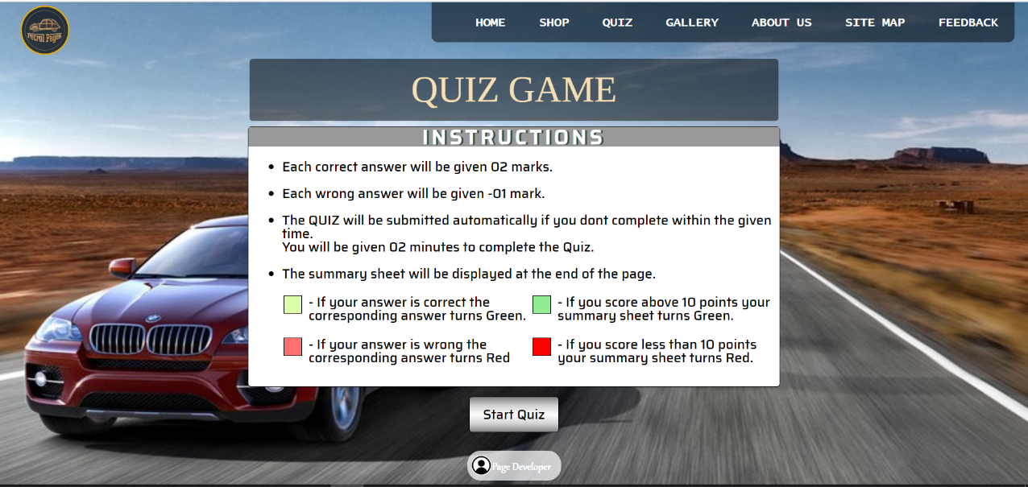Quiz_Student3.html

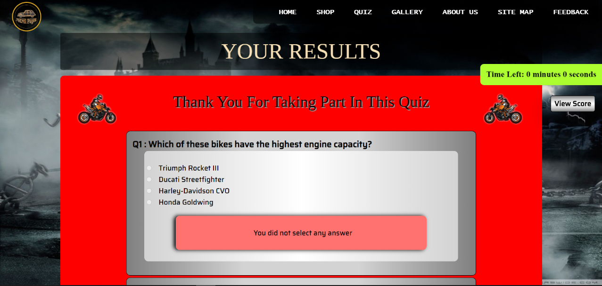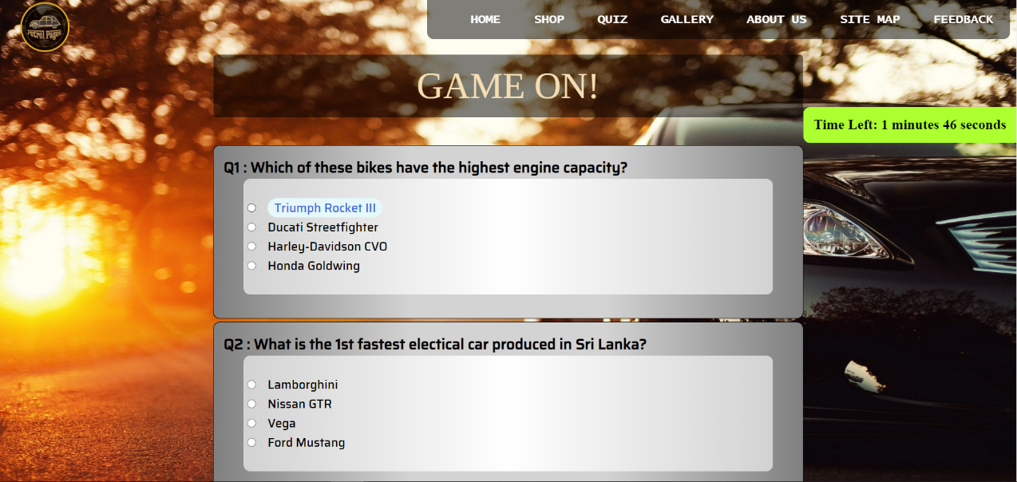

* Team_Details_Student3.html



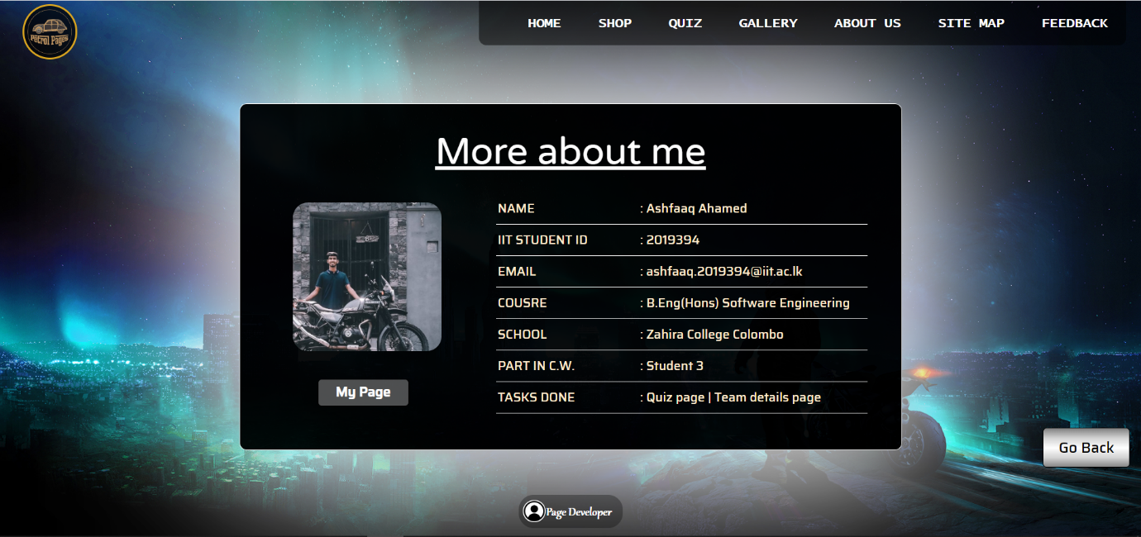

* Page_Dev_Student3.html

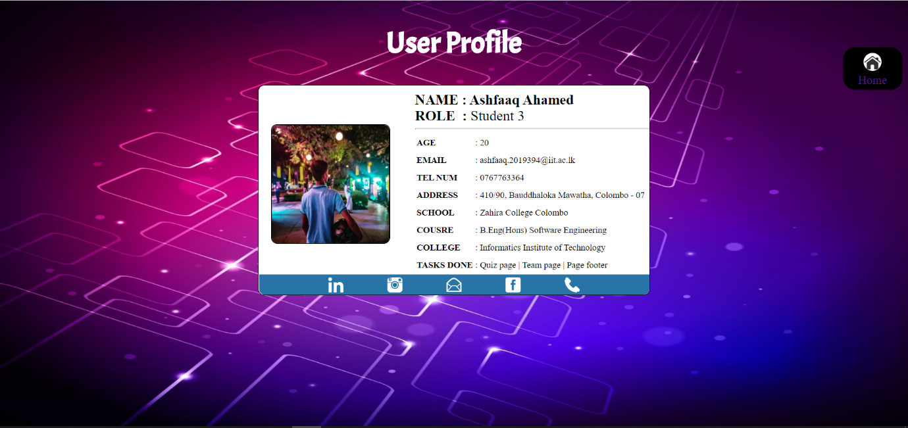

* Part_B_Student3

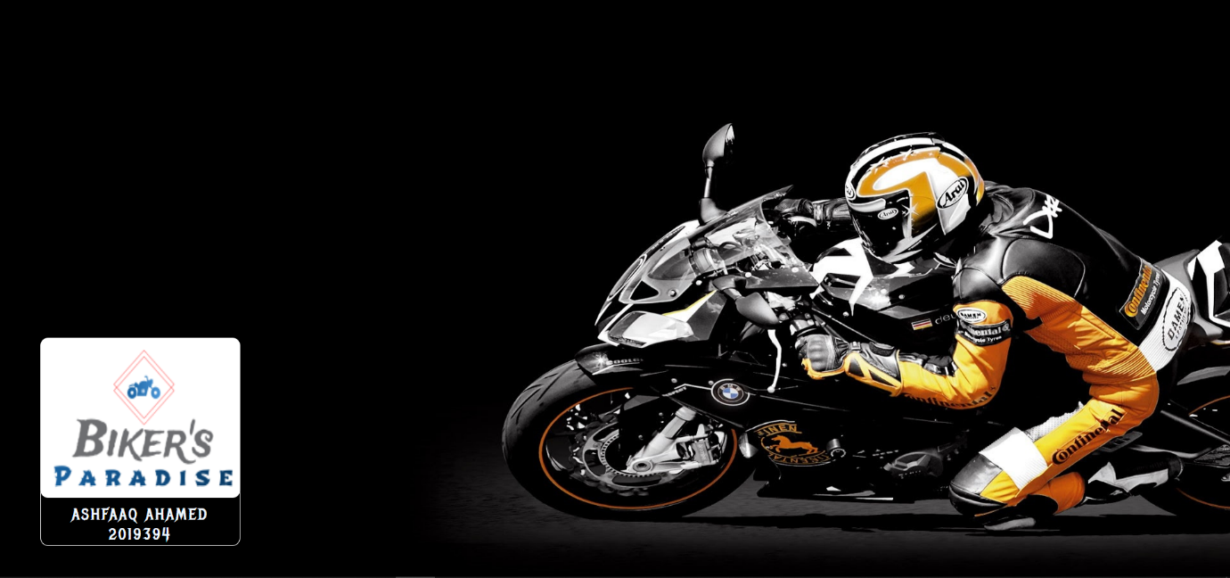

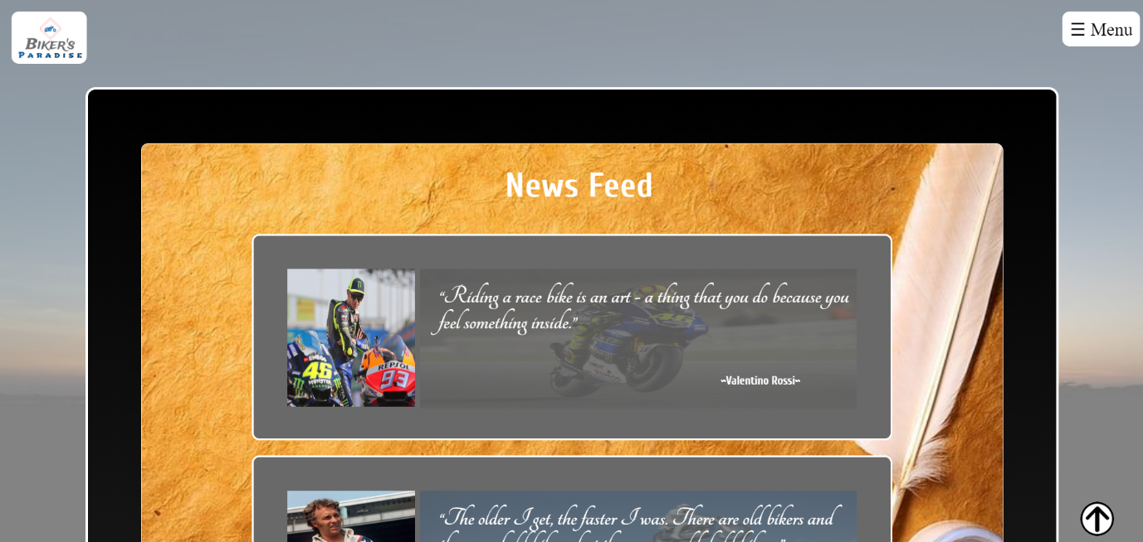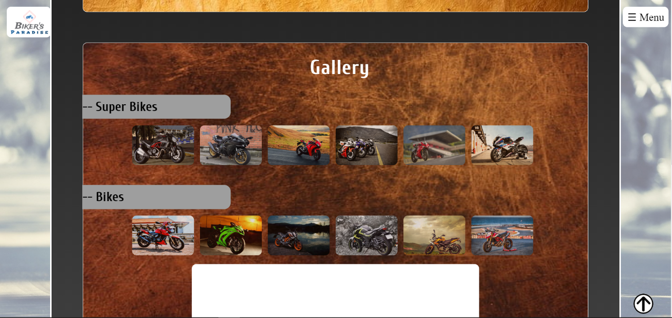

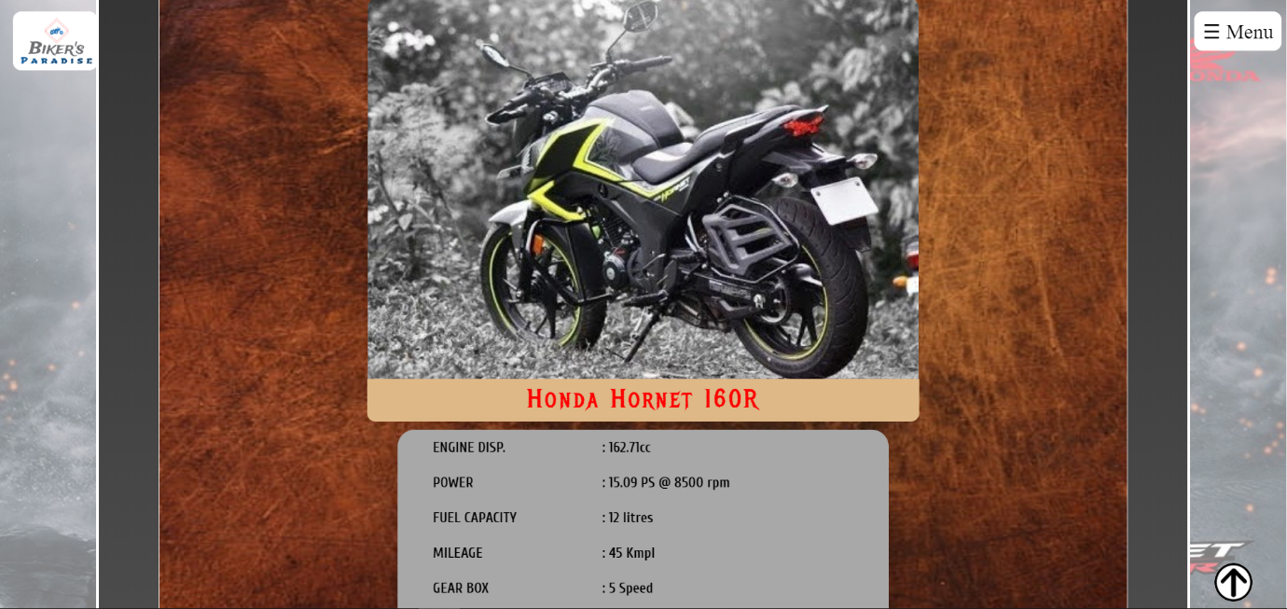

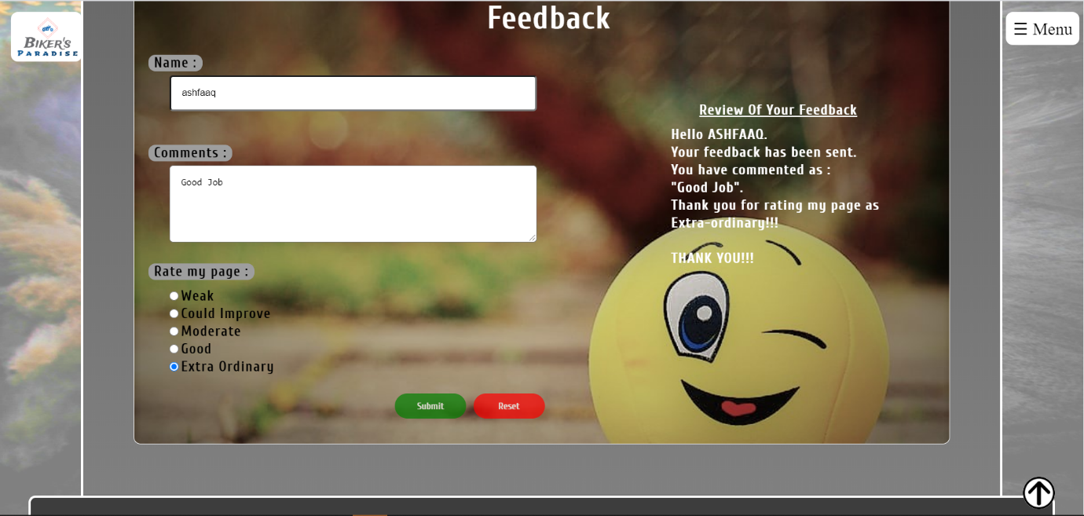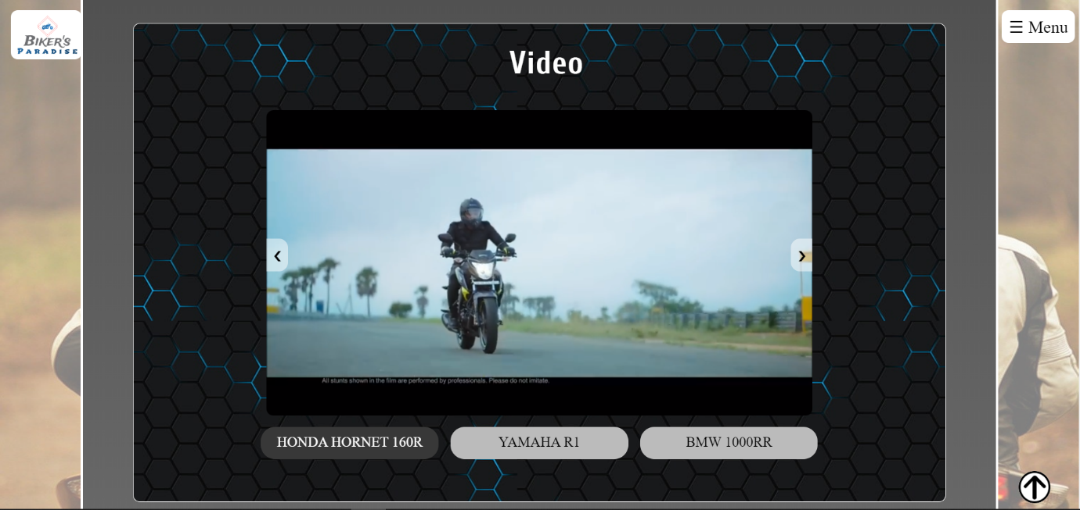

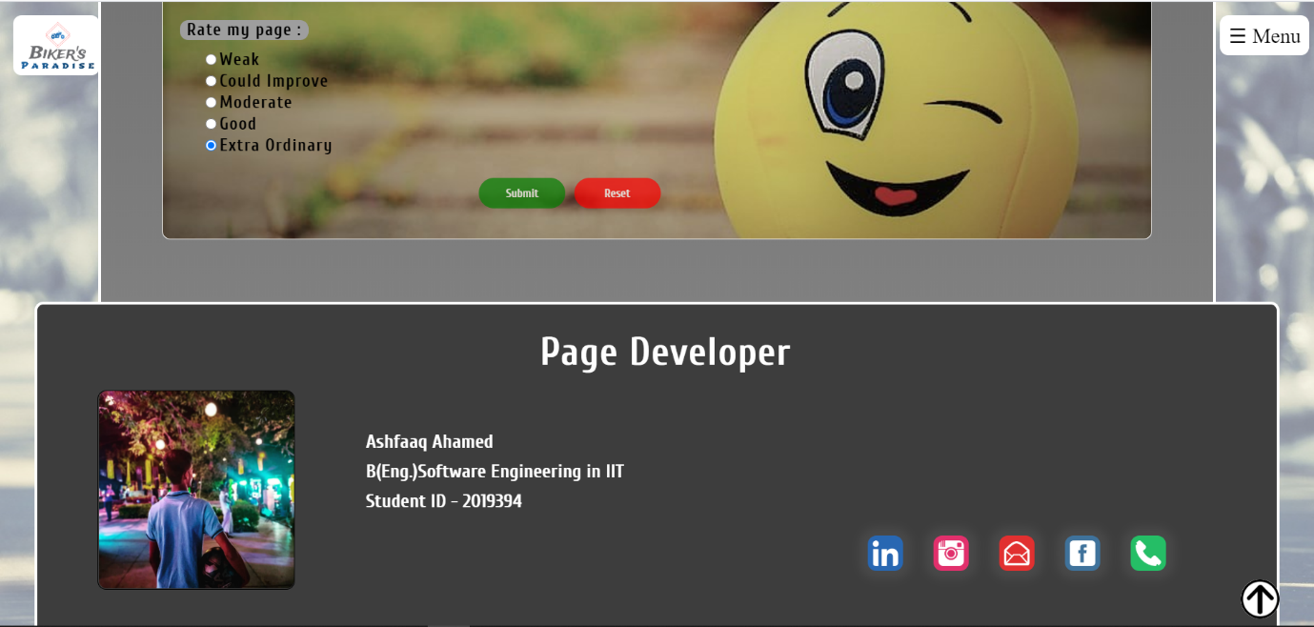

## Appendix C: Individual Statement

|  |  |  |  |
| --- | --- | --- | --- |
| Student Name: | Ashfaaq Hilal | Student Id: | 2019394 |
| State what tasks you carried out in the project. | | | |
| Quiz Page  Team Details Page  My Page Developer Page  Individual Page | | | |
| State what you enjoyed and did not enjoy about teamwork. | | | |
| Enjoyed – Came up with new innovative ideas for others page.  Not enjoy – Since this project was done remotely, we were unable to get connected easily. | | | |
| State what you learnt about teamwork. | | | |
| Time-management and leadership | | | |
| State what skills you gained/learnt from undertaking the project. | | | |
| New methods and short tricks were followed and learnt. | | | |
| State any strengths about yourself that emerged whilst undertaking the project. | | | |
| Learnt new techniques in JavaScript and CSS which I was lacking in. | | | |
| State any weaknesses about yourself that emerged whilst undertaking the project. | | | |
| I found it difficult to sort out a problem which came up while doing the project alone. | | | |
| State how you would do things better if you were to undertake the project again. | | | |
| Learn more on the front-end development side and make it more legible. | | | |
| Additional general or project specific comments: | | | |
| Most interesting section out of all other modules. | | | |
| Student Signature: | Ashfaaq Ahamed | Date: | 20/07/2020 |

Link to our web-site

URL:

<https://w1761334.users.ecs.westminster.ac.uk/>

